Survival Bread
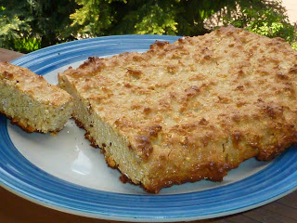
Many years ago, at a Preparedness Fair, I picked up this recipe for Survival Bread. The recipe says that after it's made, it "will keep indefinitely". Hmmm... Made me think of Lembas bread - something the elves would make (for you Lord of the Rings fans). "One small bite will fill the belly of a grown man." Since I can't stand to waste, it didn't sound like anything I wanted to HAVE to consume on an otherwise perfectly good day, with soft yeast bread and an abundance of other good foods in the fridge. But this recipe keeps popping up in front of me, so I decided to throw caution to the wind and bake up a brick of Survival Bread today.
Here's the original recipe, just as I received it:
Survival Bread

2 cups oats
2 1/2 cups powdered milk
1 cup sugar
3 Tbl honey
3 Tbl water
1 pkg. lemon or orange Jell-O (3oz)

Combine oats, powdered milk and sugar. In a medium pan, mix water, Jell-O and honey. Bring to a boil. Add dry ingredients. Mix well. (If the dough is too dry, add a small amount of water a teaspoon at a time.) Shape dough into a loaf. (About the size of a brick.) Place on cookie sheet and bake at 350 degrees for 15-20 minutes. Cool. Wrap in aluminum foil to store. This bread will keep indefinitely and each loaf is the daily nutrients for one adult.
Well, the ingredients don't sound too bad, but that last line bothers me for some reason. Healthy food should deteriorate, shouldn't it? I have teenage boys and not much goes to waste around here, so I figured it was worth trying out. Even though the recipe doesn't specify, I used quick oats. As for the liquid, that little bit didn't even begin to cover it. It was so dry, I was still stirring mostly powder, so I ended up adding another 1/3 cup water plus more - almost 1/2 cup! It was very stiff, and very sticky. I wonder if I should have added less and got my hands in there and just packed it all together when it was still a lot drier. I don't know, but here's the results:
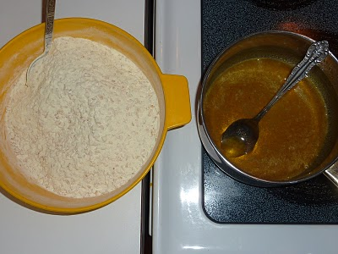

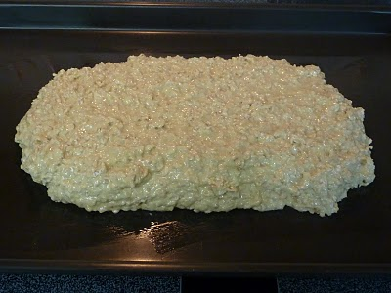

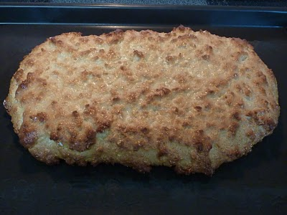

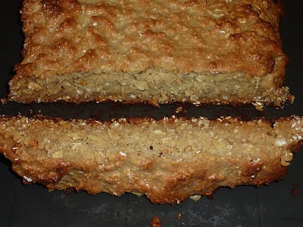

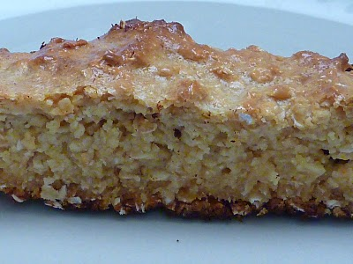
It doesn't look so bad! AND - it actually tasted pretty good! It has a heavy powdered milk taste, which I'm not a big fan of, but with a little butter, or honey, or butter AND honey(!) I hardly noticed. I'm sure the recipe can be altered. Maybe less powdered milk and more oats? Unless it's formulated to an exact scientifically nutritional specification! :) But I doubt it.

