Storing Onions
Posted by Emily
I heard or read somewhere (it might have been a comment on this site), that you can store onions by putting them in nylon stockings and tying a knot between each one. This gives them plenty of airflow so they won’t get moldy, and separates them so if one goes bad it doesn’t spread.
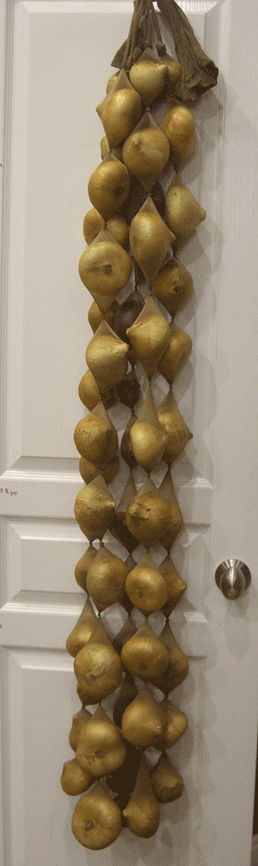
Here you see 5 “legs” of onions (queen size). I harvested 25 pounds of onions, so I figure each leg is about 5 pounds.
I cut the pair in two right up the middle, dropped in an onion, worked it to the bottom, tied a knot, and repeated until I couldn’t fit any more.
I hung them on my pantry door for a picture, but I’m actually storing them in the cool, dark basement so they will keep longer. When I need an onion, I take my scissors downstairs and cut one off the bottom.

