Short Term Food Storage
. By Dale

- Tweet

Start Building Your House
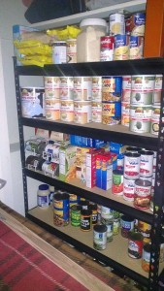
Think of prepping like building a house, you wouldn’t want to by the shingles for your roof before you even had the walls built. The same goes for prepping, you don’t need to invest in personal protection if you don’t have anything to protect.
Before we even begin to think about long term food and water storage or we need to think about surviving a power outage or a food shortage and work from the ground up.
In any grocery store, there is about three days’ worth of food (more or less) stocked and ready to sell. What do you think would happen if something catastrophic occurred? How long do you think it would take for the stores shelves to be wiped out? The simple answer, not very long.
You don’t have to go and spend $500 extra a week stockpiling food. By adding an extra $20 a week to your shopping trip in as little as 3 months you will have accumulated a nice pantry full of food. If done smart, that could be a six month food supply for your family.
Make a list of the basic things you will need in the event you could not get out for a week, a month or even three months but make sure you keep your supplies level, there is no need to have 6 month’s worth of food if you only have enough water to last a week.

Short Term Food Storage Calculator (Downloadable)
I created a worksheet that I used to help me stay a little more organized and focused on what I had and what I needed. Hopefully you will outgrow this workbook as I did and move on to bigger and better pastures.
Keep in mind this worksheet is for the short term basics, flour doesn’t taste very good by itself and I does you no good to have 50 lbs of flour if you don’t know how to use it. We also have a long term food storage calculator available for members if you have the skills to utilize items like flour, grain and rice or if you are looking at larger scale food storage.

Here’s How It Works
- On the top of the worksheet you will see “Number of Weeks Desired” enter how many weeks you are trying to stock up for in the event of a small scale disaster. You will need to enter the number of weeks for refrigerated items separately, you don’t really want 15 gallons of milk do you?
- Enter a product that your family uses, eggs, bacon, beef etc. then to the right of the product enter how you purchase the item, for example when you buy milk it’s usually in a gallon container so write GAL.
- Again to the right you will enter how much your family uses. There are two sections “Average Usage by Adults per Week” and “Average Usage by Children per Week.” Once you do this the grey boxes will auto populate for you.
IMPORTANT: You can change any of the products on the list to fit your family’s needs. You don’t need to add everything, just the items your family uses the most.
- Now enter the cost per unit. The cost per unit is what you pay for the product, If you used GAL for milk you would put how much a gallon of milk is.
- Finally, put how much you currently have on hand. After you enter this a total will pop up telling you how much you need to purchase.
- Continue this process for all of the items you want to have ready in case of a short term disaster. Once you are done it will give you a total cost on the top right, and you can now easily make a shopping list.
Excel Tip: to change a product just click on the cell you want to change and hit backspace, then enter what you want.
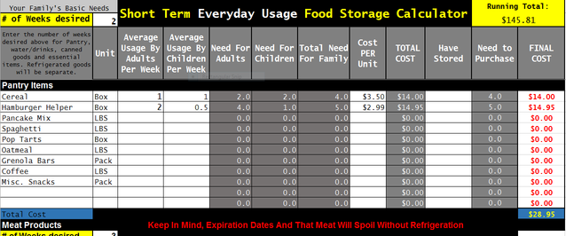
You can start from one week and work your way up from there, but keep in mind that different foods have different shelf lives and if you buy 15 gallons of milk you need to have somewhere to put it, and use it before it goes bad.
Download the Short Term Food Storage Calculator Here

Eat What You Store, Store What You Eat.
You don’t want to go out and buy 100 packs of Ramen noodles if your family will not eat them, and you don’t want to stock up on canned asparagus because they were on sale because they are just going to sit on your shelf taking up space.
On the other hand if your family likes Ramen noodles stock up whenever you can, although they are not the healthiest thing you could buy, they have a long shelf life and can be stored pretty easily.
When you are thinking about short term, think about what you will do if you have no power for a week? Or what you will do if the trucks that deliver food and supplies to your local store can’t get there? Most people don’t see this as a possibility, and that is exactly why we need to have the supplies we need and stay away from the stores in situations like this.

You Don’t Want To Run to The Store For T.P.
Just as important as food is supplies. You don’t want to go hang out with the crazies in a grid down event because you ran out of toilet paper or you have no batteries for your flashlight. If you think Walmart is bad on black Friday, just wait until there is a food shortage, you won’t just be fighting grandma for a cart.
Make a list of supplies you will need, and really think hard about this because the one small thing you forget could put a real kink in your plans. Let’s say you have enough canned food for a month but you forgot the can opener (your electric one might not work) or you have 30 AAA batteries but the only flashlight you can find takes C Batteries…put your bullet proof vest on because you are going to Walmart.

Emergency Kits
The best way I have found to make sure I not only have what I need, but I know it has been rotated and is going to work when and if I need it is to set up different storage kits that contain items for different purposes.
I have one plastic container that is my lights out kit, it contains batteries, flashlights, solar nightlights, propane, candles, three different ways to light the candles and whatever else I think might come in handy in the dark…night vision goggles are next!
Another container contains personal hygiene supplies, just like the lights out kit, this can be stored in the garage or a closet out of the way. I like to keep all of these kits, containers or whatever you use in one area, this helps because you don’t want to be searching around the house in the dark, or if you have teenagers and the power has been out for a week you will defiantly want that deodorant quick.
Another good reason to have your supplies organized is rotation, you don’t want to have flashlights that don’t work or food that is past its expiration dates. What I do is once a month bring the container in and swap out the old with the new.
When it comes to rotating food, you want to set your storage like a grocery store would as much as possible. It can become a huge chore rotating your food if you are disorganized or have cans everywhere…trust me I know. This also eliminates the possibility of thinking you are prepared only to find out that the mice have made a nest out of your toilet paper stockpile.
Hopefully you get a few ideas about where to start, how to stay organized and how to be ready when disaster strikes.

