Salt Preserving Meat, Dry Salt Packing Method

I’m at it again! This time I’m going to use the dry salt packing method. This test, like the first, will use four pieces of meat that every 30 days I will take one piece out of the salt then cook and eat it. I will let you know how it tastes every month.

The purpose for these tests is to be sure I can preserve large quantities of meat such as a deer when there’s no refrigeration available and using the minimal of preserving ingredients. After all we can’t prep and store everything we could possibly need for every scenario.

For the record, I prefer pressure canning to the brining or dry salt packing methods because the meat from canning tastes great!

My first test with salt preserving was using a brine solution or liquid salt method. The details of that 4½ month long test can be found here:

This dry salt packing method is pretty straight forward just surround the meat in canning salt about ½ inch thick separating each piece of meat and from the sidewalls of the container. Pack it in firmly and you’re done. As time goes on and the salt draws the moisture out of the meat. I may remove the meat from the salt and replace the meat juice soaked salt with fresh salt, I’ll see as time goes on.

The same meat I used in the brine test last year only it’s $0.60 a lb. more this year!
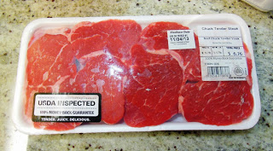

All the excess fat trimmed off.
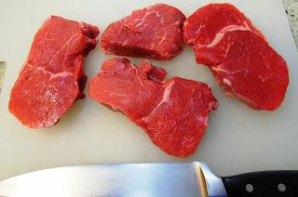

The Rubbermaid container used.
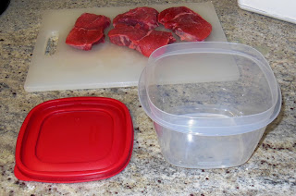

My 5 quart storage jug of canning salt.
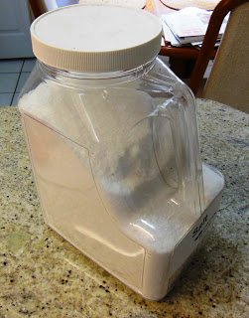

First I put down a ½ inch of salt in the bottom of the container and then placed the first piece of meat down.
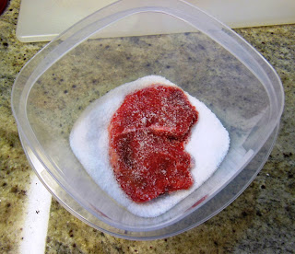

I covered the first piece of meat with ½ inch of salt then placed the second piece of meat on top of it.
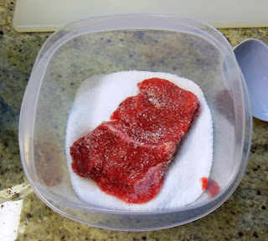

I covered the second piece of meat with another ½ layer of salt then place the third piece of meat on top of that.
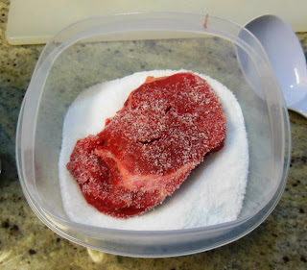

Covered the third piece of meat with another ½ layer of salt and place the fourth piece of meat on top of that layer.
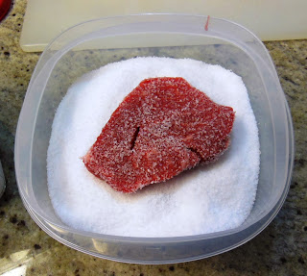

Finally I covered the fourth piece of meat with another ½ layer of salt, packed it down.
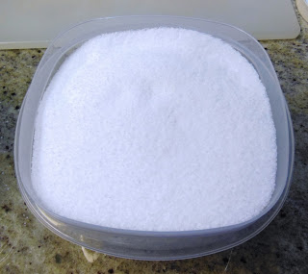

And finally put the lid on and now wait 30 days to test the first piece.
