Rice Pudding

By Granny Miller
Rice pudding is a favorite around here. My husband likes it for breakfast and I like it anytime. It’s a fantastic way to use up leftover rice. There are many different variations of rice pudding found around the world. The recipe below is classic American Farmhouse cuisine.
Rice Pudding
- Heaping ⅓ Cup of Cooked Rice
- 6 Eggs
- ¾ – 1 Cup of White Cane Sugar
- 1 Quart Whole Milk
- ½ Cup of Raisins
- ½ Teaspoon Ground Nutmeg
Pre-Heat oven to 350°.
In a large bowl combine eggs, sugar and milk. Beat well with a rotary mixer, whisk or by hand vigorously. Take care that the sugar is well blended.
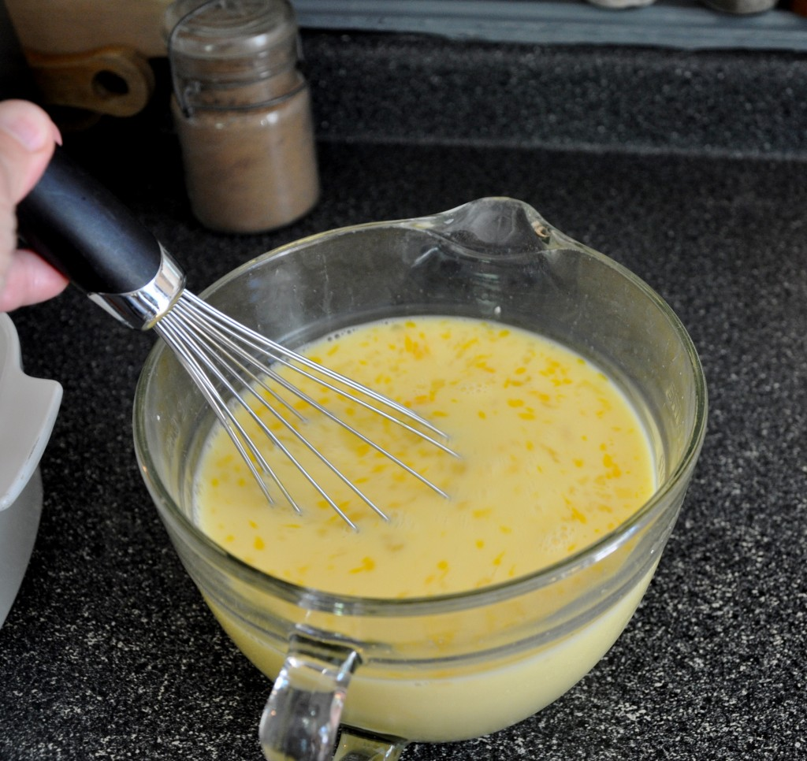
Blend Eggs, Milk & Sugar Well
Place the cooked rice in a 1 ½ quart casserole dish. Sprinkle raisins over the rice.
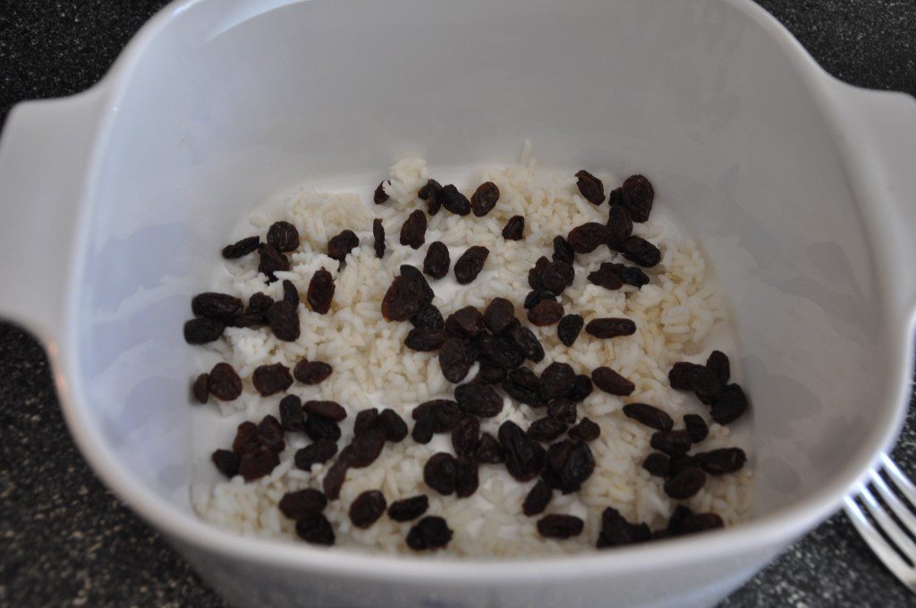
Sprinkle Raisins Over Cooked Rice
Pour the milk mixture over the rice. Stir rice and milk mixture very gently with a fork to help un-stick any clumps of rice. Evenly sprinkle nutmeg over the top. Place casserole dish in a shallow pan of water to bake. Bake for about 1 hour or until a table knife inserted into the center comes out clean. Serve hot or cold.

