Repackaging Salt for Long Term Storage
by aptprepper
Because salt is one of those essential ingredients with multiple uses, I decided to add more of it to my storage.
I bought a huge bag of salt at Costco, but knew I’d need to repackage it for storage sooner than later to preserve its quality. I know you can always break it up if it were to clump up, but it’s so much easier to use if it does not have clumps and is free-flowing. I’ve posted about bulk food storage a couple of years ago, but this time, I am doing it a bit differently.
Materials I used:
Mylar bags (one gallon size)
measuring cup or scoop
hair straightening iron
food grade 5-gallon bucket
Steps:
- Wash and dry hands thoroughly. You don’t want any moisture around when doing this. It’s best to do this away from kids or pets, to avoid accidents with the hot straightening iron.
- Scoop salt into the mylar bag with a cup or scooper until it is about 1/2 – 3/4 full.
- Gently shake the bag to make sure the salt is evenly distributed throughout the bag.
- Squeeze all the air out by placing hands on each side. Now you are ready to seal.
- Use the straightening iron, set on the high setting, and start sealing one side to the top of the bag. When I did this process a couple of years ago I used a clothes iron. But ever since I read the tip from Gaye, Survival Woman, I wanted to try using the hair straightening iron. I found that it is so much easier this way.
- Do the same thing on the other side. DO NOT TOUCH the Mylar bag after you’ve run the iron across it – bag will be hot!
- You do not need oxygen absorbers for salt or sugar. But if you are storing flour, rice or some other bulk food, you will need them.
- Label the bag with the item name and date. This way you’ll know what bag to use first when you rotate your food storage.
- Store the bags in a 5-gallon bucket with a lid. Store in a cool, dry place, with temperatures around 72 degrees or lower.
Here is a photo of the results of my salt storage project before I placed them in a 5-gallon bucket:
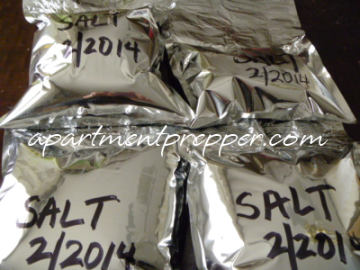
How long will it last?
Properly stored bulk foods should last 10-30 years, however, other factors such as light, heat and humidity may affect the stored food. If the food is stored at higher temperatures, the shelf life would be shorter. Storing food in less than ideal conditions may be a bit of a challenge but don’t let that stop you.
Always rotate your food storage
To avoid food going to waste, periodically go through your food storage and rotate your stores. Use up the foods with the oldest dates, and replace with a fresh batch.

