Rendering Lard for Good Healthy Cooking Fat
A GOOD HEALTHY COOKING FAT?
Before I tell you how to render your own lard, I need to get this out of the way.
I know. You’re thinking I’m insane for claiming that Scary Evil Lard is good for you. However, new research reveals the value of saturated animal fats and is bringing them back from the darkness after decades of vegetable oil propaganda.
For instance, Dr. Andrew Weil states:
“After World War II, consumption of lard along with other animal fats dropped even more thanks to the conventional wisdom of the past 40 years that the saturated fats in our diets were a principal cause of high cholesterol and rising rates of heart disease. More recent research suggests that this isn’t so – a scientific analysis of 21 studies determined that there is no significant evidence that dietary saturated fat is associated with an increased risk of coronary artery disease.” (Complete article here.)
Fact is, you’ve been sold a bill of goods. Lard – real lard – is a fine fat. From pastured, healthy pigs, lard is actually a health food.
The problem is, you can’t find good lard in most supermarkets. Instead, you’ll find tubs of hydrogenated fat that are the furthest thing imaginable from what our grandparents used to eat as children. If things take a downturn, good luck finding factory-produced cooking oils like soybean (gag), canola (choke) or Crisco (barf). And unless you have the climate for olives… plus lots of time on your hands… animal fats are likely to be the official oil of the Apocalypse.
With this in mind, my wife and I simply render our own lard from locally obtained fat from pastured pigs. Though it’s time-consuming, rendering lard is not a hard process – and the resulting fat is heavenly for frying and baking. I’d say the hardest part about making lard is finding the pig fat in the first place. Most meat counters and butchers throw it out. On the upside, you can sometimes get them to set it aside if you ask nicely. Personally, I got my pig fat from a local butchering facility.
Total cost for roughly 60lbs of pig fat? $20.00. Check it out:
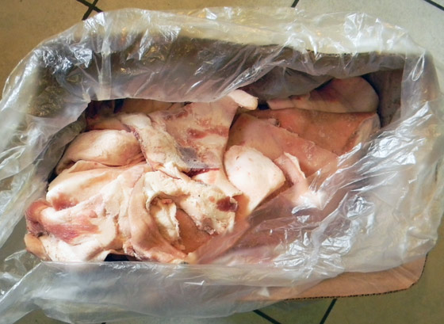
A huge mass of raw pig fat in a box makes the perfect gift for any occasion!
Once you get some fat, it’s time to start rendering lard!

Step 1: Chop it up
There are many ways to render lard. All you’re basically doing is cooking out the oil from the fat cells, then straining it into a container for later use. Ta-da! Lard!
The main trick is not to burn the fat by speeding ahead at too high a temperature. Low heat is your friend.
For the most yield, chop your fat into small pieces to allow more lard to cook out of the chunks. Because I had a huge amount of fat, and because it was still attached to some really tough pig skin, I got sick of painstakingly dicing up little chunks. The pieces got larger and larger as Rendering Day 2014 stretched on. If you have fat without the skin, it’s easy to chop it up, so go small and you’ll get more lard in the end… and you’ll get it faster.

Step 2: Cook It Down
This isn’t tough. You can use a big stock pot (I used this excellent one), pans, dutch ovens or even your crockpot.
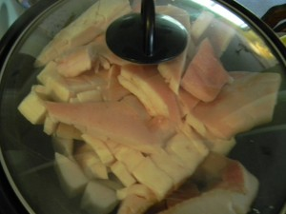
(insert culturally insensitive remark about Ramadan here)
I used all of the above. I had lots and lots of fat to process.
At one point I was cooking down fat in two cast iron Dutch ovens inside my oven, two crockpots on the countertop, plus two large pans and my giant stock pot on the stove top.
I like to get the fat heated up quickly, then turn down the heat while stirring it around to make sure it doesn’t stick as it starts to melt. Later in the process I don’t need to stir as much because the original fat chunks start to shrink and swim in a golden pool of melted lard.
The fastest method I’ve found is to heat up small chunks of fat in pats and keep stirring them; however, if you have a large quantity of fat, the stockpot is easier. And finally, if you’re lazy, just set your crockpot on low and go to bed for the night.

Step 3: Start Ladling
As the original pieces of fat start to shrink and the liquid lard is released, you’ll be able to start using a ladle to scoop out fat. I put a strainer over the jars as I ladle to keep the little bits and pieces from getting in.
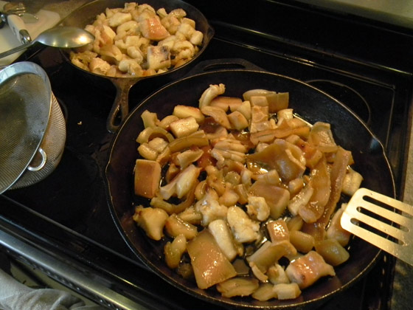
Note the sieve on the left. Also note the pizza cutter just above it. You need one of these… and the other you don’t.
It’s important to keep the heat of your cooking vessels from getting too high. You do not want to scorch any of the fat or get the lard smoking. Nice and easy, just let it cook down and release the fat under low heat. The lard will come out… don’t rush it too much.
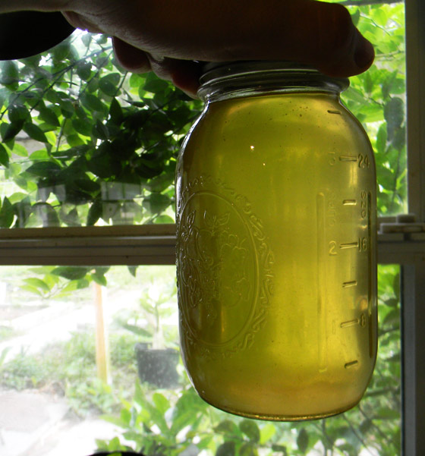
Rendered lard is not only tasty, it looks great with your home decor!
Keep ladling as the oil levels rise in the pans. It’s not a fast process, but when I use the stovetop with a couple of pans, usually all of the lard has been extracted within a couple of hours and I’m left with little chunks of crispy pork rinds. I like them with ketchup, but your mileage may vary.
By my best guess, we rendered approximately 40lbs of fat in one day and got a good four gallons of amazing lard from our hard work. I store the jars of finished lard in my freezer until needed. They keep a long, long time that way. (I haven’t got a good answer on whether they can be canned and stored on a shelf at room temperature. Is canning straight oils or fats possible? Let us know if you have the scoop.)
You can follow this same basic process with duck, beef or even bear fat.
When you have the lard finished, it’s also a wholesome oil for homemade soap. I also use it to grease the handles of my wooden tools.
In a pinch, you can even burn it as fuel.
Lard is at its very best, however, in delicious meals. Once you start using it for cooking, you’ll never go back to the grey and tasteless world of canola, corn and other vegetable oils.
Forget your fear of heart attacks. Release your nervousness over saturated fat.
Start rendering lard and using it before the world catches on and the price of fat goes up.

