RICE TUBES


By WE2′s
If you’ve ever vacuum sealed rice, dehydrated potatoes or pasta’s you’ve learned that they puncture tiny little holes in the bags (even Mylar eventually) and it’s a gonner for long-term storage. That’s why using “tubes” made sense to us.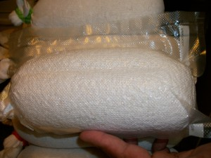
We made a visit to our local $Tree and purchased several packages of ankle high socks and several “hair bands”.
While wifey held the sock and the funnel, MrWE2 poured several cups of instant white rice (or whatever type rice you want to store) until it was about 3 inches from the top of the sock.
Then he shook the sock to settle the rice, gave the sock a “twirl” to tighten the top of it, and wrapped the hair band (like a rubber band) around top several times, bent the top part of the sock over, and again wrapped the hair band.
We then put them tall side up into a 5-gallon food safe bucket with a gasket sealed lid, and with a rubber mallet, hammered the lid in place. You can get a WHOLE BUNCH of rice tubes in a bucket!
