Quick Tips for Dehydrating Food
Over the years I have tried dehydrating various foods. I have done fruits, vegetables, meats and shrimp. Some of the items I will continue to dehydrate and some I will write off as a learning experience.
By Dave H, a reader of SurvivalCache.com
When thinking about dehydrating food for a survival situation, you most likely will be planning for the “Extended” and/or the “Long Term” levels in the Survival Food Pyramid. When I first began dehydrating, I started with small batches and vacuum bags for storage. From my experience, this seemed to be very inefficient and the vacuum bags are expensive. This has led me to where I am today. I use 5 gallon buckets, gamma seal lids, Mylar bags and oxygen absorbers.
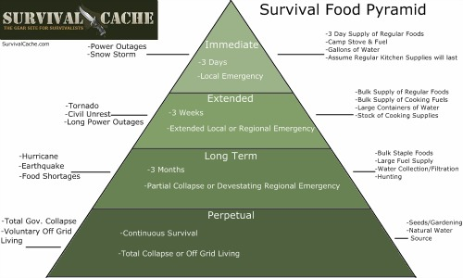

Are Fruits Worth It?
Doing fruits is not technically difficult. However, when taking into consideration that you will be dehydrating potentially years’ 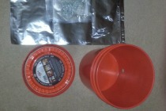worth of food the labor involved may be more than you will be willing to perform. Imagine how many banana slices it will take to fill a five gallon bucket. Therefore, I have decided that I will purchase most of the fruits for long term food storage. The one exception is pineapples. With a good corer you can quickly prepare a pineapple. I also like the smell in the winter.
I have dehydrated chicken, turkey, ham and pork. The dehydration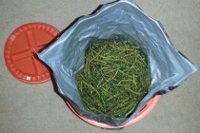 process is simple and they seem to come out fine. I do get concerned that the remaining oils will turn rancid. Therefore, I vacuum sealed the meats and kept them in the freezer. Since my goal is for decade plus storage I decided against dehydrating meats and purchased meat products specifically designed for long term storage.
Here are a couple of other items I will purchase freeze dried instead of dehydrating. Potatoes, they are inexpensive to purchase and mine tended to turn black. Onions and shrimp both turn out fine. Unfortunately, they will create odor problems in your house.
So, what dehydrates well, is easy enough to do in bulk and will store for generations? Corn, broccoli, green beans, peas, green chilies and many other vegetables will dehydrate well and have indefinite shelf life. I like the 5lb bags of vegetables. In a matter of minutes I can have them in my dehydrator.
When they are done I simply pour them into the Mylar bag. I make 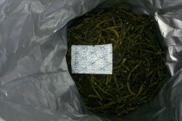certain I dehydrate them until they are crisp. Leaving moisture may allow your product to decay. Remember, you are dehydrating for the long term, not next weeks backpack trip. Put the O2 absorber in the bag with the vegetables. You can substitute hand warmers for O2 absorbers.
Close the Mylar bag and try to remove as much air as possible. Tighten the gamma seal and place in a dark cool location.
To give you some idea of the benefits of dehydrating I can put 35lbs of green beans in a 5 gallon bucket, 50lbs of peas and 55lbs of corn.

Other Things to Store & Notes:
Flour, beans, rice and pasta can be placed in a Mylar bag, which is inserted into a 5 gallon bucket with an O2 absorber. For flour I use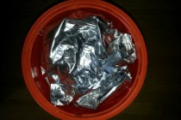 a plate to remove air and to pack as much product in the bag as possible.
Storing sugar does not require an O2 absorber. Don’t stack the bucket that contain heavy items (sugar, flour, beans, etc.) more than 3 high. The gamma seal lids will break compromising your food storage.

