Manual Kitchen Tools for Modern Survivalists
by Nancy Smith

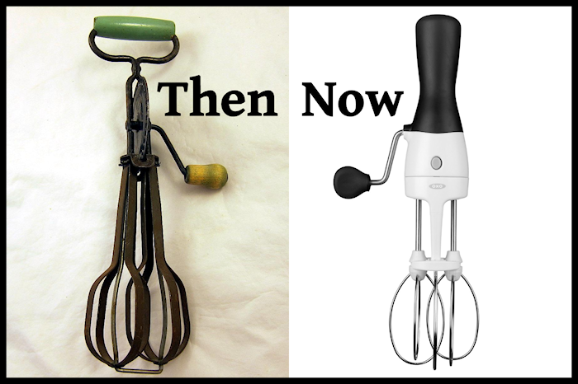
Perhaps you’ve been pining for some of those old manual kitchen tools you see in your local antique stores or on eBay. You’ve put serious thought to acquiring a few of them — just in case. You know that when the power goes out, these manual kitchen tools will be invaluable resources. There’s a reason Grandma cherished hers, after all.
Plus, Grandma could really throw a punch with her “egg beater arm” — and that’s not a bad skill to have either!
These days, most of the manual kitchen tools you see in antique stores are only for display purposes. The rust and crust has taken over and reduced the usefulness (and sanitariness) of these once-upon-a-time heroes of the home gourmet. But that doesn’t stop you from wanting them.
I know, me too. I find myself gravitating towards all those important things Grandma used.
So this past year I’ve been acquiring and testing modern versions of the best manual kitchen tools and teaching myself ways to use them in my modern life. For instance, I now make mayonnaise from scratch in just seconds (here’s my post on how to make mayo with powdered eggs) with the hand mixer. I’ll never go back to overpriced, factory-made glop again.
When you have a few simple, inexpensive whipping and mixing tools such as these in your kitchen, you’ll find yourself whipping up eggs for a souffle, cream for your pie, or simple mayonnaise for your tuna salad. They’re great survival tools for those of us who cook – and these are so easy to use that even non-cooks (like my hubby) can use them.
I think our wonderful grandmothers would have really gotten a kick out of them.

1. Egg Beaters Have Come a Long Way, Baby
That’s right. Egg beater technology has come a long way in recent years. I always looked at egg beaters in antique stores and flea markets, thinking I should get one. But the crusty, rusty specimens I came across did not look appetizing or particularly useful. And in the event of a power failure, I need tools I can rely on.
Enter the modern egg beater. It’s a multi-tasker and if you only get one of these tools, get this one – it’s the only one I’ve seen where the beaters are elevated so that while the device rests on bottom of the bowl. The beaters don’t; this prevents wear and tear on the bowl, the beaters, and your arm. There’s no more “chinking” of the beaters hitting the bowl.
It comes apart and can be popped into the dishwasher or hand washed, and there’s a nice grip on the top that makes it easy to grasp. I can tell you from experience that the speed and power of the whipping mechanism is simply awesome. Here’s my hubby in action – whipping up some some egg whites (this is my first YouTube video and his first time whipping egg whites!:)): https://www.youtube.com/watch?v=Ko6gVJjCbQM&feature=player_embedded
2. Use A Hand Mixer for Making Sauces and Batters Quickly without Electricity
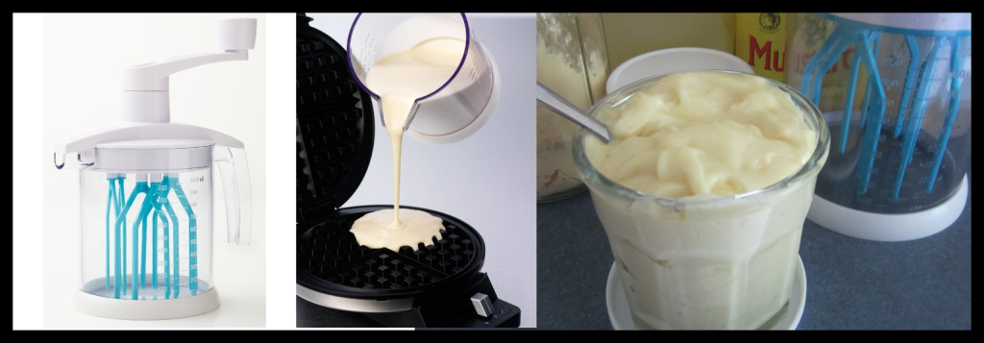
A good sauce will take any plain food to another level. And after a disaster has struck and the smoke has cleared, a lovely sauce over plain pasta or wild greens will help keep spirits cheery. Good sauces, however, can be a lot of work: many, such as mayonnaise and vinaigrette dressings, require a lot of arm-wrenching whisking in order to emulsify properly.
A little hand mixer, such as this one I use for my shelf-stable mayonnaise, is one of my favorite modern hand tools for the kitchen. It’s compact and whips incredibly fast – faster even then the egg beater. So I use it when I’m making sauces and batters particularly. It makes short work out of whipping up a hollandaise, mayonnaise or even crepe batter. (Hollandaise dresses up canned ham beautifully if you’re looking for a way to rotate your stock, incidentally.)
3. A Bit of Whipped Cream Makes Everything Better
After a disaster strikes, it can be the simple things that make everything feel more normal. And whipped cream is just one of those simple, deelish things that so many of us love. I read the reviews on this little hand-powered cream whipper and went for it, since it was inexpensive and if it was silly I could always return it. But I ended up loving it – it’s perfect for when you want to whip a cup of cream or make a little meringue. I’ve always had trouble making a very stiff cream – but less than 30 pumps of this little cream whipper and I’ve made perfectly stiff peaks of cream as you see in my photo below. I find that even though it’s not so much of a multi-tasker, the ease that it introduces makes it a worthwhile tool to have in my kitchen.
And because it’s hand-powered, you can use it no matter what happens – a bit of whipped cream makes everything better.

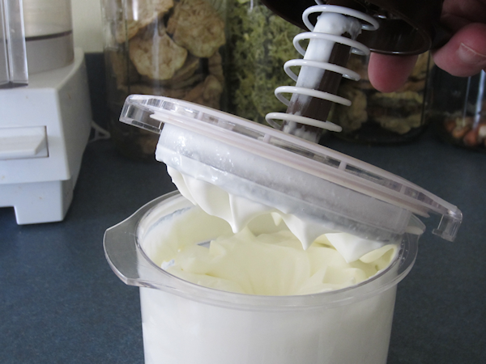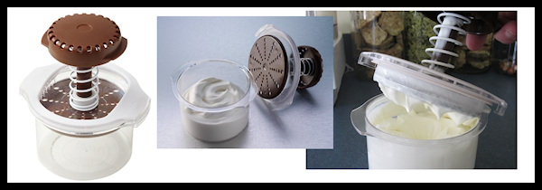
With these three hand-powered kitchen tools, I am now a lot more secure in my kitchen. I know with certainty that I can prepare beautiful food without electricity like our grandmothers did. And while my own “egg beater arm” is still pretty wimpy, I’m happy to know that I can make life better, one sauce at a time, when disaster strikes.
(P.S. If you want the antique egg beater in the post photo, you can get it from this very nice woman on eBay who permitted me use of her photo. The modern egg beater is here.)

