Make Your Own Survival Bars
Apparently there are a couple of different recipes out there for these, we just used one I had been given by a food storage lady. Now, this was really a fun experiment, because there were 6 of us making these survival bread loaves, and of course they turned out 6 different ways. We’ll discuss what happened as we go through the directions.
Ingredients:
2 cups oats
2 1/2 cups powdered milk
1 cup sugar
3 TB honey
1 3 oz package jello (orange or lemon)
3 TB water
Mix the oats, powdered milk, and sugar together in a bowl: A couple of us used regular oats, a couple used quick oats. I really don’t think it matters which you use–whatever you have on hand is fine.
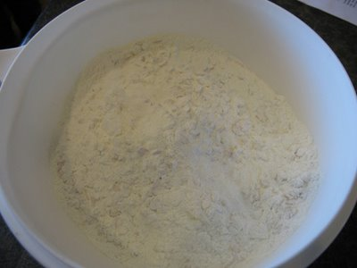
In a medium pan mix water, jello and honey. Bring to a boil. We found that a rolling boil was better than just beginning to boil for the mixing step. I did not know why the recipe called for lemon or orange jello so we made some with raspberry and watermelon. When we tasted them, we figured the lemon or orange were specified due to the high amount of sugar in this recipe! The sweet jello bars were REALLY sweet when they were done!
One of us also mis-read the instruction email and mixed her jello in with the dry ingredients, so we just boiled water and honey at this step and it gave the final product a slightly different texture, but still worked.
Lemon jello barely boiling:
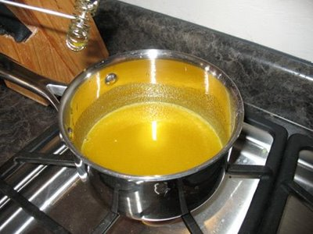
Raspberry jello at a rolling boil:
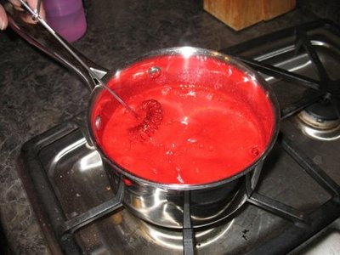
Add jello mixture to dry ingredients. Mix well. If the dough is too dry, add a small amount of water a teaspoon at a time. This is where it got a bit tricky. You want this to be dry, but it has to be moist enough to stick together, and this stuff is stiff!!! Spoons only work for about 30 seconds–you’ll end up cleaning your hands and smashing it all together that way (or you could use your mixer, I guess–why didn’t we think to do that???)
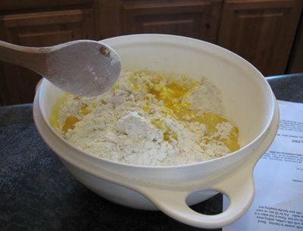
Add the water a little at a time–do NOT get impatient and just add a bunch of water! You’ll be able to stick it together lots easier, but the idea is for it to be dry so it will not mold in your car trunk like your kid’s leftover tuna fish sandwich…
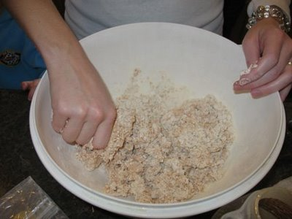
Shape dough into a loaf about the size of a brick.Yeah, right. We had a couple of Martha Stewarts with us that were able to form lovely brick shaped loaves, I just wasn’t one of them. I don’t think it really matters what shape your loaf is–it’s not like you’ll be posting pictures of it on the internet or anything . . . I’m thinking if I do these again, I’m going to make smaller loaves anyway and just have 3 smaller loaves instead of one big loaf. I’m going to need a chisel to be able to eat any of this!
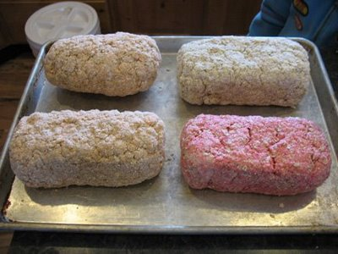
Place on a cookie sheet and bake at 350 degrees for 20 minutes.Another recipe I found says to put it in the oven and dry at low heat. That might be better overall. Our loaves got a bit brown on the bottom and we had severe stickage to the pan (think melting/cooking jello+sugar), so you might spray your pan first. Here’s the loaves after they cooked. Okay, I know, they look just like the loaves before they cooked, but really, I didn’t just go to the other side of the pan and take a picture, these were the cooked loaves.
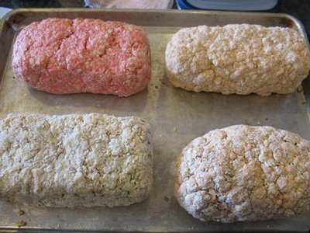
Cool. Wrap in aluminum foil to store.I do not know why you wouldn’t put it in a ziplock or something, but I guess maybe it stays dryer in the foil. Not sure about you all in humid climates–this probably wouldn’t last in foil–I think I’d maybe make sure it was really dry, then vacuum pack it with my foodsaver if I lived anywhere besides the desert!
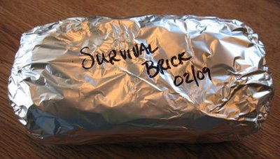
This bread will keep indefinitely and each loaf is the daily nutrients for one adult (approx 2000 calories). This is what the paper says. My loaves are going in the back of my suburban when I get my car kit put together and we’ll see how long they last! This was not too difficult to make. I figured the cost of 1/4 of a #10 can of powdered milk at $2.00 (we got the powdered milk at $8/can–lots of places are more expensive than that) the jello at $ .50 (okay, mine was $.97 because I had to buy it at the little store here in town–jello is a non food that I don’t usually have in my food storage), the sugar, honey, and oats another $1.00 or so. So on the cheap end, these cost $3.50ish for 2000 calories, compared to $4.95 for 2400 calories of the commercial emergency food bars. These are larger and heavier than the commercial bars also. I will say however, that the orange jello brick (my personal favorite) actually tasted pretty good and not all processed and shortening (yep, a real word).

