LDS Cannery (Home Storage Centers)
by Prepared Housewives
The Home Storage Centers (aka Canneries) are operated by The Church of Jesus Christ of Latter-Day Saints, but are available to the public as well. Some people have known about them for years, but are often intimidated to go. I finally built up enough courage and stepped foot into my first one about 3 years ago! Immediately, I became addicted, especially to the Hot Chocolate and the option to buy bulk food at a decent price! Now I make a few trips a year to refill my buckets, and can extra items for my food storage. The volunteers that work at the canneries are absolutely delightful and ready to help anyone, members and non-members alike! So get over your fear, grab a buddy, and head to a cannery near you!
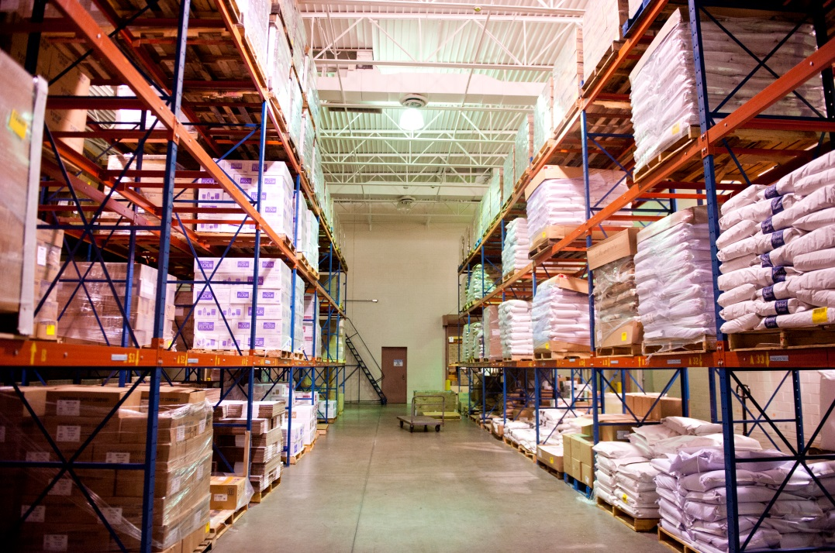

Plan a Trip to the Cannery:
- Order Form - Print off a form for your next trip to the cannery.
- Locations – Find a Location Near You!
- LDS Cannery Labels – This post has pictures of all the cannery labels containing storage life & ideal conditions, preparation instructions, and ingredients!
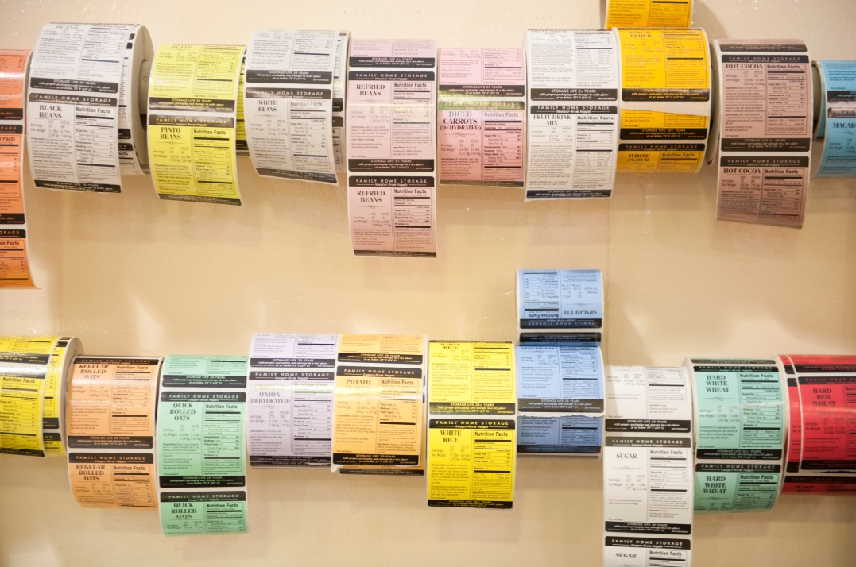

Options for Purchasing Items:
Each cannery has different policies, so make sure to call before going.
- MAKE AN APPOINTMENT - Each cannery usually has specific times they set aside to help individuals can items. Find out from a LDS Welfare Specialist for the assigned date for your area, or call the local cannery to make an appointment (non-members are welcome too). Remember no outside food is allowed to be canned, so plan on purchasing food that is available.
- BUY IN BULK - Anyone can stop by anytime the cannery is open to purchase bulk items, pre-packaged food, or overflow goods. It’s a good idea to go ahead and call the cannery beforehand to make sure they have the items you’d like to pick up. Don’t forget to order all the packing materials you’ll need such as cans, pouches, oxygen absorbers, lids, etc.
- BORROW CANNER/SEALER - Often times a canner and/or pouch sealer is available to borrow to take home, so you can seal or can your own food. Just make sure to call the manager to check availability and make an appointment to borrow them.
- PURCHASE ONLINE - If you do not live near a cannery, they now have the option to buy many of the items online!
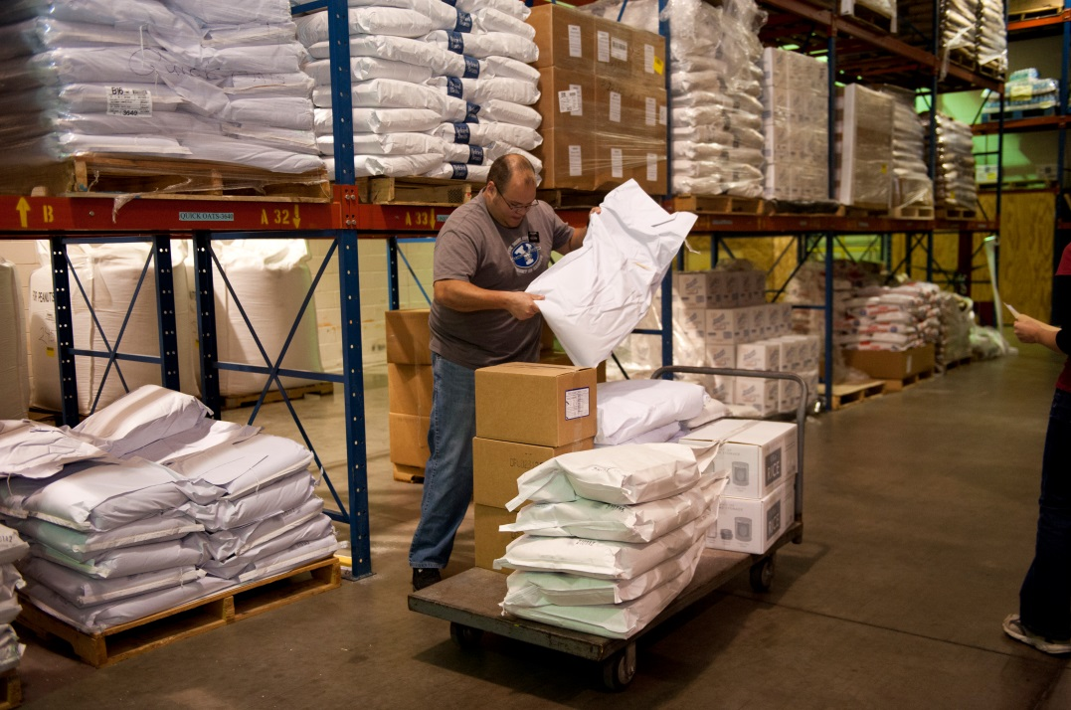

Payment at the Cannery:
- Credit cards are now accepted
- Checks (Depends on Cannery)
- Cash, EXACT amount – NO exceptions

What to Expect When Canning Items:
When canning items at the cannery you usually go during an assigned shift for your area that lasts about 3 hours. Sometimes they allow walk-ins, or you can call and set up an appointment, but it depends on the cannery.
When you go, make sure to bring your order form filled out in either the can or pouch column. Please note when you are canning food the price for the packing material is included, so there is no need to order any. The option for ordering packing materials is mainly for those who plan on canning or sealing their items at home.
Be prepared to come on time, work with others during the assigned shift, help fill everyone’s orders, and then clean up. You’ll always be assisted, so don’t worry about knowing anything about the cannery! Just come pack food, have fun, and know there is always someone there to help.
After everyone is done you’ll pay for your food and take it home to enjoy!

*The Hot Chocolate is the Best!!!
Just in case you missed my Hint earlier!*
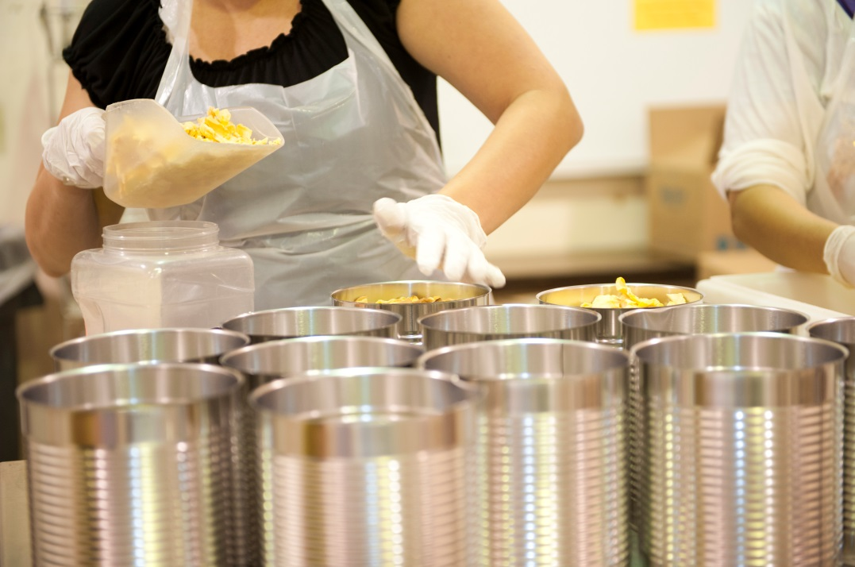
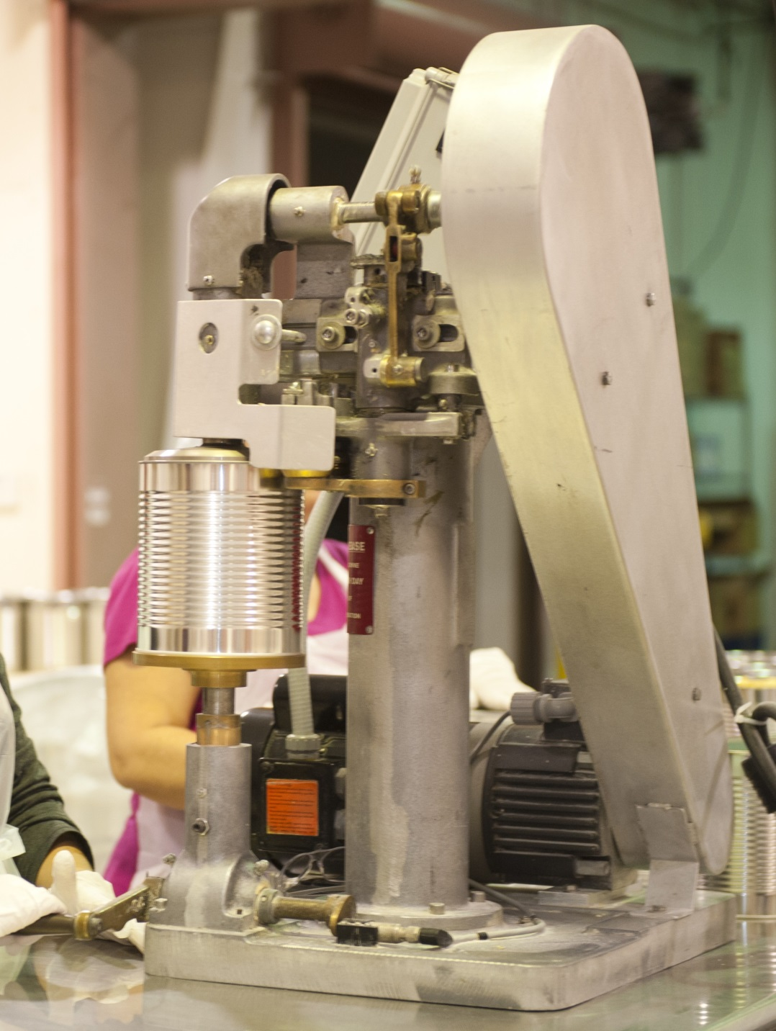
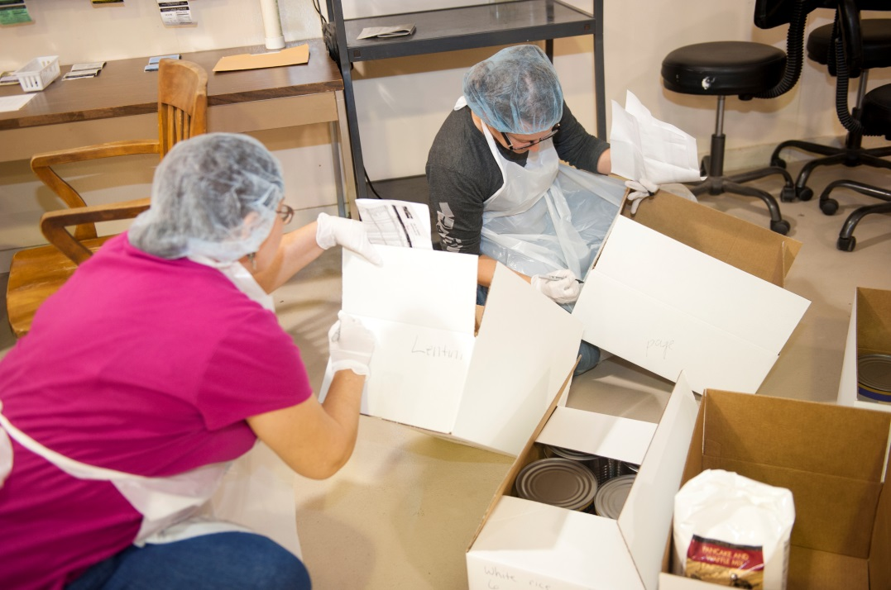
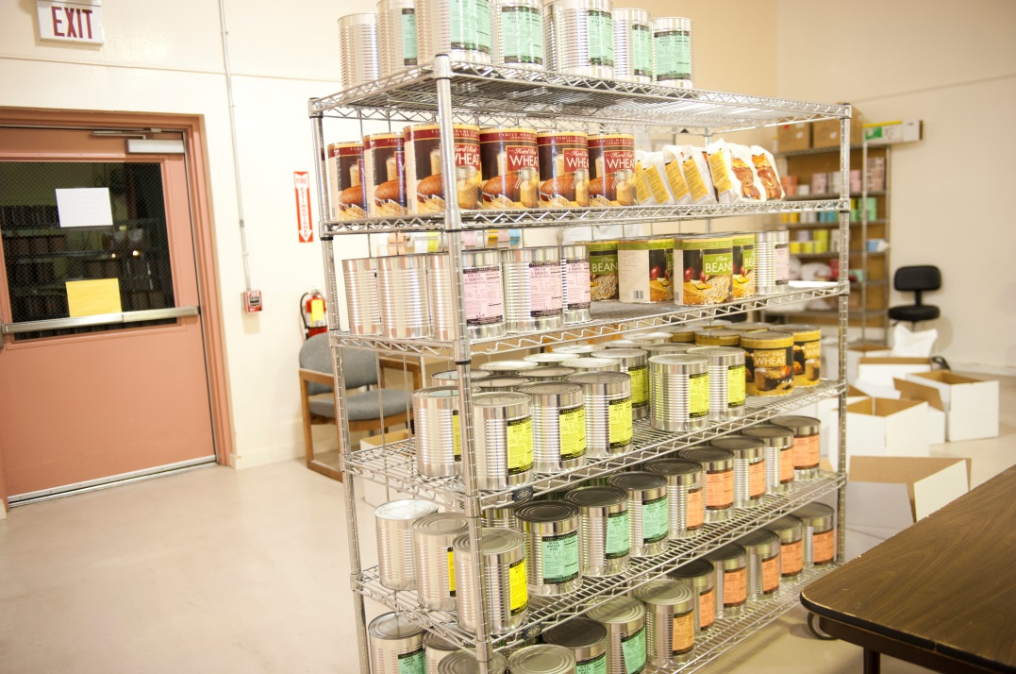

Other LDS Food Storage Resources:
- All is Safely Gathered In - Family Home Storage pamplet to help you get started with Food Storage.
- Basic Recipes – Here are some basic recipes you can make with food from the cannery.
- Longer-Term Food Supply – Recommendations on how to package and store food long-term.
- Drinking Water Guidelines - Water Storage & Purification guidelines discussed.
- Frequently Asked Questions

