Kimchi

Kimchee has been on the to-do list for ages, actually since coming back from the big apple with my two tubs, which didn’t last long- but hey ho. Kimchi originates from Korea and is a fermented mix of vegetables and seasonings. It has been around for 3000 years and is a national institution in it’s home country- so much so that in 2010 there was a national crisis in Korea, a spike in the price of ingredients and kimchi itself left the Korean government having to subsidise imports of cabbage.
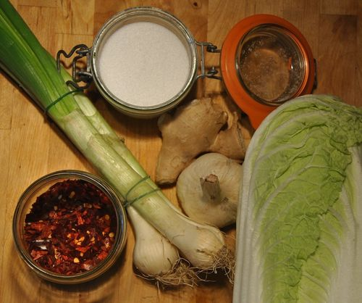
Ingredients:
- 1 large Chinese Cabbage (also known as ‘Napa cabbage’, stateside)
- 100g salt
- 4 cloves garlic
- 4 spring onions
- 1 inch piece of Ginger
- 2 chillies or 30g of dried chilli flakes
First off, chop up the cabbage and place it in a bowl and toss well with the salt- the idea here is to get the salt to suck out some of the moisture from the cabbage and help create a brine. Leave for 1 hour.
Meanwhile finely chop all the other ingredients. Chillies are particularly difficult to find in France, partly because the general consensus in my experience is that the French are fannies when it comes to heat so they don’t stock them in the mupersarket- there is a reason the French word for man is ‘homme’. Fortunately the merry little town of Espelette (see here) is just down the road and Basque folks love a bit of fire! A bunch of dried chilli flakes and a sprinkle of cayenne pepper will give you more than enough heat if you are at a loss.
Back to the cabbage- it should now have decreased in volume by almost half, drain off the liquid, rinse the cabbage in cold water to remove any excess salt and pat dry with a tea towel.
Now mix all your ingredients together in the bowl, cover with a towel and leave in a cool place for 4 days, stirring once a day and tasting. You can pot it up earlier if you are happy with your level of fermentation.
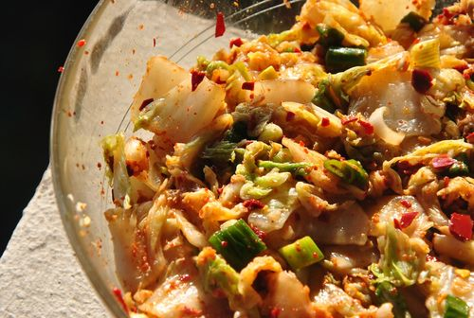
Pot up in a jar tightly and add a little water so that the kimchi is covered by brine. It will keep in the fridge for up to 2 months, provided you haven’t demolished it by then.
Basically what is going on in the bowl is that the various microorganisms present in the raw ingredients, most notably lactic acid, is able to grow and perpetuate because of a more than 3% brine that you have created for your kimchi to live in.

