Is Stockpiling Food A Good Idea?

When I was a little boy, and we ran out of peanut butter, my mother would send me downstairs to get another jar off the shelf.

Usually, there would be two more jars behind that one.

My mother, just like her mother before her, always had months of food on hand at any given moment.

I grew up assuming this was normal, yet as a young adult, I didn't shop this way.

After buying “BIG", I might have two weeks of food on hand, but never three jars of peanut butter, eight cans of pork and beans or ten loaves of frozen bread.

I once asked my grandmother why she always had so much food in the house, and her answer was, “just in case.”

Now in my mid-30s, with a child of my own, I fully understand her answer.

My grandparents grew up during the Great Depression and World War II. They and their peers saw our fragile economy collapse in 1929, the market crashing, banks folding, and an entire way of life threatened.

During World War II, they experienced rationing of sugar, gasoline, and consumer goods. Of course, the war effort required sacrifice, and they lived in constant fear of an Axis victory.

When the war and rationing ended, they continued stockpiling food and never stopped.

Not all that long ago my family relied wholly on the ability to go to our local grocery store and pick up whatever we need on a moment's notice.

I'd drive around with my tank on empty, knowing I can stop and get gas anytime I need it. While the gauge on my grandfather's old Buick never fell below half a tank.

I use to rely solely on my utility company to bring gas and electricity directly into my house, without which my family would freeze to death in the cold Upper Midwest winters.

These are all typical modern day expectations; citizens are completely relying on others for basic survival, the assumption being the dollar will always be able to buy these goods and services.

We assume money is as close at hand as the nearest ATM, and the value of the dollars we withdraw will be stable, both dangerous assumptions.

On September 11th, while New Yorkers were pulling together for the common good and fire and police agencies all over the country were sending people and equipment to Ground Zero.

What was the rest of the country doing?

Many were sitting in their cars, in long lines, waiting to fill their tanks with $4.00 gasoline. Price gouging occurred all over the country as some store owners saw a chance to capitalize on people's fears.

Luckily 9/11 was a one-day affair, and no follow-on attacks occurred. The price gouging didn't spread beyond gasoline.

If we had endured another day or two of attacks, would it have spread to food or other consumer goods? If there had been a sudden run on banks, would the ATMs have been shut off?

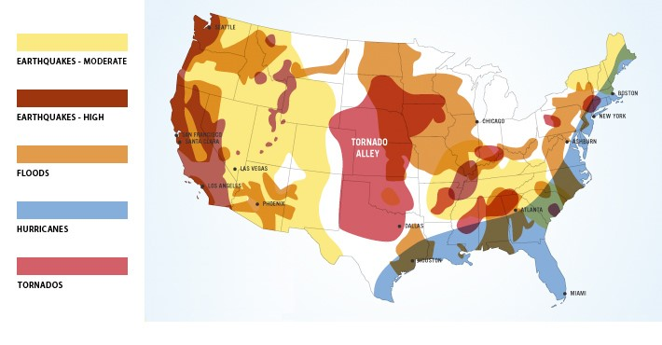

Now Take A Minute To Imagine The Aftermath Of A Real Serious Catastrophe, Natural Or Otherwise…

Imagine a man whose family lives paycheck to paycheck finds himself standing in line at the local grocery with a ten-dollar bill while watching the food disappear from the shelves and prices rise before his very eyes.

He has maybe two days of food in the house, and he has to do something.
So he throws the ten dollars on the counter, overfills up his cart with whatever he can find and runs from the store.

A chain reaction sets off, mass looting begins, followed by men carrying the only currency still honored, firearms.

The store empties within hours and will not be restocked because what store owner wouldn't board up the windows after his inventory is looted?

Couldn't happen? Just look at the looting that occurred after the Rodney King trial in Los Angeles, during the power outage that swept the Northeast a few years ago, or that occurred during Hurricane Katrina.

Civilization Disappears Along With Power, Water, and Food

For a brief time, it must have felt to those in New Orleans that they had seceded from the Union. Words on paper -- even disaster response plans -- cannot feed the masses, illuminate the dark or purify water.

The City of New Orleans learned that the real value of their emergency plan was less than the paper it was printed on.

Relying on a faceless Federal Government headquartered a thousand miles away, to swoop in and save us in times of disaster is a fool's strategy.

Even the most stable, civilized nation on earth is only three days from anarchy, or at least martial law, at any given moment.

Our constitution, our laws, and our public institutions are the framework that binds this nation together. However, when the power goes off, the water is polluted, and food becomes scarce, we are divided and divided we fall.

Ironically, The More Technologically Advanced A Nation Is, The More Vulnerable

We rely heavily on computers, electricity, petroleum and vehicles for all aspects of our daily lives, and when those technologies fail or are unavailable, our system breaks down.

In this country, we expect others to pick up the pieces for us when disaster strikes.
It's not that we're lazy. It's just the way we've been conditioned to have the expectation "Big Brother will rescue us".

For the majority of us, disasters and our survival are in the hands of others: the City, the State, the National Guard, FEMA, the utility companies, etc.

So What Did Our Great - Great Grandparents Do?

When our ancestors moved west to tame a new frontier they took no government promises.

They did take horses, covered wagons, casks of water and food, rifles and ammunition for hunting and protection, axes for chopping wood, etc.

They provided for themselves, and their communities come hell or high water.

We must recover some of that pioneer spirit -- that need to accept responsibility for ourselves and others, rather than expecting someone else to tow the line.

During times of crisis, the human condition can lead to behaviors as destructive as any terrorist's bomb.

We laugh when Homeland Security gives us tips such as keeping jugs of water on hand or fresh batteries in our flashlights, but when disaster strikes it is no laughing matter.

The unprepared citizen will find himself in that grocery store, among the looters, risking his life for scraps to keep his family alive.

We will have more power outages, earthquakes, tornadoes and hurricanes and, yes, terrorist attacks.

Now is the time to prepare, to plan, to ensure our families' survival, and, yes, maybe those extra jars of peanut butter would be a good place to start.

What Are The Best Foods To Stockpile?

After some quiet reflection, you, like many of your fellow citizens, have decided that maintaining a healthy food stockpile is not crazy paranoia and is in your family’s best interest.

Good for you.

• Now just what kind of food stockpile do you need?

• What kind of foods?

• What other kinds of supplies?

• Just how big do you want it?

If you are relatively new to prepping for survival you may be excited by this new endeavor we call food stockpiling, but after the initial excitement is over, do you really want a stockpile that requires constant attention, rotation of foods stuffs and occupies half your basement?

It’s Time For Some Decision Making

How long do you need your food stockpile to last?

A week? A month? Three months? Six months? How about a year?

A year’s supply of stockpiled food may be overkill for most survival situations short of an apocalyptic event (i.e. TEOTWAWKI).

However... if you're anything like me, and I know you are since you're reading this, you know you'll sleep better at night knowing you have at least a year's worth of food stockpiled on premises.

Trust me, the sound sleep you get knowing you and your family's food requirements are taken care of are well worth the time, money and space.

You should never underestimate the value of a good night’s sleep.

The average family already has at least one week of food stocked, and few have at least two weeks of stockpiled food on hand at any given moment.

This is just the nature of living in 21st Century America and having a pantry, refrigerator and freezer.

Most natural disasters will not require survival stockpiling food beyond a few weeks, a month at the outside.

If you are talking political upheaval, revolution or some other Third World intrusion into our ordered American lifestyles, you may want to stockpile food for up to three months.

By that time society should be regaining some semblance of order.

However, if you think society will collapse into anarchy, you may want to stockpile for a year or longer.

One thing to keep in mind is that anarchy is an unnatural vacuum---no central authority---and human politics hate a vacuum.

Somebody or some group will fill the void---perhaps not as altruistic as our current politicians (if you can imagine that).

Still, humans are pack animals and will band together.

Society in one form or another will return.

This means if you do have a massive stockpile of food, these friendly folks may just relieve you of it, anyway.

Let’s assume you decide on stockpiling food in the mid-range of options, a six month supply of food on hand at any given time for your family.

• So what foods should you stockpile?

• What stockpiled foods are stable in storage?

• What are human nutritional requirements?

For the serious prepper who wants a significant food stockpile that will last for many years with very little hassle, you should purchase freeze dried, prepackaged meals from a reputable emergency food supplier.

These prepackaged meals are designed to meet your family’s basic nutritional needs.
The best thing about this option is how fast and simple it is.

Just figure out the amount you need, order it online, find a good place to store it in your home and then sleep better at night.

You can order a year's worth today or buy a smaller amount over time, it's up to you.

Maybe you can swing a couple hundred dollars’ worth every 6 months, in a year or two you'll have a substantial food stockpile to protect your family.

Check out this monthly budget plan option.

The human body needs fuel, calories, namely: fat, protein and carbohydrates.

In the long run the body also needs certain vitamins and minerals to function properly.

Some of the vitamin and mineral requirements will be met by your food stockpile, but adding a couple large bottles of a good daily multi-vitamin is a good insurance policy against scurvy and other vitamin deficiencies.

Your real concern is choosing storage-stable foods that are dense in calories: fat, protein and carbs.

Rice and dried beans are great sources of carbs and protein and in their nearly zero moisture condition, can last almost indefinitely if stored in a dry location.

Foods spoil in the presence of bacteria, fungi and mold---all of which require water.

Many foods are naturally preserved not by chemical preservatives, but by their packaged moisture levels.

Remember that microorganisms simply cannot grow without water. Stored in a dry, enclosed container, inside their sealed plastic bags---dried beans and rice will last for many years.

Furthermore, they are easy to prepare. Boil them in water until soft, add a little salt or other dry seasoning. They even taste pretty good, especially when hungry.

Another great source of fat, protein and carbs is peanut butter. Stored in sealed jars, peanut butter has a very low moisture and very high oil and fat content, which prevents spoilage.

It is also very calorie dense.

So what about dried or smoked meats for protein?

Jerky, beef, chicken or turkey, will last a very long time---again due to good packaging, low moisture and high salt content. However, jerky is not high in calories or fat and is very expensive unless you make your own.

This brings us to a whole other topic: preservation.

There are several good methods for preserving meats and fish: drying, smoking and salt-curing---however, we’ll save those topics for another day.

How about canned fruits?

Modern cans do have a plastic coating inside, but the high acidity of many fruits can still cause the cans to corrode from the inside over time. I’ve seen this phenomenon with apple sauce.

In a real food emergency the fruits can still be eaten, but may taste metallic or rusty. However, if you are starving you won’t even notice.

So what about other supplies?

If I’m preparing and stockpiling food for my family, food won’t be my only concern.

Here are some others: aspirin, anti-biotic ointments, bandages, prescription drugs, OTC cold/flu medicines, knives, tools, matches and bullets to name a few.

Some of these may already be included in your emergency survival kits---also a good idea, by the way.

Finally, There Are Three Cardinal Rules For Stockpiling Anything

Rule #1: We don’t talk about our stockpiles with anyone.

Rule #2 and #3: See rule number #1.

If you choose to ignore these rules and share your stockpile with others outside your family---well, it’s great that you are doing the good Samaritan thing, however, realize you are sacrificing your family’s security when you do and be prepared to lose it all if things go bad.

If your heart tells you helping others is just as important as helping your loved ones---then follow your heart, let your love light shine and be prepared to accept the consequences.

Your Simple Stockpiling Food Action Plan

Action 1 - Decide on how many months of food you want to begin stockpiling in the case of an emergency.

This is a personal choice and I cannot make this decision for you. However, if you are a regular ready of this site, you know that I truly believe that our modern civilized society is a fragile proposition at best.

I'm not sure in which form the ultimate catalyst will be but pick your poison: EMP (natural or coordinated), global financial meltdown, droughts, government tyranny, you name it.

The bottom line is there are many possible black swan type events and if you add up the odds of one of them occurring in your lifetime...well, you become very motivated to get prepared ASAP.

Action 2 - Figure out how many calories your family needs per day to survive.

This one is relatively straightforward with the right tools.

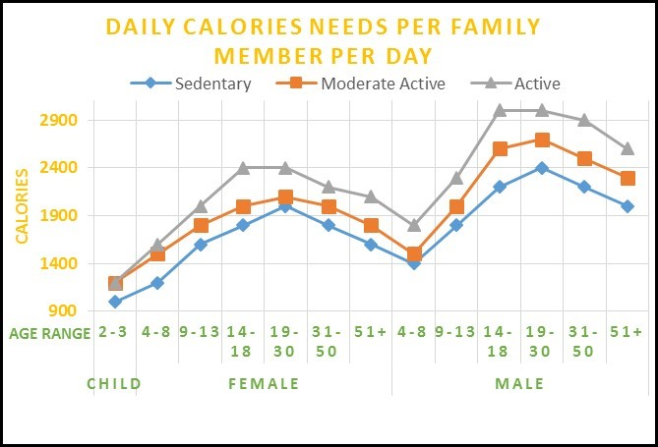

Action 3 - Purchase the amount of emergency food as you calculated from a reputable dealer.

I recommend you buy from the same place that I buy from: Valley Food Storage.

Their prices are the best when factoring everything in such as shipping, quality sealing/containers, ingredients, plus, their products are tasty, the food bucket containers are high quality and very stackable (making storage much easier and less intrusive).

Plus, they are the Food Storage Company I personally use to build up my food stockpile.

Finally, here's Valley Food Storage’s comparison chart for your review and their long list of reviews.

Honestly, this just may be the best investment you'll ever make for your family.

Plus, you'll finally be able to sleep better a night knowing you have 1 of the 5 essential resources needed for your family’s survival.

Action 4 - Store this food in a cool, dry location, secure location and don't tell anyone about it.

That's it...4 easy steps that you can complete today.

One Of The Best Investments You'll Ever Make

In my opinion, this is THE BEST investment you can make. Why? Because the alternative (a.k.a. the downside) is too scary.

Unlike your typical dollar investment (where worst case downside is losing all your money), the downside we are talking about in regards to a stockpiling food investment is your family starving.

You might be thinking "but Jack, what if my food stockpile investment never pays off?" Great, life continues as normal...enjoy.

But I ask you…what if it does pay off?

