How to dehydrate eggs
by admin
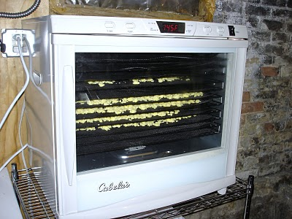
With all the canning tutorials on this blog I’m sure that most of my readers think all I do is can. NOT true! I also dehydrate some foods for long term storage and today we’ll discuss dehydrating eggs to make a shelf stable powdered egg.
But first, I want to let you know about a book that I consider my go-to reference for all things dehydrated. The title is Mary Bell’s Complete Dehydrator Cookbook.
We bought it at the same time we bought our commercial dehydrator and it’s gotten a lot of use! We dehydrate fruits like strawberries, apples, and pears and we’ve also dehydrated potato slices, green peppers, chili peppers, and made fruit leather using the dehydrator. On my to-do list yet for the dehydrator is celery and carrots.
I don’t usually do dehydrating tutorials, though, because it’s so very simple. Usually you just slice the food thin and pop it in the dehydrator. Hardly tutorial-worthy, eh?
But eggs are just a teeny bit more complex. With eggs you have some safety concerns that you wouldn’t have with fruits and veggies.
For instance, it’s not recommended that you dehydrate raw eggs. The first step ought to be cooking them until they’re dry.
I also consider the source of eggs. My first choice would be local eggs produced by free range hens. In my neck of the woods in February it’s not so easy to come by fresh free range eggs in larger quantities and I hate to run the dehydrator for just a tray or two.
This time I used organic eggs purchased at Costco. Not my first choice, but an okay runner-up.
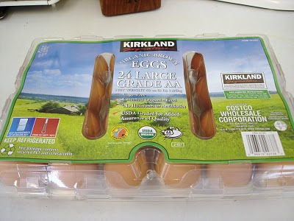
For this project I used a food processor, a non-stick pan, my gas range, and the commercial dehydrator. Feel free to substitute other equipment if you need to.
I found that working with about eight eggs at a time was the most manageable load for my equipment. I also realized in retrospect that a blender could have been a better choice for whipping up the eggs and resulted in a bit less mess!
So…I cracked open about 8 eggs and dropped them into my food processor and let it whirl a bit to whip them up.
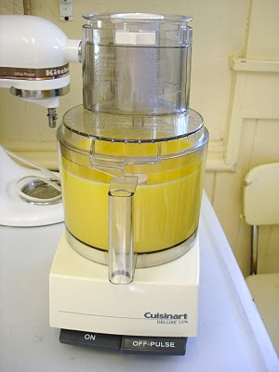
Then I transferred the whipped eggs into a non-stick pan. I found that cooking them low and slow resulted in the best scrambled egg and the least waste. On my gas range that meant a setting of 2.
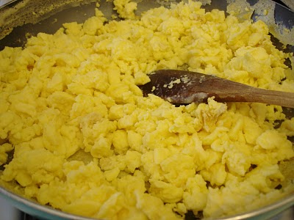
After scrambling the first batch I transferred the eggs into a bowl and cleaned the pan. It is important to clean the pan between each batch of eggs because you’re not using any additional grease and the pan does get gunked up fairly quickly.
After all the eggs were scrambled I then began to spread them out on the dehydrator trays. I used the fine mesh fruit screens to minimize having small pieces drop through the trays.
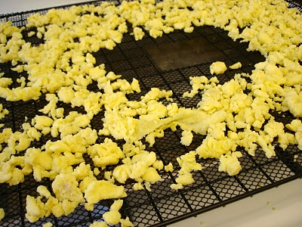
Then I placed the trays into the commercial dehydrator. Four dozen eggs yielded 4.5 trays of loosely spaced scrambled eggs.
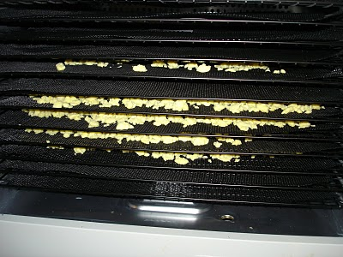
I set the dehydrator at 145 degrees F and set it for 18 hours.
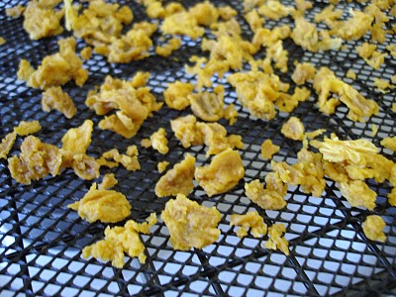
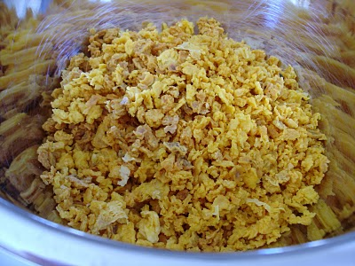
After the eggs were completely dried then I removed the trays and put the dried eggs into the food processor. I let them spin a while to pulverize them into a fine powder.
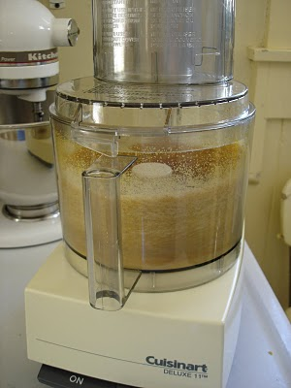
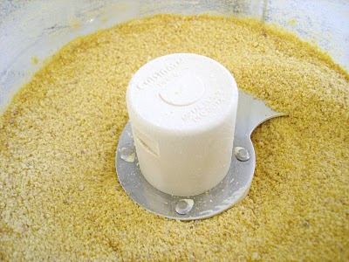
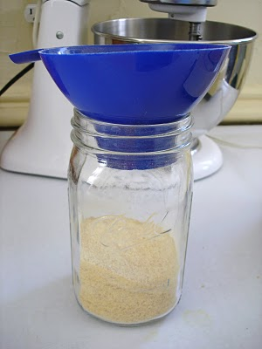
Then I transferred the powdered eggs into a mason jar and used our FoodSaver to seal to remove excess air and seal the jar for storage in our pantry.
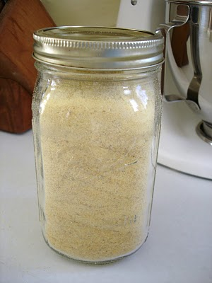
To use the eggs I’ll measure out 1 Tbsp of dried egg and add in 2 Tbsp of water to make the equivalent of one large egg.

