How to Wax Cheese
Before I tell you how to wax cheese, let me tell you why. Waxing cuts down on mold and putrefying bacteria’s access to cheese while it ages, and it also prevents cheese from drying out too much. Both good things.
But to be honest, I put off trying waxing as long as I could simply because I didn’t want to use wax. And until we had a cow, we could keep up with the cheeses I made from our goat’s milk — so no need to wax or put up cheese for off-season.
Fast forward to now. Getting 4 to 5 gallons of milk a day means I make a lot of cheese. One-third of my fridge is filled with aging wheels and quarter-wheels of mostly cheddar (our favorite). To prevent molding and/or drying out, I could move them to the freezer, but that presents three problems:
1) The freezer is pretty full already;
2) The cheeses won’t age or develop flavor in a frozen state; and
3) I’d like to learn methods that don’t rely on refrigeration or freezing at all.
So… learn to wax, I must. And I did! My good friend Jerri from Homesteader Supply coached me for my first waxing. Over the telephone, she gave me her best tips (the dipping method, below). I even turned on the video camera and captured that first time waxing on film.

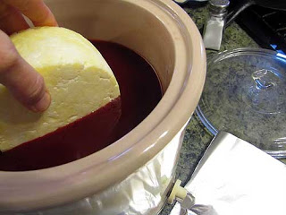Cheese treated with cheese wax will store for up to 25 years at a mild to cool temperature. It will continue to age. But it won’t get moldy! (And even if it does in parts, you can simply cut off that part, and re-wax over it.) Be sure that you select block sizes of cheese that you and your family can easily consume within a 3 to 5 day period in order to avoid it going bad once you’ve cut into it. Now I really doubt that cheese will be around in my pantry for that long, I'm not sure I'll be around that much longer! So if I get a solid 5 to 10 years I'll be feeling pretty good!
My choice is a crock pot dedicated to cheese wax. It has great depth and just seems safer for handling hot wax.

Method: Waxing Cheese
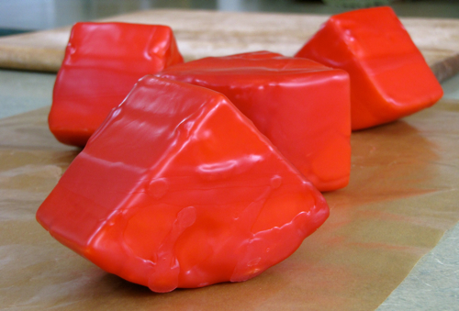
You can dip the cheese in wax, or you can brush the wax on your cheese. You need more melted wax for the dipping method — to ensure it is deep enough for the cheese to be submerged sufficiently. I tried brushing as well. I found that the dipping method yielded prettier cheese, yet I was limited in what sizes of cheese I could use by the size of the melted wax container and whether the wax was deep enough. So there are pros and cons with both — choose what works best for YOU.

What You Need
- cheese with a dry rind* — either a complete wheel or cut into quarters
- cheese wax** — buy from Cultures for Health or Homesteader Supply
- cheese brush — a natural bristle brush (optional)
- a double-boiler set up — use something for the wax that you don’t mind getting waxy, like an old pot or coffee can
- wax paper
- tongs (optional)
- masking tape and Sharpie for labeling
*Ideally, allow cheese to form a dry, yellowish rind by being left uncovered and on a rack in cool storage for a few weeks. I do this overnight in my kitchen, on cooler nights.
**According to Cultures for Health, 1 pound of wax will do 12 to 20 cheeses if brushing on, but you’ll need to start with a few pounds of wax for dipping to ensure sufficient depth. Store wax in cool place, away from any high heat. Keeps indefinitely.

The Dipping Method
Melt wax in a double boiler so that it is not directly over the heat source. Do not leave unattended; wax explodes at high temperatures. Choose a container for the wax that will fit your desired sizes of cheese. An old coffee can is an ideal size if cutting the cheese wheel into quarters.
Grasping one corner of the cheese with your hands (careful!) or the tongs, dip the rest of the cheese into the wax. One thin coat is better than a thick coat. Hold in the air for 10 seconds or so for the wax to harden. Set down on wax paper. Repeat for other pieces of cheese. Be sure to fill up any air spaces to prevent mold growth.
Grasp the original piece of cheese and dip the unwaxed end. One thin coat is better than a thick coat. Hold in the air for 10 seconds or so for the wax to harden. Set down on wax paper. Repeat for other pieces of cheese.
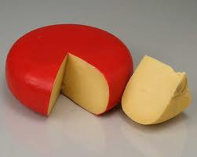Repeat both steps to add a second coat of wax to all pieces of cheese. Label cheese with type and date. Use masking tape or a piece of paper. The piece of paper can brushed into place with a thin coating of wax with a wax brush.
Store cheese in a cool location (such as refrigerator or cold cellar) for the duration of the aging and storage. To eat cheese, peel off wax. Save it and strain it through cheesecloth to reuse over and over again.

The Brushing Method
Melt wax in a double boiler so that it is not directly over the heat source. Do not leave unattended; wax explodes at high temperatures.
Brush two coats of wax onto the cheese, filling any holes to prevent air gaps. Robin P. (eCourse member) shared her method with me: brush wax all the way around the rounded side of the wheel, then brush the flat top, then brush the flat bottom. Allow for drying times in between. Then repeat over all. Finally, brush on a paper label (containing type of cheese and date) with a thin application of wax.
Store cheese in a cool location (such as refrigerator or cold cellar) for the duration of the aging and storage. To eat cheese, peel off wax. Save it and strain it through cheesecloth to reuse over and over again.
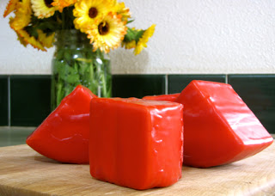 Click on Picture for a video

