How to Make an Edible Apple Swan!
by admin2

Check out this video that shows us how to make an edible swan from an apple. With the tutorial on how to carve the apple you can make these beautiful swans too. The King Of Random has the video and shows at the end how he made swans from different colored apples for a really pretty presentation.
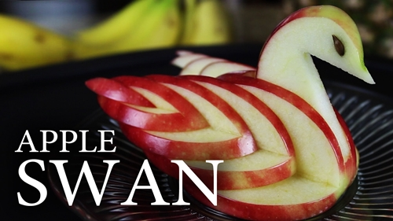
http://www.youtube.com/watch?feature=player_embedded&v=uLXEiMIiF5E

