How to Make Sugar From Beets
Beets yield an alternative sugar, one with an earthy aroma and slight vegetative taste; it’s not a bad sugar, just quite different from the refined, white, granulated sugarcane product with which you’re familiar. The beet sugar you make at home differs slightly from the beet sugar you buy in stores, too. Commercial beet sugar undergoes centrifugal and chemical processing to separate the solids from the syrup, using ingredients that include charcoal, mineral lime, and hardened calcium or bones. Homemade beet sugar, on the other hand, requires only water and heat, and although you won’t get pearl-white granules, you will get a natural product.
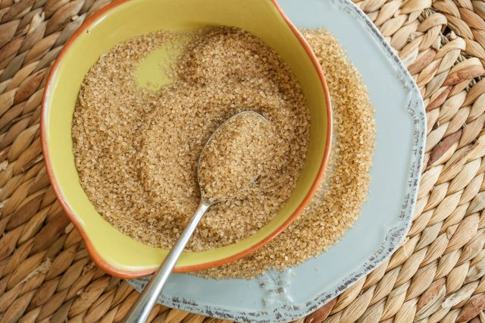
Wash the beets under cool running water and trim 1/4 inch from the tips and tops. Peel the beets. Ten pounds of sugar beets yields about 1 cup of sugar.
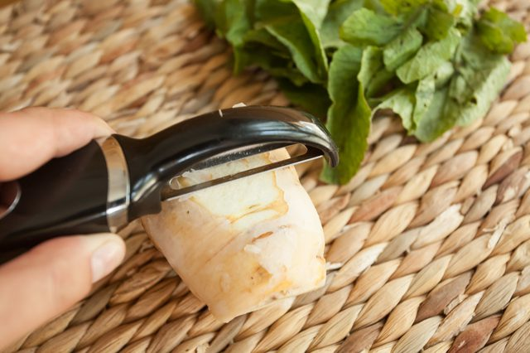
Slice the beets into 1/4-inch-thick slices and rinse them under cool running water. Arrange the slices in an even layer on a plate lined with a couple of moist paper towels; then cover them with a couple more layers of moist paper towels.
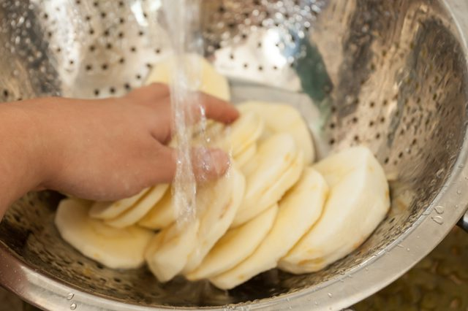
Microwave the beets on high until steaming, about 3 to 4 minutes. Shred the beets in a food processor and transfer them to a wide pot.
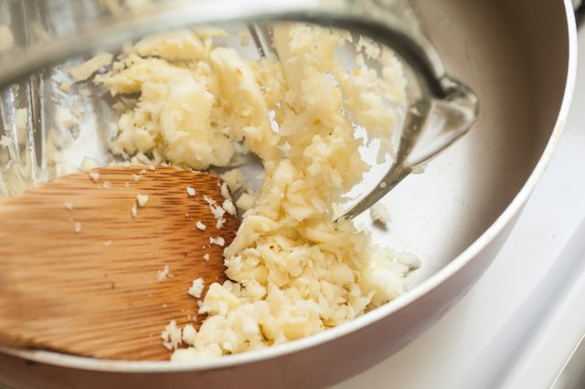
Add 3 times as much water as beets to the pot and simmer them for about 45 minutes. Heat the oven to 250 degrees Fahrenheit and strain the liquid. Transfer the liquid to a shallow baking dish.
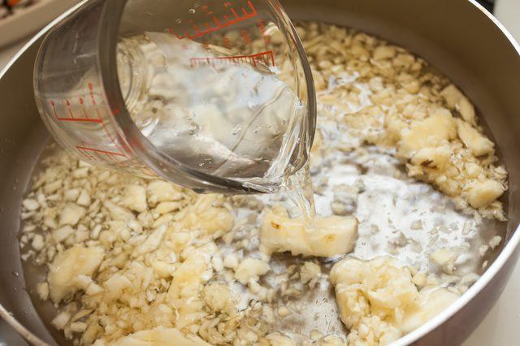
Evaporate the liquid in the oven until moist, raw sugar develops, about 8 to 12 hours. Transfer the raw sugar to a cookie sheet in an even layer to cool.
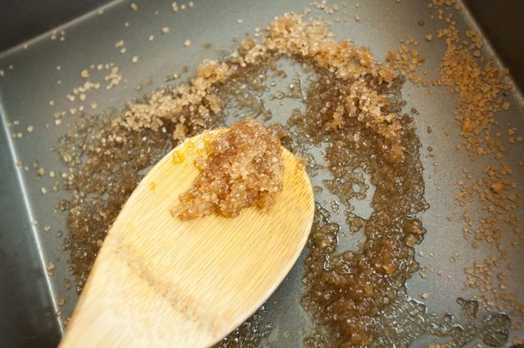
Transfer the sugar to an airtight storage container and gently pack it in. You can store homemade beet sugar in an airtight container in the refrigerator for up to 2 years in low humidity. Check the sugar before using it for any odors, discoloration, or other signs of spoilage before using.
