How to Make Off-the-Grid Survival Mayo
by Nancy Smith
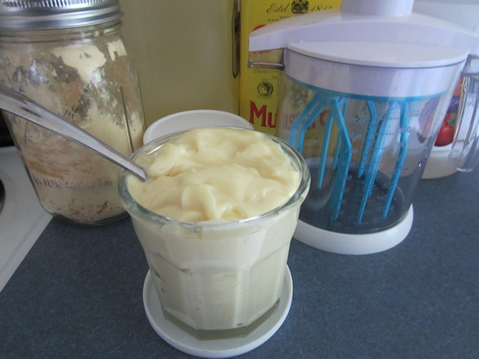
Could you face a zombie apocalypse without mayonnaise?
This is a question only you can answer. While many of you know the pleasures of homemade mayonnaise, I’m presenting to you today the how-to on shelf-stable mayo made without any electricity. It’s what I call homemade survival food – simple to make as long as you have a few basic ingredients and the right tools.
Being able to make a simple thing like mayonnaise with shelf-stable ingredients will allow you to create all sorts of lovely dishes that you wouldn’t otherwise be able to make. Pair your homemade-survival-food-mayo with a good tuna or a luxurious crab and baby, you’ve got a real meal.
Making mayonnaise is really more of a method than a recipe. Basically, making mayonnaise involves whipping up eggs enough so that they accept oil – in other words, so that the mayo emulsifies. This is easy enough with an electric mixer, but without power it’s more difficult. I must confess, I’ve tried to make this mayonnaise with just a balloon whip, but I was never able to get it to emulsify consistently. Plus, it was a major drag on my arm. As I get older, I’m looking for ways to save my body from additional strain. So instead, I use this nifty little hand mixer I bought on Amazon, but of course you can use any kind of mixer you like.
Now, on to the recipe/method. First, let’s start off with a standard ingredients list (substitutions are towards the bottom of this post):
2 tablespoons powdered egg (here’s the kind I use)
1 tablespoon dry mustard (helps with emulsification)
2 tablespoons water
2 tablespoons vinegar
1 1/2 cups vegetable oil
1 tsp salt
Now, the method:
Add powdered egg, dry mustard, water and vinegar into a deep bowl or hand mixer:
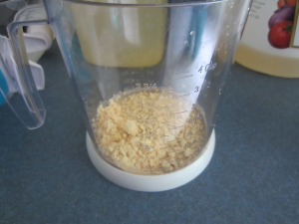
Whip this until it starts to become a little frothy:
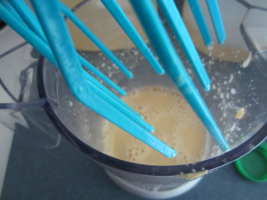
Now, let it rest for 5 minutes – this gives the egg powder time to absorb the liquid. Then, very slowly, drop the oil into the egg mixture. VERY slowly is the key. At first, just a few little drops at a time, then you can increase as you go. My little hand mixer has a handy hole in the top so I can drizzle it in that way easily:
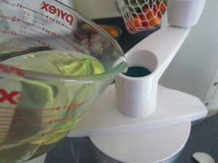
Keep whipping, and you’ll start to feel the resistance of the newly forming mayo. Add a little more oil, and whip, and so on. Stop adding oil when the mayo is at the consistency you’d like it to be. For me, it usually takes 1 1/2 cups of oil. At the very end, add the salt and give it another whip or stir it in.
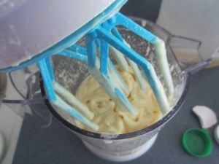
Store, covered, in the refrigerator. I store my mayonnaise in a “working glass” – which we also use for everyday glassware. You can get very nice lids for them, and so they’re great for bringing along an iced tea while you run errands, layering in a strawberry shortcake, etc. Very heavy-duty, and because they’re straight-walled, they’re easy to get into with a knife or spoon.
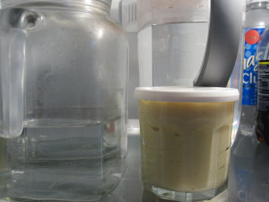
This will keep for about a week in the fridge. In the event of a prolonged power outage, you could make just a little (cut the recipe in half, for instance). Using the hand mixer makes it a very easy process, so it’s not a big deal to whip up a little mayo as needed.
How to use survival mayo? Make shelf-stable crab cakes, as I mentioned in my luxury canned meat post, and you’ll have plenty to barter with. It’s decadent with a little garlic powder and/or smoked salt.

About the hand mixer:
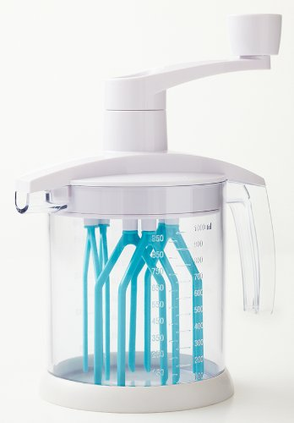
I’ve tried and tried to make this mayonnaise with just a whisk (my husband can attest to my choice words in the kitchen). It took a long time and never whipped up very well. All that I could ever manage was a runny slurry and a tired arm. But I was resolved to not use anything that plugged in.
I found this hand mixer while getting together my monthly order at Amazon and because it had such great reviews (although none pertaining to mayonnaise-making), I decided to give it a whirl, so to speak. Now that I have one, I find that I use it for many fancy-pants foods from crepes to fresh whipped cream and butter (when I’m not using ghee).
The hand mixer has these little whipping “fingers” that turns a liquid into emulsion very quickly, and it has a non-skid bottom so you don’t have to hold it against the counter to keep it stable. It’s quite brilliant.
It truly makes short work of this mayonnaise too – honestly, less than 60 seconds, and I’m done. It was inexpensive and is now an invaluable part of my prepper’s gourmet kitchen. I highly recommend picking one up.
Now, on to substitutions.
- Eggs: you can also use two whole, fresh eggs if you have them. Reduce the water to one tablespoon.
- Mustard: you can substitute regular, prepared mustard of any sort for the dry mustard.
- Vinegar: I use apple cider, but white vinegar is fine too. Rice wine vinegar also works. And lemon juice is superb – it just won’t last in the fridge quite as long. If you use lemon, consider making a home-made tartar sauce for your catch! It’s yummy.
- Vegetable oil: I’ve heard others use olive oil, but I’ve never been able to emulsify it. However, I have successfully used canola, walnut, and rice bran oil (my favorite).

