How to Make Homemade Extracts
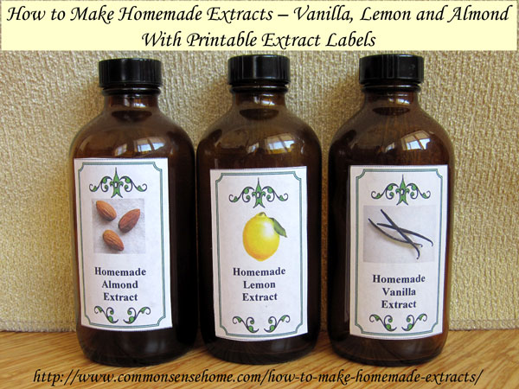
I do a fair amount of baking, especially once the weather gets cooler, so I figured I could save quite a bit of money if I learned how to make homemade extracts. It turns out it couldn’t be much simpler – the biggest skill required is patience – and I can have plenty of extract for pennies on the dollar compared to buying high quality extract. This post covers how to make the three homemade extracts I use the most – vanilla, almond and lemon.
Always make sure all your containers and kitchenware are well cleaned. If you want, you can sterilize by boiling for ten minutes, plus one minute per every 1000 feet above sea level. I haven’t boiled, I’ve just used well-washed everything, and I haven’t had any problems.

How to Make Homemade Vanilla Extract
Use 2 ounces of beans and one pint vodka for every pint of extract that you want to make. (For one cup of extract, use one ounce, and so on.)
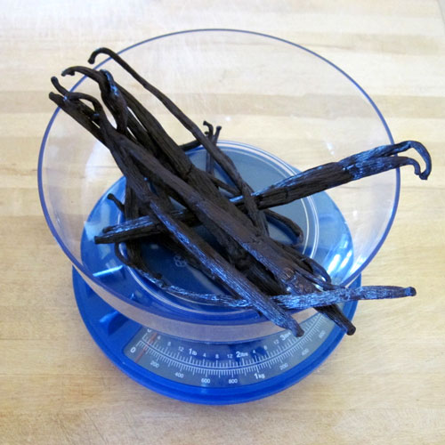
Chop the beans into 1/4 to 1/2 inch long pieces. Many recipes call for slicing and scraping, but if you simply cut the beans into small pieces, you can get the same results with much less mess and effort.
Place the cut vanilla beans in a lidded, glass jar with 80 proof (40% alcohol by weight) vodka. I prefer to use vodka bottled in glass rather than plastic, and watch for whatever’s on sale. Lately I’ve been using Svedka. You can see the bean pieces at the bottom of the jar and the floating vanilla flecks.
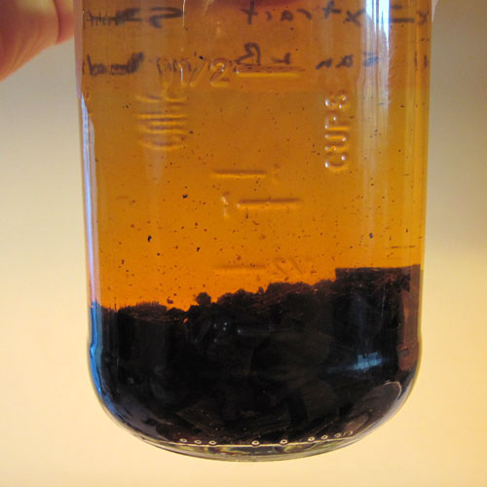
Shake the bottle once a day for at least a month, and you have homemade vanilla extract. I usually aim for two to three months. The color and flavor will deepen with age.
Strain the finished extract through cheesecloth, a coffee filter or a flour sack towel to filter and place in a dark bottle. Our affiliate, Mountain Rose Herbs has a variety of sizes of extract bottles in brown glass, as well as some in blue glass. You can also order from other places online, or reuse empty extract bottles that you already have on hand. Alternatively, you can measure right out of your brewing bottle and continue to let the rest steep, or pour off some and let the rest steep. I like to bottle what I’m using separately to reduce any risk of contamination from dipping into an open jar (even if it is filled with alcohol). You really don’t need to strain if you’re just pouring off the top, and you can add more alcohol a few times (depending on how much you draw off and how strong your beans are).
Store in a cool, dark location.

If you buy the vanilla beans in bulk you can save even more (I have split orders with friends). You can also buy assortments of beans and mix and match types for subtle flavor differences. I think my homemade extract with a mix a beans tastes and smells as good or better than any commercial extract I’ve tried.
For gift giving, you may want to consider using different alcohols (such as brandy or rum) combined with different bean types for a truly unique gift. Or just make up one big batch and split it into small decorative bottles.

How to Make Homemade Lemon Extract
This recipe is based on the post “How to Making Baking Extracts” from the Denver Post.
Combine the zest from 1 lemon, 1 teaspoon sugar and ½ cup 80 proof (40% alcohol by weight) vodka. Don’t use the pith (white part) of the lemon- just stick to the yellow – as the pitch is bitter. I like to use my Microplane zester to get a beautiful, fine lemon zest.
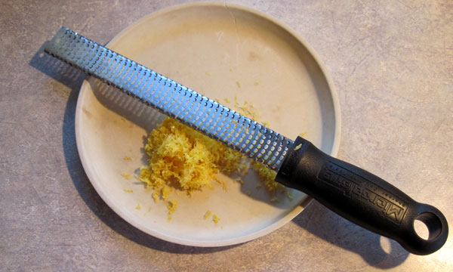
Lemon zest with the Microplane Zester
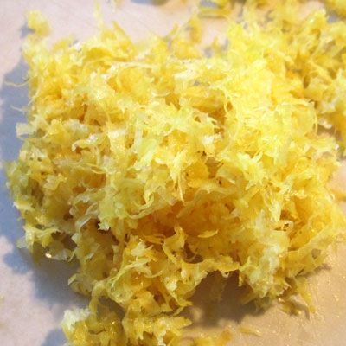
Place zest, sugar and vodka in a lidded, glass jar.
Shake the bottle once a day for at least a month, and you have homemade lemon extract. I usually aim for two to three months. The flavor will improve with age.
Strain the finished extract through cheesecloth, a coffee filter or a flour sack towel to filter and place in a dark bottle. Alternatively, just pour off a small portion for use and allow the rest to continue steeping.
Store in a cool, dark location.

How to Make Homemade Almond Extract
Commercial almond extract is made with bitter almonds, which contain a cyanide precursor, which I don’t suggest brewing at home. In fact, some folks argue that you should use natural almond extract at all, only the synthetic. For my part, I’m more likely to trust nature than chemists, and I’ve read that the same pits and seeds that contain the cyanide precursors also contain anti-cancer compounds. I don’t go out of my way to consume extra seeds and pits, but I don’t worry if they occasionally get eaten.
These instructions are based on the E-how post “How to Make Your Own Almond Extract“. By now, you know the drill, but we’ll go through the steps and proportions.
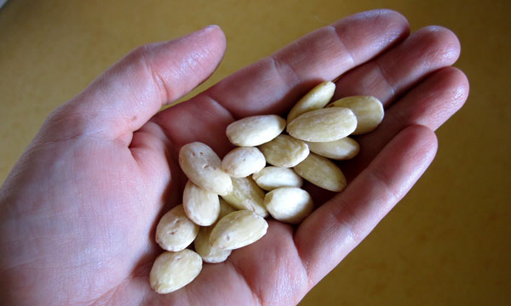
Use 12 whole, raw skinless almonds and one pint 80 proof (40% alcohol by weight) vodka for every pint of extract that you want to make. (For one cup of extract, use 6 almonds, and so on.) My almonds had been in the freezer for while, so I used more. The skins will make the extract more bitter, so it’s best to opt for skinless. Better tasting almonds make better tasting extract.
Chop almonds and place almonds and vodka in a lidded, glass jar. More surface area means more flavor transfer from almonds to alcohol.
Shake the bottle once a day for at least a month, and you have homemade almond extract. I usually aim for two to three months. The flavor will improve with age.
Strain the finished extract through cheesecloth, a coffee filter or a flour sack towel to filter and place in a dark bottle. Alternatively, just pour off a small portion for use and allow the rest to continue steeping.
Store in a cool, dark location. This extract will not taste as strong as commercial almond extracts, so you may want to make a small batch and see if you like it before making it in quantity.
And now you know how to make homemade extracts. The same concept can be used with homegrown mints for homemade mint extract, or to make homemade orange extract and coconut extract. The shelf life is indefinite – alcohol is a preservative – but I’m sure the flavor would fade after a year or so once the solids have been removed from the brew.
If you’d like to use the labels shown in the photos above, just click on the image below to open a printable pdf file. The file is large, so it make take a couple minutes to open, especially if you have a slow connection like I do.
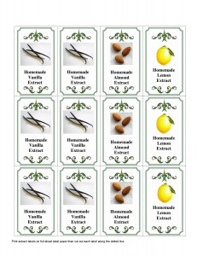
Homemade Extract Labels
The process is similar for Infusing Herbs in Oil, Water, Vinegar, Alcohol or Honey.
You may also enjoy How to Grow Stevia and Make Your Own Extract.
