How to Make Homemade Biscuits from Scratch
By Andrea
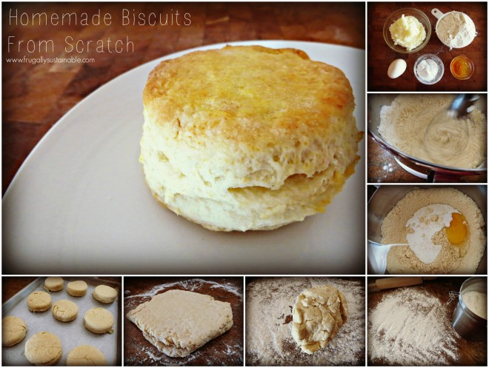
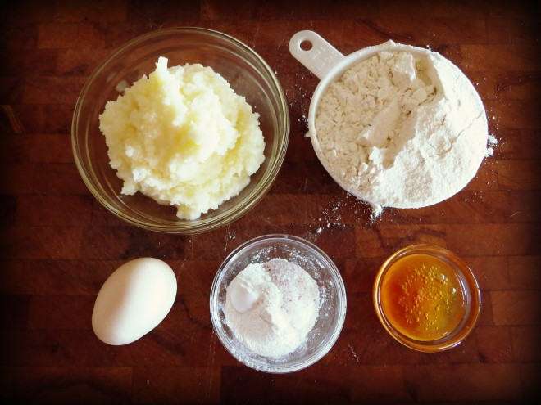
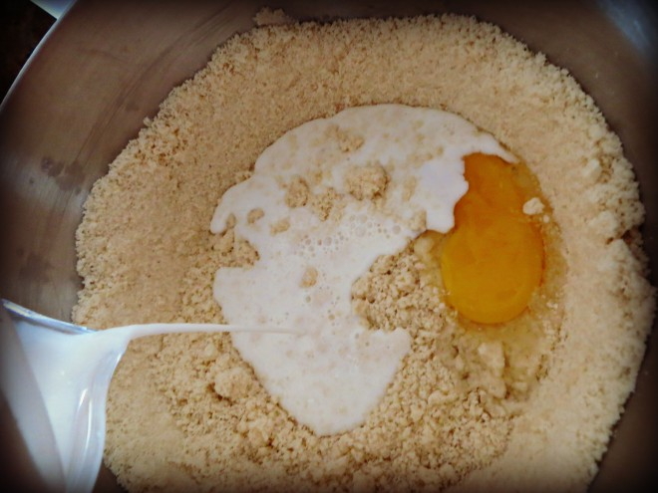
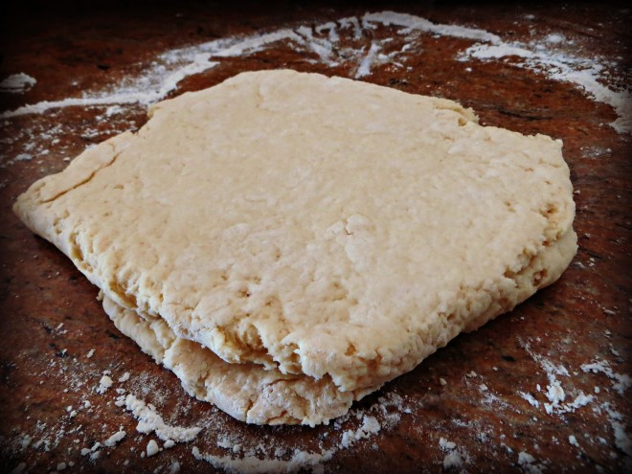
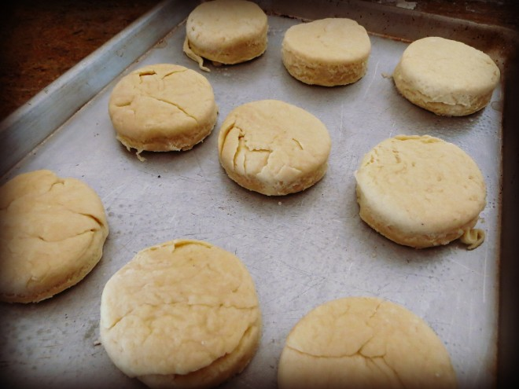
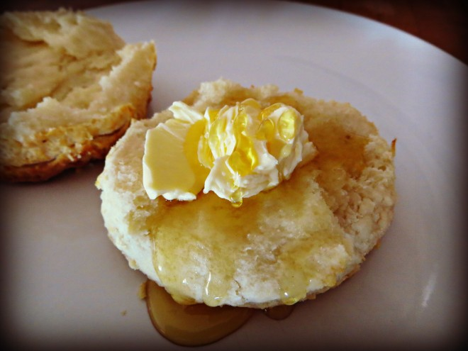
Homemade Biscuits from Scratch
Ingredients
-3 cups organic, unbleached all-purpose flour
-1/2 teaspoon real salt
-4 teaspoons aluminum free baking powder
-1 1/2 tablespoons raw honey
-1/2 cup grass-fed tallow, or butter from grass-fed cows
-1 pastured egg
-1 cup whole milk, or homemade buttermilk (see recipe below)
Supplies Needed
- Pastry Blender, or use your food processor or Kitchen Aid Mixer
- Flour Sifter
- Biscuit Cutter, or the top of a wide-mouth glass mason jar will do just fine
- Rolling Pin
- Cookie Sheet, or 12″ round cast iron skillet
Method
- Preheat the oven to 450 degrees.
- Sift together flour, salt, and baking powder.
- Using a pastry blender, food processor, or Kitchen Aid Mixer cut cold tallow (or cold butter) into the flour.
- Stir in the remaining ingredients just until the dry ingredients are wet and well incorporated.
- Flour a flat surface.
- Dump the dough onto the floured surface.
- Using a rolling pin, roll out the dough until desired thickness is achieved. Note: I roll mine out anywhere from 3/4″-1″ thick.
- With a biscuit cutter or top of jar/cup — cut out your biscuits! Note: You will have to continue to ball up and roll out your dough again a few more times before all the biscuits are cut.
- Place cut biscuit dough on cookie sheet or cast iron skillet.
- Cook in oven for 13-17 minutes. Watch closely and remove when biscuits are golden brown and fluffy.
Note
-To make your own buttermilk, combine 2 cups of whole milk (preferably raw) and 1 tablespoon of lemon juice in a bowl and let stand at room temperature for about 15 minutes. The milk will curdle. Stir well before using and store in the refrigerator. It will keep fresh for a couple of days.

