How to Make Homemade Baby Formula
by Ann Marie Michaels

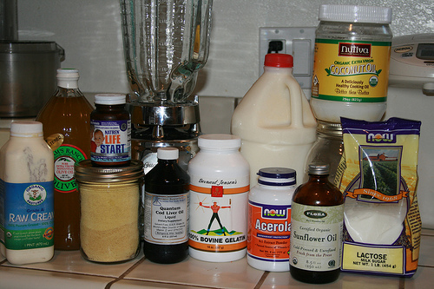
Why would you want to make homemade baby formula? Everyone knows breast milk is the best thing for babies. But some of us have not been blessed with an easy time breastfeeding. I loved breastfeeding and had no problems… until I started having issues with my breast milk supply when my baby Kate was only 4 months old.
I tried everything to increase my breast milk supply (fenugreek, round-the-clock pumping, taking her to bed with me for 3 days, etc.). But to my great despair, I had to start supplementing with formula. I felt like a complete failure as a mother.
When my Great Uncle Roy (in his 80s) read on my blog that I was having breast milk supply issues and had to start formula feeding, he emailed me a link to the Weston A. Price Foundation to warn me about the dangers of soy formula.
The more I read, the more I realized that every formula on the market these days has soy in it (usually soybean oil and/or soy lecithin). The more I read about the dangers of soy, I came to the conclusion that there is no good commercial infant formula available. I became determined to find a healthier alternative for my baby. Enter Sally Fallon and Mary Enig’s recipe for homemade baby formula.
I’m so grateful we found the homemade baby formula recipe. My daughter got a bad case of cradle cap on commercial baby formula. When we switched to homemade baby formula, her cradle cap disappeared and it never came back.
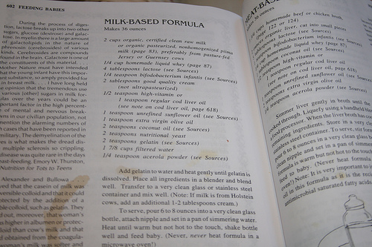

Notes on the Recipe
The recipe that follows is slightly modified (just the method, not the ingredients) from the recipe by Sally Fallon and Mary Enig published in the book, “Nourishing Traditions”. This recipe is also reprinted on the Weston A. Price Foundation website, where you will also find a recipe for the goat milk and meat-based formula, which can be used when raw cow’s milk is not available, or for infants who are allergic to cow’s milk. These recipes are also on the Real Milk website.
Many, many thanks to Sally Fallon and Mary Enig for formulating and publishing these wonderful recipes. I’m personally forever grateful for them.
Lastly, here is what Sally Fallon writes about the homemade cow’s milk formula:
Our milk-based formula takes account of the fact that human milk is richer in whey, lactose, vitamin C, niacin, and long-chain polyunsaturated fatty acids compared to cow’s milk but leaner in casein (milk protein). The addition of gelatin to cow’s milk formula will make it more digestible for the infant. Use only truly expeller-expressed oils in the formula recipes, otherwise they may lack vitamin E.
The ideal milk for baby, if he cannot be breastfed, is clean, whole raw milk from old-fashioned cows, certified free of disease, that feed on green pasture. For sources of good quality milk, see www.realmilk.com or contact a local chapter of the Weston A. Price Foundation.
If the only choice available to you is commercial milk, choose whole milk, preferably organic and unhomogenized, and culture it with a piima or kefir culture to restore enzymes (see my resources page for sources of starter cultures).
Now… on to the recipe!

Homemade Baby Formula
Makes 36 ounces

Equipment Needed:
Blender (you can use a whisk and a bowl but I think it’s much easier in a blender)
Glass bottles (you can also use BPA-free plastic bottles like Medela or Born Free; do NOT use plastic bottles with BPA — it’s toxic!)

Ingredients:
LIQUID
Whole milk, preferably unprocessed (raw) milk from pasture-fed cows (2 cups) — where to buy milk
Filtered water (if you don’t have a filter, use bottled distilled water, reverse osmosis water, or spring water) (1 7/8 cups)
Homemade liquid whey (Click here for the recipe for homemade whey — scroll down to the bottom of the page) Note: Do NOT use whey from making cheese — it will cause the formula to curdle. Use only homemade whey made from yoghurt, kefir or separated raw milk.(1/4 cup) — where to buy milk
Good quality cream (ideally organic and raw, but at least not ultrapasteurized), more if you are using milk from Holstein cows (2 TBS or more)
Coconut oil (2 tsp) — where to buy coconut oil
High-vitamin cod liver oil (store in the fridge) (1/2 tsp) — where to buy cod liver oil
Expeller-expressed sunflower oil (store in the fridge) (1 tsp) — available from Radiant Life — where to buy
Extra virgin olive oil (store in a dark cupboard) (1 tsp) — available from Radiant Life
DRY
Lactose powder (4 TBS) — available from Radiant Life — where to buy
Frontier brand nutritional yeast flakes (2 tsp) — available from Radiant Life — where to buy
Gelatin (2 tsp) — available from Radiant Life — where to buy gelatin
Natren bifidobacterium infantis (store in the fridge) (1/4 tsp) — available from Radiant Life — where to buy
Acerola powder (1/4 tsp) — available from Radiant Life — where to buy
It is very important to use the exact amounts that are called for (I have not changed any of the amounts). This recipe was formulated by a nutritionist (Mary Enig) and is designed to be as close as possible to human breast milk.
If you are looking for a homemade formula made with goat milk, please see the goat milk version on the Weston A. Price Foundation website.
The only thing I changed in the recipe is how I make it. In the original recipe, they say to add the gelatin powder to the filtered water and warm it slightly until the gelatin dissolves. Many people also like to add the coconut oil to the water so it liquifies. I used to do all of that but after making formula day in day out for over a year now, I find it’s easier just to throw everything in the blender and then scoop out the frothy stuff at the top. You can try it both ways and see what works better for you.
It is also very important to use the recommended brands. If a brand is listed, buy that one. The Weston A. Price Foundation has done a lot of research on these brands. When a brand is specified, there is a reason for it.
Please DO NOT use regular olive oil from the grocery store. adulterated with cheap oil. Also, get a good quality cod liver oil (one of the brands listed). Brands like Carlson are not recommended (they have the wrong ratio of vitamins A & D).
Most everything on the list is available from Radiant Life catalog — you can find them on my resources page. I buy my lactose, sunflower oil, gelatin, acerola powder, olive oil, and nutritional yeast from them. They ship fast and their customer service is great. You can usually find coconut oil and Natren bifidobacterium infantis at Whole Foods or other health food store if you have one close to you.

Recommended Brands:
High-vitamin cod liver oil: Green Pastures where to buy
Nutritional yeast: Frontier
Gelatin: Bernard Jensen
Acerola powder: Now
Olive oil: Chaffin Orchards, Bariani, Olea — see my resources page (There are a few more acceptable brands listed in the Weston A. Price shopping guide which is available from their website.)
Where to find real raw milk.
Instructions:
1. Add the 2 cups of milk to the blender.
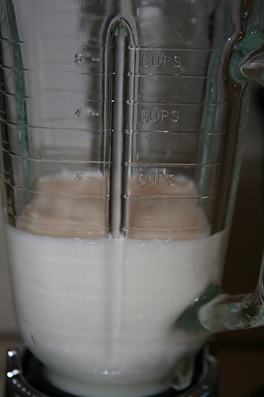
2. Add the 1/4 cup of whey and the 1 7/8 cups of filtered water.
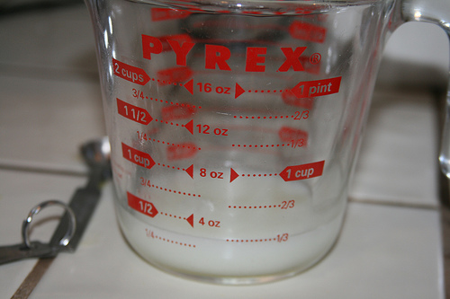
3. Add all the dry ingredients. (I add the dry ingredients first because then I don’t get my measuring spoons wet.)
4. Add the rest of the liquid ingredients.
5. Set out some clean glass bottles. How many you will need depends on how much your baby drinks at each feeding. I use 6 bottles and fill them all about 6 ounces each.
6. Using a teaspoon, scoop the clumpy snow-like top layer of formula and distribute evenly into the glass bottles. if you don’t scoop it off the top, it will not pour and will get stuck at the bottom of the blender.
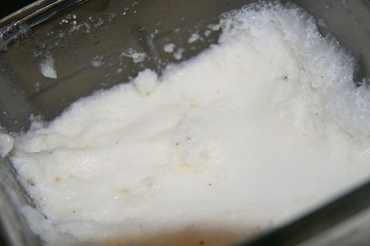
7. Distribute the formula into the bottles. When you get near the bottom, you’ll notice that the gelatin is kind of sticking around down there (this is why they recommend warming it in water). If you just swirl the formula around in the blender, making sure the gelatin mixes in, you can easily distribute it among the bottles.
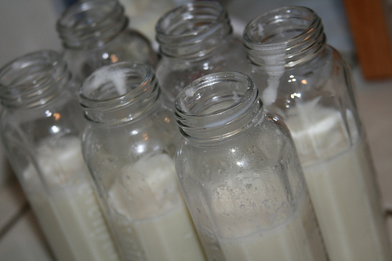
8. Put clean nipples and lids on the bottles and stick them in the fridge.
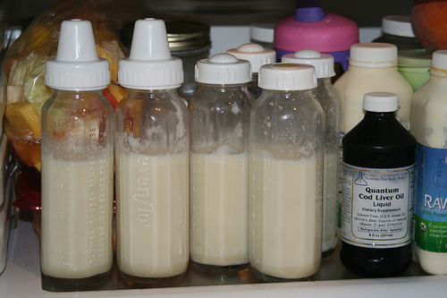
9. To serve, take the bottle out of the fridge and set in a Pyrex measuring cup or coffee cup halfway full of boiling hot water. When warm, shake bottle well and feed baby. Never, never heat formula in a microwave oven!
I bought this Zojirushi hot water dispenser. It was a wonderful investment for warming formula and baby purees. I think you can also use a baby bottle warmer.
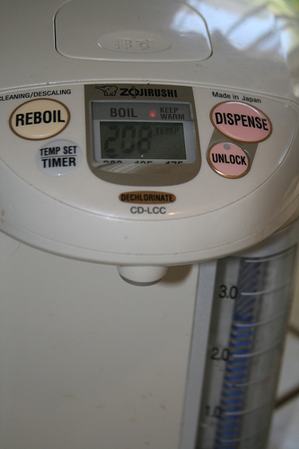
I do not recommend setting a cold bottle just out of the fridge in a saucepan of simmering water. I broke a few bottles doing that — which is why I bought the Zojirushi. If you are going to use a saucepan on the stove, use a room-temperature bottle only.

