How to Make Cheese from Powdered Milk
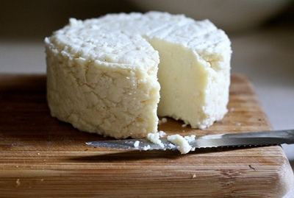
Here’s another recipe I wanted to test out that puts to use the buckets of powdered milk I have stored. Remember if you are constantly rotating your stored food (especially the 3-month food supply) not only will you greatly reduce the chance of anything going bad, but you’ll actually be learning to use your bulk-stored food and eating what you store — some of the most important rules in food storage.
To make cheese from powdered milk is an easy process (unexpected since I never had any experience making cheese before this). Here’s how it works:

What You’ll Need
- Powdered Milk
- Water
- Cooking Pot
- White Vinegar or Lemon Juice
- Cheesecloth or Clean Cotton T-Shirt

How to Make Cheese from Powdered Milk
I used a small amount of ingredients so I could test it out first before using the full recipe. The full recipe calls for:
- 3 cups powdered milk
- 6 cups water
- 1/2 cup plain white vinegar
In my instructions I quartered this recipe as follows:
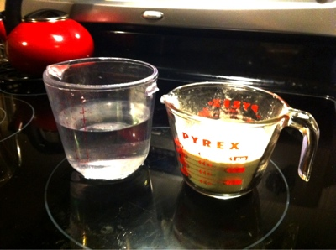 | Step 1: Mix together 3/4 cups of powdered milk with 1 1/2 cups of cold water in a cooking pot. Stir until dissolved.
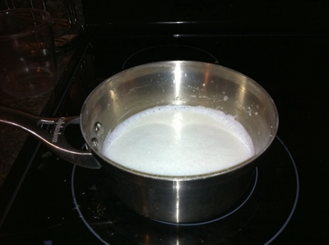 | Step 2: Stir milk over a medium-low to medium temperature until it becomes hot to the touch but not scalding (this should be around 140º if you’ve got a cooking thermometer)
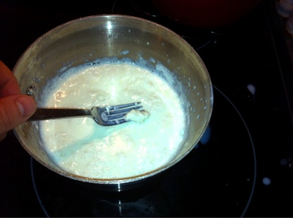 | Step 3: Maintaining the same temperature, stir in 1 tablespoon of white vinegar or lemon juice. You should immediately begin to see the curds separating from the whey.
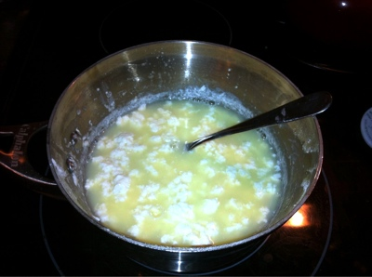 | Step 4: Continue cooking to allow the curds to separate from the whey. After a few minutes there should be large globs (if that’s a real word ) of curds in an amber pool of whey. If it’s still too milky, add another tablespoon of vinegar, stir and cook it on medium to medium-low heat until the curds completely separate from the whey.
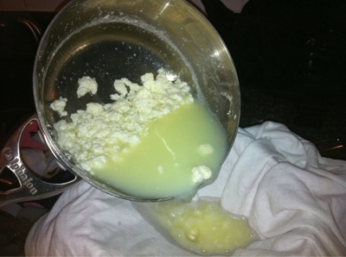 | Step 5: Pour the curds and whey into a colander lined with a clean cloth, cotton t-shirt or cheesecloth to drain off the whey (this sweet liquid can be used in the place of water in other baking recipes so drain it into a bowl if desired).
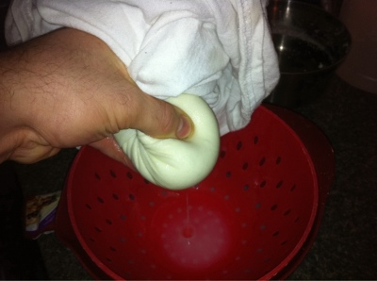 | Step 6: Taking the cloth or cheesecloth (a t-shirt in my example) squeeze the curds to press out any remaining whey.
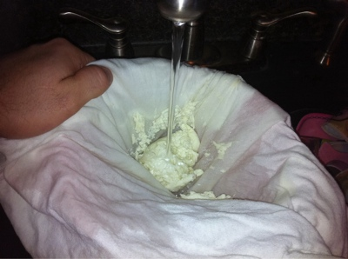 | Step 7: Rinse the curds — which is essentially (I’ve been informed that this is more a paneer style cheese and not ricotta. Ricotta is made by further processing the poured-off whey. For more instructions into this, check out the links in some of the comments below) at this point — under cool water and eat fresh or store in the fridge.

Conclusion
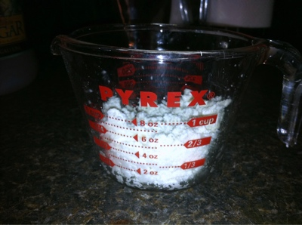
What you should be left with is about the same amount of curds as you measured out in powdered milk.
Since I used 3/4 cup of powdered milk in the above recipe, it resulted in about 3/4 cup of curds — so plan your recipes accordingly.
I was really excited when learning this, since I love lasagna. Pasta as well as tomato sauce — in the form of canned tomatoes (or powdered tomatoes) — stores very well, but fresh cheese doesn’t. Now that I know how to make fresh cheese easily from my stored powdered milk, even lasagna can be enjoyed during the end of the world.

