How to Know IF Your Food Is Spoiled
There are many methods and theories on how long to keep and use food, or when it has gone bad. There are some signs that are visible, and many that are not. Scientists say that not all bacteria are harmful, and there is a big difference between spoilage bacteria and actual harmful pathogens. They even say if it tastes bad, it may not be bad. They also warm us that the most harmful pathogens hat will result in illness cannot be detected by sight, odor, or smell.
We will go over some basic food spoilage signs, telltale evidence, and ways to avoid your food spoiling in the future. With food shortages, food recalls, avoiding harmful chemicals and practices used, and the hard work it goes into growing your own food- these signs and methods can be helpful in preventing any waste. Ingesting spoiled foods can be fatal. A simple bout of diarrhea can lead to dehydration and organ failure within days. Hopefully, telling when your food is spoiled can also help you and your family avoid any preventable food borne illness, so you don’t have to wait for SHTF to find this knowledge useful.

Exposed to Heat
Food items that need to be refrigerated need to carefully handled when transporting them, or they are removed from the ideal temperature. Most people do not know the temperature of their refrigerator or the fact that 1/4th of refrigerators in the US are operating at too warm a temperature for optimum safety precautions reports the Federal Transit Administration. There is a “Rule of 4’s” when dealing with leftovers or prepared foods. No more than 4 days at 40 F degrees. Most people do rely on refrigeration for their safety device.
Ways to keep your food safe
When transporting food from a restaurant, do not let it sit for more than 2 hours. From the grocery, it should not be more than 20 minutes. When using any food that needs refrigeration, not leaving it out past a few minutes can help immensely by keeping the base temperature low. Here is a FDA quick reference PDF on food temperatures.

Slime
Any tackiness or sticky feeling meats should be tossed. Microbes cause slime. Yeast and aerobic bacteria, much like infection and phlegm, produce slime when they are manifesting their colonies. Bacteria can come from the animal, its handling, processing, transportation, or packaging.
https://youtu.be/BlKP35bct2o
Ways to keep your food safe
Proper handling and clean surfaces is best practice. Washing your hands and all utensils that come into contact with the food is the best way you can hope to avoid bacteria at home.
Microorganisms and food spoilage:

Mold
Ironically, most mold that you will see on breads and fruits isn’t toxic, according to Purdue University studies. They suggest just cutting a few inches past the mold and it will be fine to eat, unless you have a mold allergy. People who are sensitive to mold and ingest it may have adverse reactions.
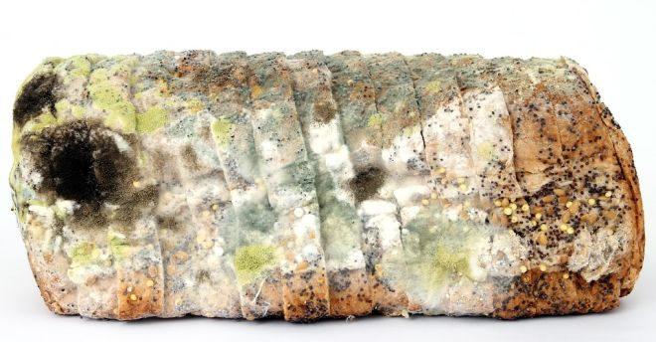
Ways to keep your food safe
Keep moisture away from breads. Store them in air tight containers or packages. With fruit and vegetables, store them in baskets and use moisture whisking materials such as cloth or paper.

Freezer Burn
If you see small ice crystals or any frost on your food, that’s not from temperature or freezing too fast. That is freezer burn, and what happens when frozen food loses its moisture meaning the internal texture has changed from the surface. It usually is a signal of drastic change to its flavor, and in many ways it is still safe to eat, but it probably will not taste the same when originally frozen. If fresh food was frozen correctly it should last quite a while, at least 3-5 months.
Ways to keep your food safe
When you freeze food at zero F degree, it should be safe infinitely. Freezer burn can be prevented by safely packing foods in air tight containers or the zipping lock types of bags. Squeeze as much air out of the bag before zipping the seal as you can.

Time
With preserving meats and drying them, etc. time is for that technique. For normal food to be consumed with a meal, or food that is just purchased, a good rule of thumb is seven days past the “sell-by” date is considered safe. On that 7th day, it should be composted or used for other than human consumption.
Ways to keep your food safe
To make sure no harmful bacteria has time to develop, the rule of thumb is raw meat should only be in the refrigerator for 3 days. This includes raw chicken, beef, pork, lamb, and veal. Cooked leftovers should only be kept for 4 days or less.

Inspect Cans
Cans that show bulging or swollen sides should not be used. The internal seal could’ve been compromised and gases could be causing that expansion. Corroded metals can indicate internal problems.
If you open the can and the food appears cloudy or murky in any way, it should be thrown out. Any unpleasant odor or gas-like off-putting smells indicate spoilage.
It is especially important to dispose of any canned food you think may be compromised, do not give it to pets or use it for compost as it could contain the fatal bacteria that cause botulism. Use extreme caution with canned and jarred foods.
https://youtu.be/bAWvzkK74gU

Changes in appearance
Produce will show signs of spoiling before any other foods, with root vegetables coming in a close second.
- Carrots will become soft and either go pale or get darker and rustier colored.
- Grapes will get darker and deflate, and get soft mushy spots around the stem.
- Tomatoes will get wrinkled and start to seep fluids, the skin will sag and bunch.
- Bananas will get darker and pull from the stems.
- Stone fruits will get wrinkled and soften, and the texture will go soft.
- Cucumbers and greens will get bitter and dark.
- Leafy vegetables will darker around the edges and get slimy.
- Avocado’s stem button will seem dark and start to mold first.
- Cauliflower will show rust colored slime at the floret’s root base.
- Any soft white fuzz is an indication the produce should be thrown out.
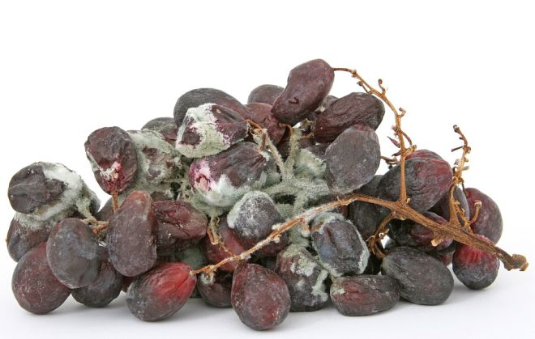

Internal Gas
Much like a canned food, it can be hard to tell with eggs. Of course, when you crack it, if anything is foul smelling or “sulfur-y” it should not be consumed. For eggs, you can immerse them in 4” of tap water. How they float will tell you their freshness.
- If the egg sinks, it is fresh.
- If it stands up, it is okay but aging. The higher it rises, the older it is.
- When it floats, the gas has progressed into spoiling it. The gas is what makes it float.

Discoloration in Meat
When you unwrap your meat, the first thing you should do is smell it. Any foul or unpleasant odor indicates it has spoiled. If you want to be sure, let it defrost. Any tackiness or stickiness means bacterial growth has occurred, so it should be discarded.
When meat spoils it can get darker, or it can pale. It used to be they told you to check the meat bladder in the package, if it’s full of dark blood it doesn’t mean the meat is bad, but it’s not super fresh and you have less time to let it sit. The same can be said for visual appearance, the blood in the muscle will darken as it ages so that could be a sign of aged meat, or meat on the verge of going bad.
Other ways to preserve meat for survival: https://youtu.be/AulCuXNjl94

Flour mites
These are pretty nasty. The worst part is you usually can’t tell they are present unless it’s an advanced colony. They come in packaged food and feed on flour, germ, and mold and can spread their presence to other dry goods. You do not want your pantry and stockpile ruined when the time comes to use it! Black dots are weevil larvae which can be killed in the same methods.
Ways to keep your food safe
To determine if you have an infestation, look at your dry foodstuffs. Any small beige “sand” around the edges of the packages or in the white flour, that’s mites. To prevent them is easy. Use air tight containers. If you do have them, or just want to make sure, they die by being cold! Freeze any food stuffs overnight and that should kill them. Wipe down your shelves with vinegar and water. They hate bay leaves, so using them as a shelf decoration would help avoid any future infestations. Some people say diatomaceous earth helps kill any shelled bugs like mites and weevils, but my pets have trouble and sneeze with it around so I do not use it.
Killing flour mites video: https://youtu.be/ptMMJ6fNX6w
A video on food spoilage and its prevention: https://youtu.be/CkoOm4Lxmjk

Final Thoughts
People who cultivate their own meat and foods from hunting, foraging, farming, and raising usually can’t just check the packaging for dates, so sight, smell, and tactile senses are a must when checking foods. They usually incorporate drying, curing, salting, and other methods of preservation for longer periods of storage. I wish I could say everything we had was from self-sufficiency, but we do store shop for some staples. In this day and age, it’s smart to use all resources to prepare and stockpile the best you can.

