How to Dry Apples
Maybe your apple tree was overzealous in production, maybe you bought too many apples thinking you wanted eight apple pies--whatever the reason, you now have a lot of extra apples on your hands. Why not try drying them out? Dried apples are delicious, healthy snacks that can be stored for months. Follow these easy steps to dry your apples.

Ingredients
- 
Apples
Lemon juice
Water
Cinnamon, nutmeg or allspice (optional)

Part 1 of 2: Washing and Coring the Apples
- 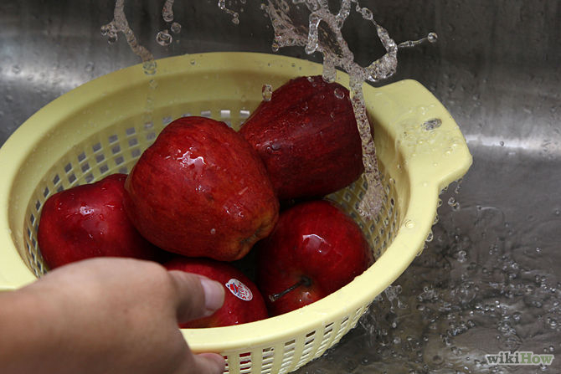
1
Wash the apples you have selected. You do not necessarily need to peel them. The skin adds extra flavor to the apples and also contain a good deal of the fiber apples are famous for. Other people like to peel their apples because they do not like the texture of the dried skins. It is really just a matter of what you like.
Ad
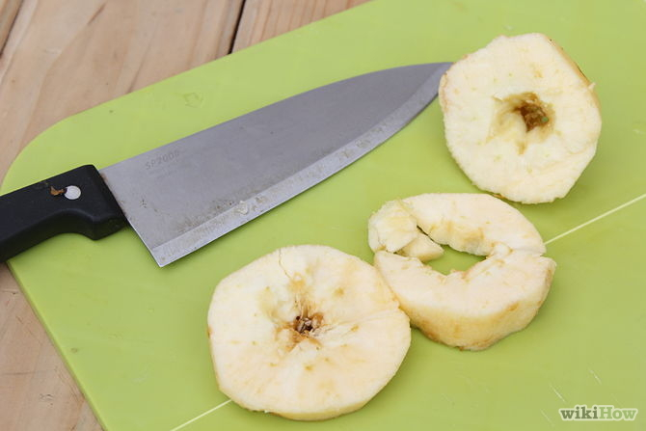
2
Cut away the cores. You will also want to cut out any worm-eaten parts. Kitchen stores sell apple corers that will easily and efficiently remove your apple cores. However, if you do not have one of these devices you can also core your apples by hand.^{[1]}
  - If you are using these apple for decorations, or you really like your food to look as beautiful as possible, skip the coring. Apples that are not cored and are cut so that they keep their circular shape have a pretty star pattern in the center created by the core.
- 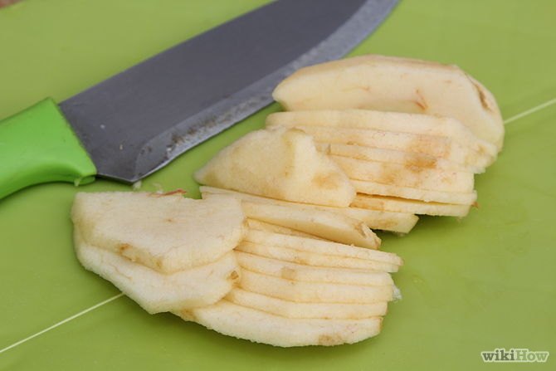
3
Cut the apples into thin slices. You can either cut your apples so that they retain their circular shape, or you can cut them into thin wedges. Again, this is simply based on your own preference.
- 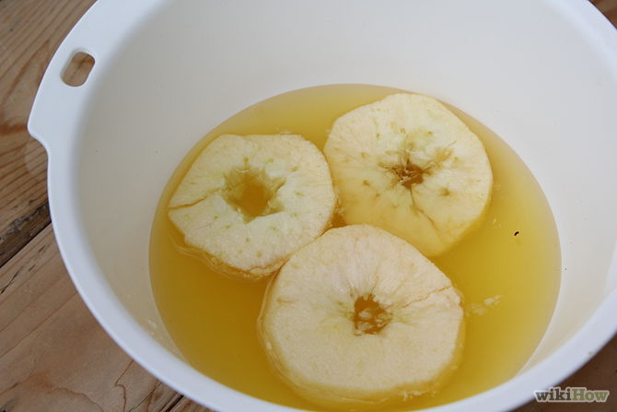
4
Dip your slices into a solution that will keep them from browning. An excellent solution for this is lemon juice, pineapple juice and water mixed together. The pineapple juice isn’t necessary but it adds sweetness to the mixture that counteracts the sour flavor of the lemon juice.^{[2]}
  - You can also add orange juice and lemon juice mixed with water.
- 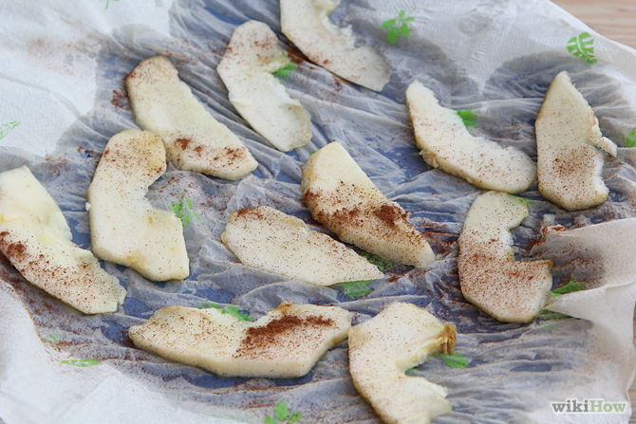
5
Sprinkle seasonings on the slices (optional.) Some people like to flavor their apple slices with spices like nutmeg, cinnamon, or allspice. These give the apple slices a flavor boost, but unflavored apple slices are equally delicious.^{[3]}

Part 2 of 2: Drying the Apples

Method One: Using the Oven
- 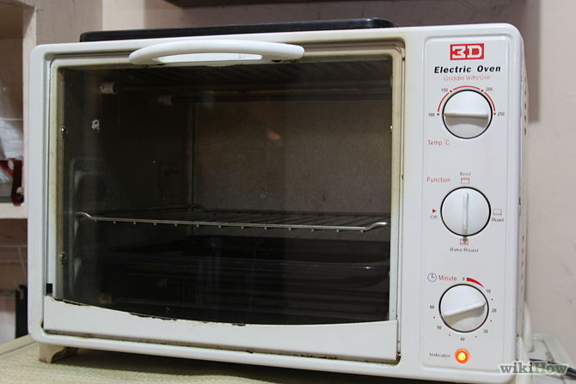
1
Set your oven to 200ºF (93.3ºC.)^{[4]}
- 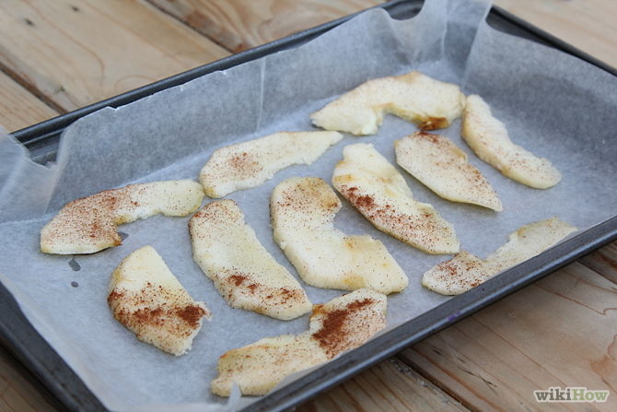
2
Place the apple slices on a baking sheet covered with parchment paper. Make sure that they are not overlapping or else they will fuse together while they are drying.
- 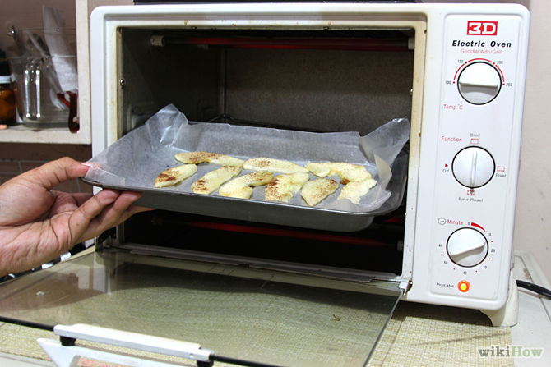
3
Place the baking sheet in the oven. Bake the apple slices for an hour. When the hour has passed, remove the sheets and flip all of the the apple slices over. Bake the apples for one more hour is you prefer your apples to be a little less crispy. If you like crispy dried apples, bake them for two more hours.
  - You should keep an eye on your apples and check them periodically. All ovens are different and your oven might take a longer or shorter amount of time to dry the apples.
- Turn the oven off but do not take the apples out. Inside, crack the oven door open a small amount and let the apples cool inside the oven. You should not take the apples out until the oven has cooled completely (this should take one or two hours.)^{[5]}

Method Two: Using the Sun
- 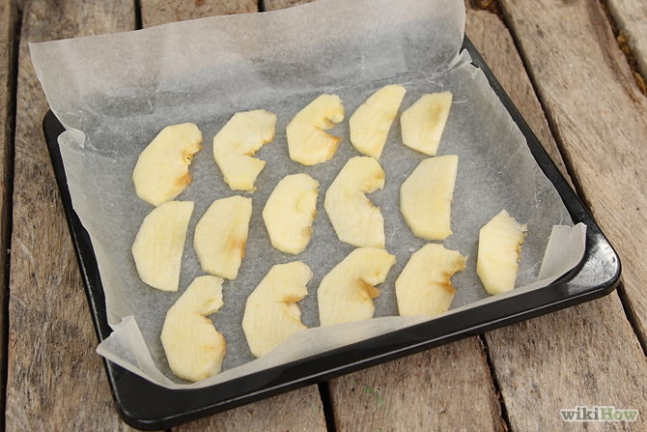
1
Spread the apple slices on some shallow cooking trays. Cover the bottom of the trays with parchment paper or some other cooking paper before placing the apples on the trays. Cooking trays that have lips are better than cookie trays because the drying apples may leak a little juice which could make a sticky mess.
- 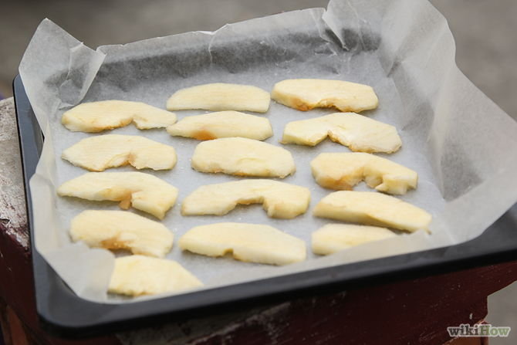
2
Place the apples in the sun on a warm (or hot) day. Cover the apples loosely with cheesecloth to protect the fruit from any pesky bugs. In the evening, before the dew falls, bring the apple slices indoors so that they do not get moldy. Place the tray in a dry spot in your house.^{[6]}
- 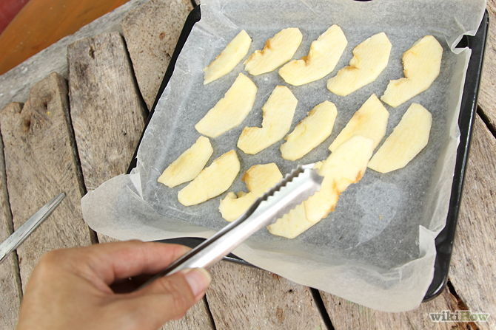
3
Turn the apple slices. At least once a day, turn the apple slices over so that the underside faces the sun. This will result in an even drying. You should also turn them when you bring them in for the night.^{[7]}
- 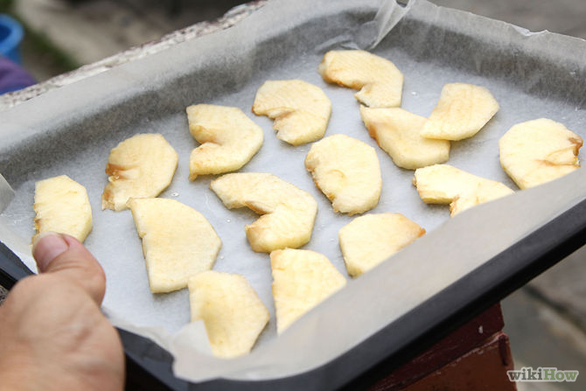
4
Place the apples in the sun again. The next day, spread the apple slices in the sun again. They will probably become quite dry during the course of the day. Normally this method takes about two days to be fully completed.
- 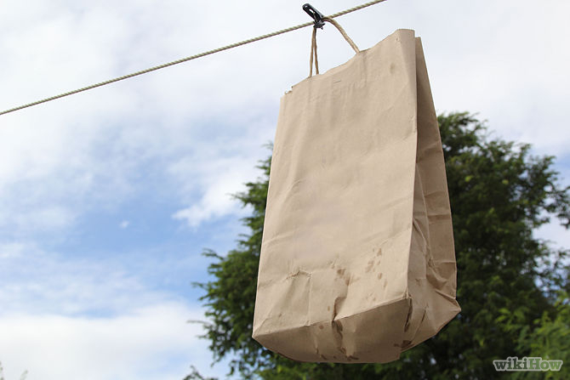
5
Hang the dry apple slices. When the apples are quite dry, which is when the outside flesh is not moist at all, put them into brown paper bags and hang them up in an airy, dry place; alternatively put them in plastic airtight containers for storage.
Ad

Method Three: Using a Food Dehydrator
- 1
Arrange the slices on the drying rack of the dehydrator. Try to spread them out so that none of the pieces are touching each other. If they do touch, they might fuse together while the are in the dehydrator.
- 2
Turn the dehydrator on. If your dehydrator has a temperature control, set it to 140ºF (60ºC.) Using the dehydrator will take anywhere from 12 to 24 hours depending on the type of apple and how thickly you cut the slices.^{[8]}
- 3
Take them out when they are done. You can tell when a dried apple is done by feeling it. The slices should feel bendable or leathery and not brittle. Some people liken them to the consistency of a fresh raisin. Store the apples in airtight containers until you are ready to sit back and enjoy them.

