How to Dehydrate Blueberries
by Jennifer

How To Dehydrate Blueberries Step by Step:

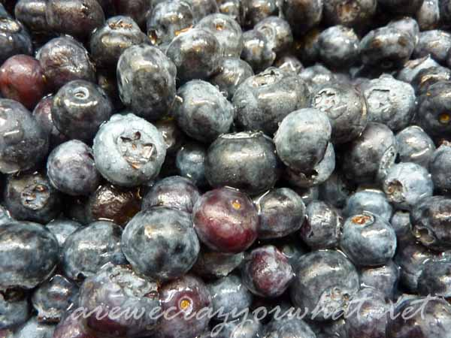
Start with fresh sweet blueberries. You might make a note next time you purchase a package of blueberries as to where they came from. Blueberries from northern states tend to be sweeter than those from southern states, in my experience. So next time you get some super sweet blueberries make a note as to where they came from so you can know what to look for when you 're looking for blueberries to dehydrate. We're not adding any sugar in the dehydration process so you want to start out with the sweetest blueberries you can find.
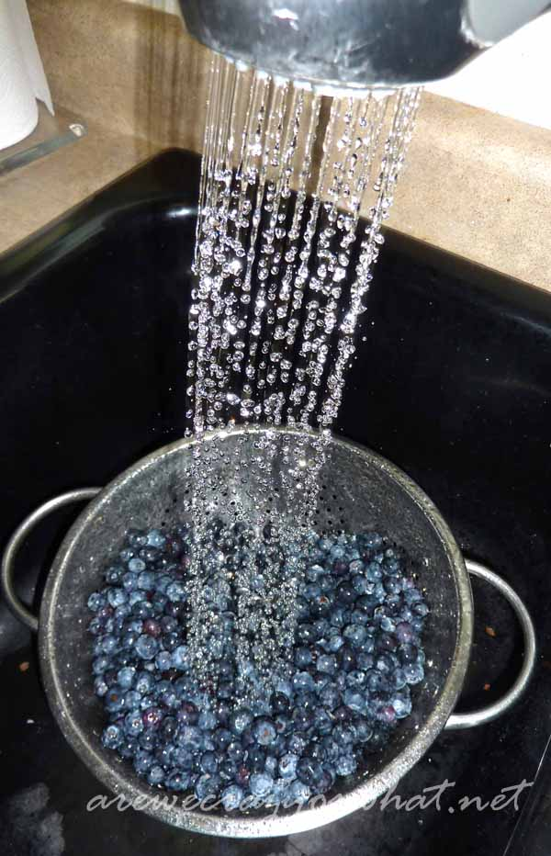
Wash your blueberries.
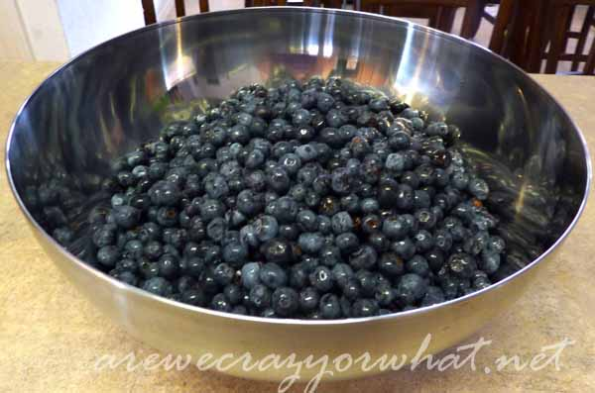
That's a lot of blueberries! I have a nine tray Excalibur Dehydrator, and this is about 14 dry pints of blueberries. I filled up 7 of the trays. Two pints to each tray.
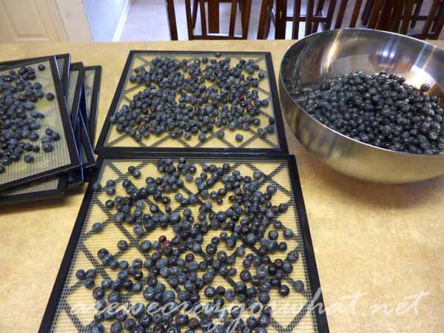
Simply place the blueberries on the tray.
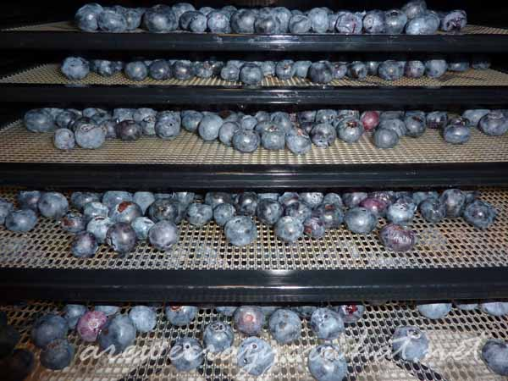
And place in your dehydrator. There are some directions for dehydrating blueberries that will tell you to take a knife and puncture each blueberry. You can do that if you want. I decided it wasn't worth the time it would take so I leave mine with no punctures.
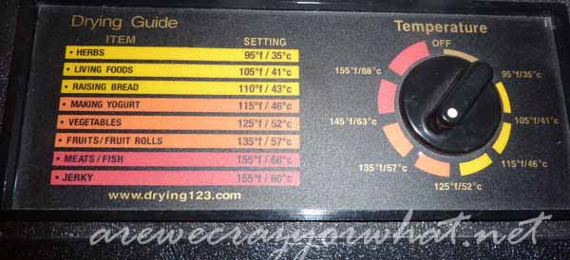
The down side to not puncturing your berries is that they will take longer to dehydrate. These took about 35 hours.
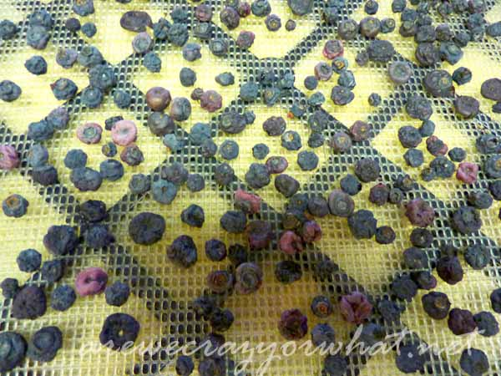
This is what the blueberries look like when they are dehydrated.
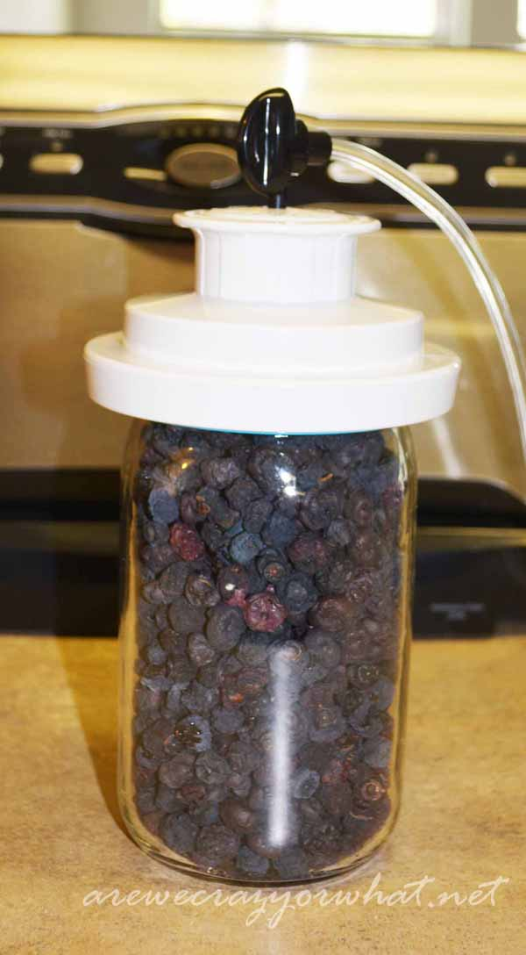
I like to store my dried fruit in canning jars. I vacuum packed these blueberries with a FoodSaver using the FoodSaver attachment for wide mouth jars.
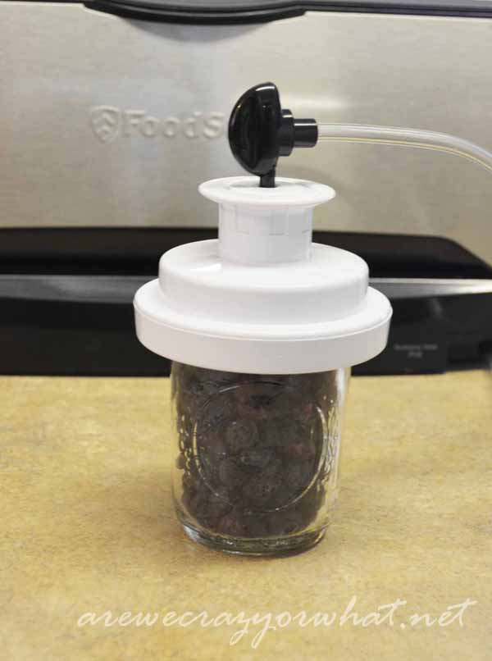
Here I'm using a smaller jar and sealing with a regular mouth attachment to vacuum pack the blueberries.
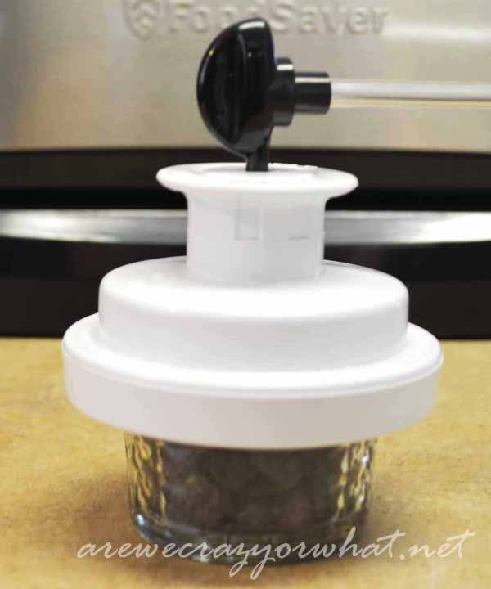
I love the FoodSaver attachment because it will fit on the little 4oz jars as well. Here are just enough blueberries for some muffins or perhaps a snack for my boys.
I put the blueberries in the freezer for two weeks to pasteurize them, then store them in a cool dry place. See, super easy! Buy them. Wash them. Dehydrate them. Eat them. That's it!

