How To Plan Your Pantry
by Kathy
Canning and freezing are a lot of work, but preserving your own food is one of the most satisfying homemaking task when it is finished. I love hearing those lids pop as they seal after a day of canning. You may wonder if canning is worth all the hard work, I believe it is! There are seasons of life that it is difficult to can and that is OK, that does not mean you are a failure at homemaking.
Most of us were not brought up preserving our food, which makes it a daunting task to tackle. It is so important that our daughters learn this skill. As they get older, they are able come along side us and be a huge help to the family. Hopefully, by the time they have their own home, canning will just come naturally for them…because that is in-part what skilled homemakers do!
Whether you’re harvesting your own fruits and vegetables, buying from the local farmer’s market or buying straight from the grocery store, summer is the best time to stock up on groceries at good prices! Of course the best way to save money on food and to stock up your pantry is to can, freeze or dry as much as possible.
Plan to stock your pantry for winter or hard times. Teach your kids to always be planning for the future. It’s not just about living for the day, but about thinking ahead, to provide for your own and to meet the needs of others.
He who gathers in summer is a prudent son,
but he who sleeps in harvest is a son who brings shame.
Proverbs 10:5
It Begins with a Good Plan
- Estimate how much of your usual food you need to last your family 6-12 months.
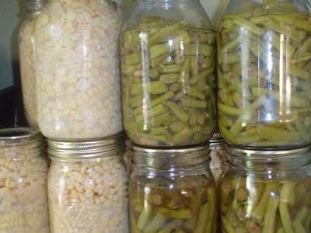
Some Examples:
We usually eat green beans once a week, which is 1 or 2 jars to feed 6 of us. Some weeks we may not eat green beans and some weeks we may have company and need extra, so this is an average.
- Green Beans - 40 weeks x 2 jars = 80 quart jars
I canned 28 jars from one bushel, so 1 – 1 1/2 more bushel will give me enough for the fall through the spring, and we eat fresh beans during the summer. This amount applies to sweet corn too.
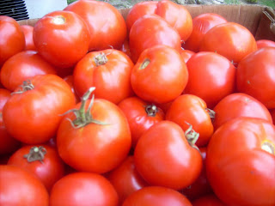
We are pasta lovers and I make my own sauce. I need 4 quarts of tomatoes a month for sauce and 2 more quarts a month for soup, chili, etc…
- Tomatoes- I plan 6 quarts a month x 12 months = 72 quarts to last me a year. I usually do about 100, better to have to many than run short.
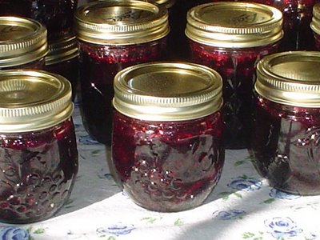
- Jam and Jellies- 1 -1/2 pint a month for us, plus I make 10-15 to give away, they make great hostess gifts = 25 -1/2 pints.
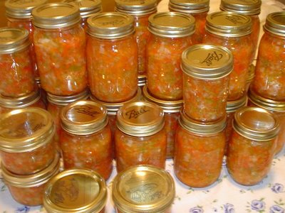
- Grandma Brodock’s Sweet Pepper Relish- 12 pints for us, 10-12 to give away = 25 pints
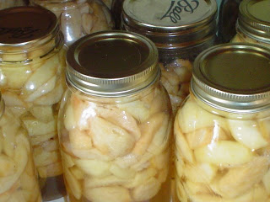
- Apples- 2 jars per pie. I make pies for us occasionally, but I mostly make them for fellowship meals and desserts to take other places. Plan on 20-30 quart jars.
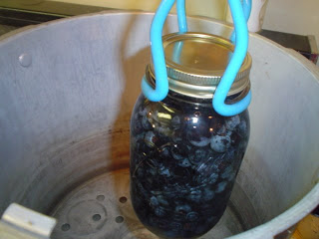
- Berries- for pies, pancakes, waffels, muffins, I can as many as I can, at least 20 quarts.
I prefer berries frozen for smoothies and such, I try to freeze 10-15 quart size ziplocks.
Having a list of what you need helps you to be alert to good sales while items are at their peak season. Watch for great prices and buy in bulk. Keep your canning supplies stocked and ready to be used. Even if you are only canning one canner at a time (7 quarts for mine) it is better than canning nothing.
Other items to can:
- squash
- banana peppers
- potatoes
- apple sauce
- vegetable soup
- tomato soup
- pickles
It does take some extra work, but it is SO WORTH IT!

