How Much Food Fits in a 5 Gallon Bucket?
Based on my math, a typical 5 gallon bucket holds 0.71 cubic feet of anything you want. Filled with water, it will hold 42 pounds of the stuff, not counting the weight of the bucket (typically 2 pounds.)
That means for any liquid or semi-liquid food such as wine, beer, peanut butter, honey or cooking oils, just remember 42. Readers of the Hitchhiker’s Guide to the Galaxy may recognize this number as the ultimate answer to life, the universe and everything.
Once you start talking dry foods the weight really starts to vary.
This is a small list to get you started in planning for how many buckets you will need to store a given weight of certain foods. It also happens to be a great list to get you started in thinking about different foods that can be stored long-term!
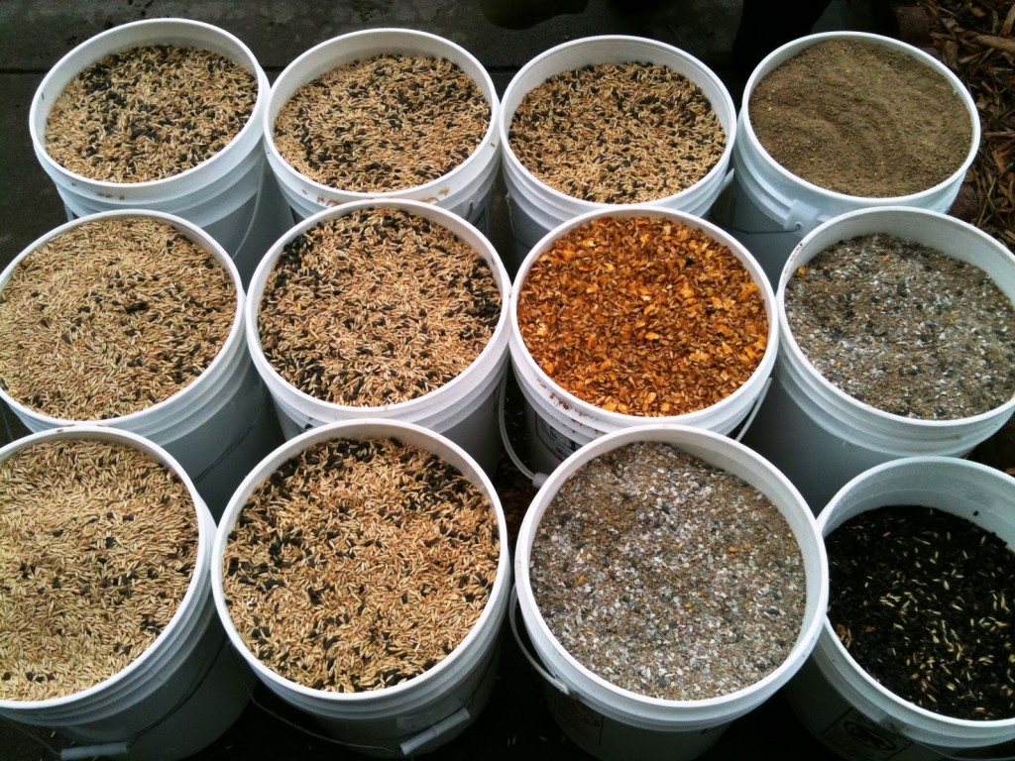

Maximum Weights of Dry Goods that will Fit in 5 Gallon Bucket
Hint: use the keyboard shortcut Ctrl+F to search this page for the specific food you are looking for.
WHOLE GRAINS:
Cracked Red Wheat 29.2 lb. 64.2 kilos
Hard Red Wheat 37.5 lb. 82.5 kilos
Hard White Wheat 37.5 lb. 82.5 kilos
Pearled Barley 36.7 lb. 80.7 kilos
Whole Corn 37.5 lb. 82.5 kilos
Hulled Buckwheat 35 lb. 77 kilos
Flax 31.7 lb. 69.7 kilos
Long Grain White Rice 36.7 lb. 80.7 kilos
Long Grain Brown Rice 35.8 lb. 78.8 kilos
Par Boiled Rice 35 lb. 77 kilos
Rolled Oats 20.8 lb. 45.8 kilos
Oat Groats 35 lb. 77 kilos
Oat Bran (Fine) 25 lb. 55 kilos
Rye 35 lb. 77 kilos
9-Grain Cereal 31.7 lb. 69.7 kilos
Hulled Millet 35.8 lb. 78.8 kilos
FLOUR:
Wheat Bran 12.5 lb. 27.5 kilos
All Purpose Flour 33.3 lb. 73.3 kilos
Cornmeal 33.3 lb. 73.3 kilos
BEANS:
Beans 35 lb. 77 kilos
Anasazi 33.3 lb. 73.3 kilos
Black Turtle 35 lb. 77 kilos
Black Eye 31.7 lb. 69.7 kilos
Garbanzo 33.3 lb. 73.3 kilos
Great Northern 35 lb. 77 kilos
Green 8.3 lb. 18.3 kilos
Green Peas 33.3 lb. 73.3 kilos
Kidney 33.3 lb. 73.3 kilos
Lentils 35.8 lb. 78.8 kilos
Lima 35.8 lb. 78.8 kilos
Mung 37.5 lb. 82.5 kilos
Pink 34.2 lb. 75.2 kilos
Pinto 34.2 lb. 75.2 kilos
Refried 20.8 lb. 45.8 kilos
Small Red 34.2 lb. 75.2 kilos
Small White Navy 37.5 lb. 82.5 kilos
Soy 33.3 lb. 73.3 kilos
PASTA:
Pasta – Macaroni 20.8 lb. 45.8 kilos
Pasta – Egg Noodles 13.3 lb. 29.3 kilos
Pasta – Spaghetti 29.2 lb. 64.2 kilos
DEHYDRATED VEGETABLES:
Diced Carrots 16.7 lb. 36.7 kilos
Cross-Cut Celery 6.7 lb. 14.7 kilos
Chopped Onions 15 lb. 33 kilos
Potato Dices 13.3 lb. 29.3 kilos
Potato Flakes 12.5 lb. 27.5 kilos
Potato Granules 37.5 lb. 82.5 kilos
Potato Slices 8.3 lb. 18.3 kilos
Split Green Peas 37.5 lb. 82.5 kilos
Tomato Powder 29.2 lb. 64.2 kilos
DEHYDRATED FRUIT:
Applesauce 16.7 lb. 36.7 kilos
Apple Slices 8.3 lb. 18.3 kilos
Banana 11.7 lb. 25.7 kilos
DEHYDRATED MILK/DAIRY:
Butter Powder 20.8 lb. 45.8 kilos
Margarine 20.8 lb. 45.8 kilos
Cheese Blend 20.8 lb. 45.8 kilos
Non-Fat Milk 29.2 lb. 64.2 kilos
Morning Moo White 29.2 lb. 64.2 kilos
POWDERED EGGS:
Powdered Eggs 20.8 lb. 45.8 kilos
Powdered Whole Eggs 20.8 lb. 45.8 kilos

