Homemade Honey Sticks

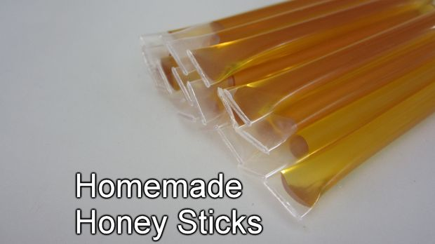
Honey sticks are a great little treat. They are delicious. They are portable. They have an extremely long shelf life. But most importantly, they are easy and fun to make. You may even want to get the kids involved. So here is a simple tutorial on how to make your own honey sticks.

Step 1: Materials
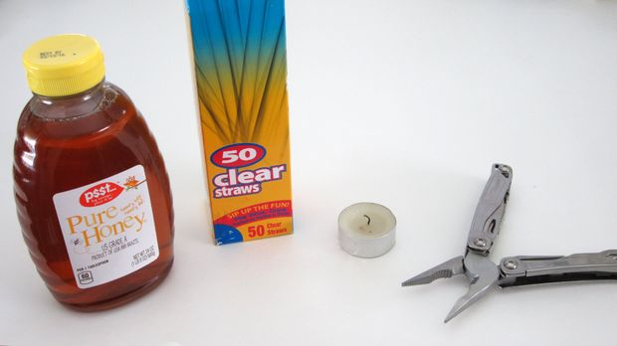

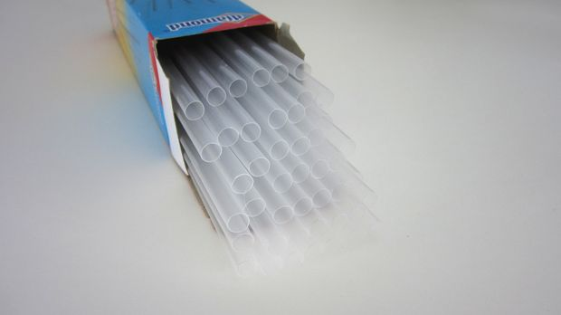
Here are the materials that you will need for this project:
Honey: There are a lot of different types of honey that you can use. You can use any basic honey that you find on the shelf at your grocery store. Or you can find specialty honeys that are made primarily from one type of flower. Each different flower type gives a distinct flavor. Most areas with a lot of farm land will have bee keepers that will sell locally made honey.
Straws: Any plastic straw can work. I prefer to use clear straws. The process is a little easier if you can see the honey as you are filling the straws. Also a clear straw shows off the delicious honey inside.
Candle: You need a heat source to seal the ends of the straw. I like to use a candle because it is stationary but you can also use a lighter.
Needle Nose Pliers: You need a pair of pliers to pinch the straw and hold it shut while sealing the ends. The narrow tip of needle nose pliers works best.

Step 2: Cut the Straws to the Desired Length
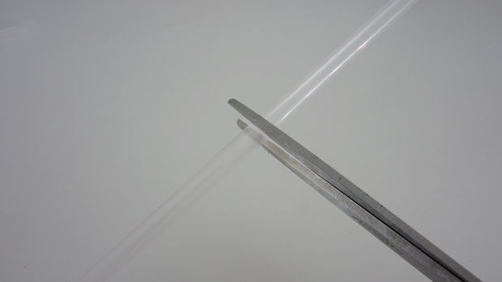
The first thing that you need to do is cut the straws to the desired length. Keep in mind that you will lose about a centimeter on each side during the sealing process.

Step 3: Fill the Straw With Honey
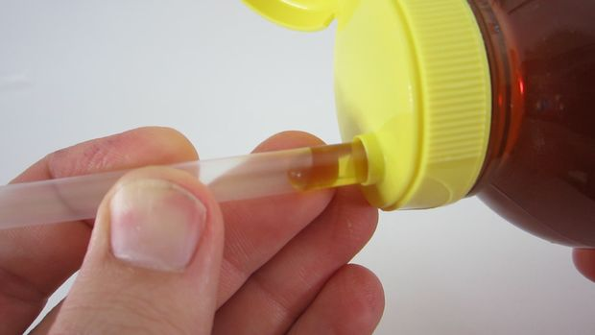

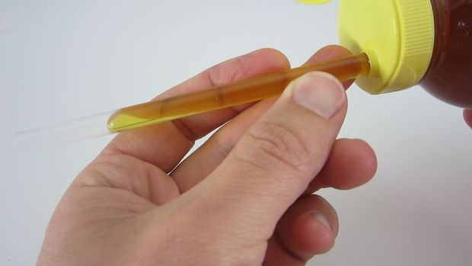

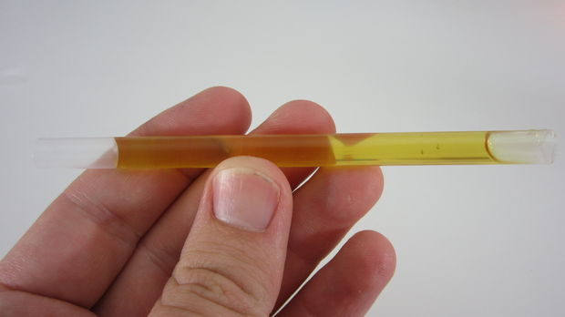

Press the straw against the opening of the honey bottle and gently squeeze the honey into the straw. Add honey until it is about one inch from the opposite end. Then remove the honey bottle. Tilt the straw so that the honey to falls to the center of the tube. You want to have room on each side seal the straw.
If you are not using honey from a squeeze bottle, you can insert the honey using a syringe or a funnel with a lot of patience.

Step 4: Pinch the End of the Straw Closed
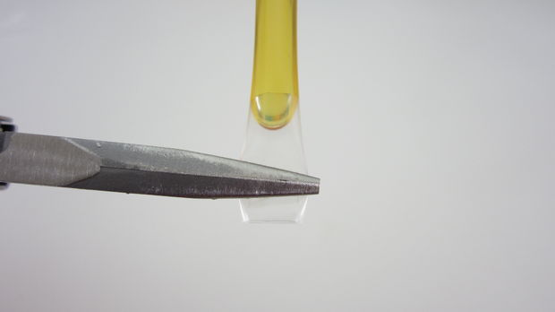
The end of the straw where the honey was added still has some honey residue so we want to seal the other end first. Take the needle nose pliers and pinch the clean end of the straw closed. You want to have about 1/8 inch (3mm) of straw sticking out past the pliers.

Step 5: Melt the End of the Straw to Seal it
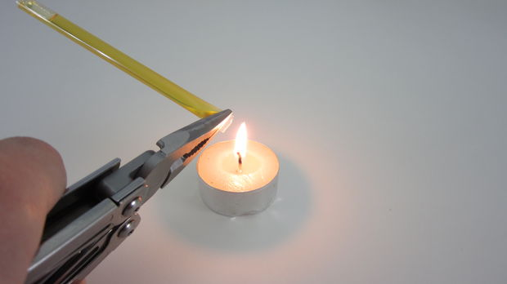

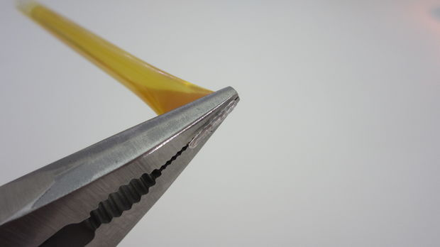

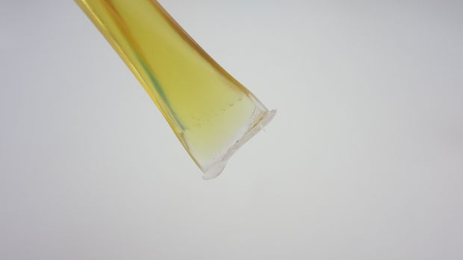
Now you want to carefully melt the plastic at the end of the straw to seal it. I recommend holding the end of the straw near the side of the flame (not above it). This gives you the most control. Work slowly.
Once the tip is melted, move the straw away from the candle but continue holding it closed with the pliers. You need to wait for the plastic to completely re-solidify. After a few seconds the plastic will be cool and you will have an air tight seal.

Step 6: Let the Straw Sit So That the Honey Can Settle to the Bottom
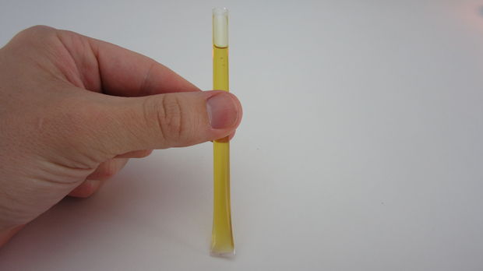

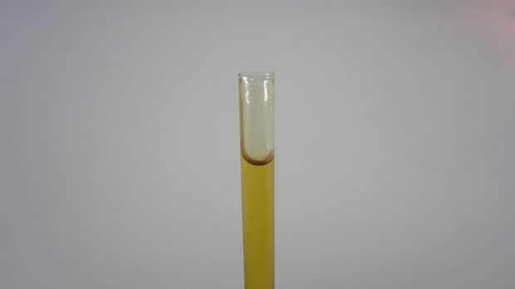

Before sealing the second end, you want to drain out any residual honey. Prop the straw up and let it sit for several minutes to allow the honey to fall to the bottom.

Step 7: Seal the Second End
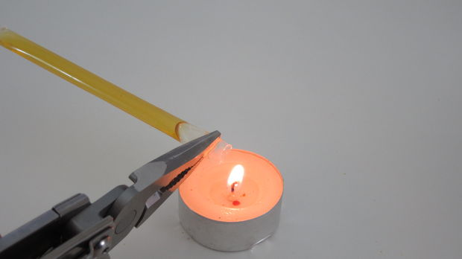

Now just repeat the same sealing process. Pinch the end of the straw with your pliers. Then slowly melt he tip. If there is any honey still in the end of the straw, it may start to bubble out. If this happens, you can wipe it off with a wet cloth. Now the straw is sealed on both ends.

Step 8: Enjoy Your Delicious Honey Sticks
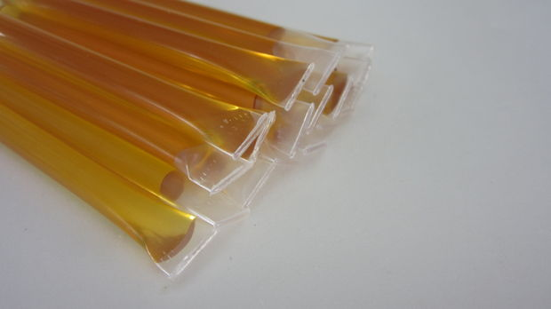

You have successfully made your own honey sticks. You can pack them up and take them with you wherever you go. They can make a tasty snack or you can use them to sweeten your cup of tea.
If properly stored, these can last forever. But they will probably get eaten up before long.

