- 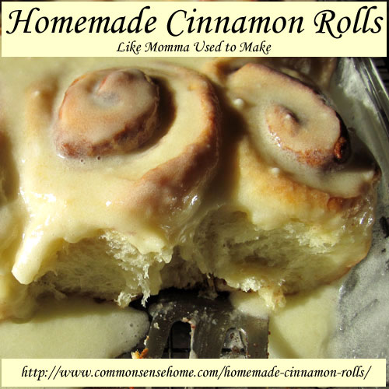
These rolls were a family favorite that mom used to bake for most holidays, along with kolache and rolache. (No idea of the proper spelling on that one – same dough as kolache, but rolled up into a crescent, brushed with egg wash and sprinkled with salt and poppy seed). Later she also added Hungarian rolls. Christmas time would have Polish tea rings. I bake less than mom did (trying to avoid so much white sugar and white flour), but special occasions call for special recipes and memories of family traditions. Sometimes I make these as Caramel-Pecan Cinnamon Rolls, with a caramel sauce baked in the bottom of the pan, usually I just make them with icing because my boys like them better that way.

Homemade Cinnamon Rolls
Ingredients
Dough
  - 2 packages (1/4 ounce each) active dry yeast (4 1/2 teaspoons)
  - 1 cup warm milk (110° to 115°)
  - 2 eggs
  - 5 tablespoons butter, lard or rendered poultry fat, melted
  - 1/2 cup pure cane sugar
  - 1 teaspoon salt
  - 5 cups all-purpose flour
Filling
  - 2 tablespoons butter, melted
  - 1/2 cup pure cane sugar
  - 1 teaspoon ground cinnamon
Caramel Sauce
  - 1 cup butter, cubed
  - 2 cups packed brown cane sugar
  - 1/4 cup GMO free corn syrup or honey
  - 1/2 to 3/4 cup chopped pecans
Icing
  - 1 cup confectioners’ sugar (powdered sugar)
  - 1/3 cup butter, softened
  - 1/2 teaspoon vanilla extract (homemade vanilla extract is great if you have it)
  - 1 to 2 teaspoons whipping cream or milk, or more for a thinner glaze

Directions
Preparing the dough: In a large bowl, dissolve yeast in warm milk. Add the eggs, butter (or lard or poultry fat), sugar, salt and 3 cups flour. Beat until smooth. Stir in enough remaining flour to form a soft dough.
Turn onto a lightly floured surface; knead until smooth and elastic, about 6-8 minutes. Place in a greased bowl, turning once to grease top. Cover and let rise in a warm place until doubled, about 1 hour. (You could also use the dough cycle on your bread machine, or mix with with something like the Bosch Kitchen Machine or the dough hook on a heavy duty KitchenAid stand mixer.
While the dough is rising, prep your caramel sauce or icing.
For caramel sauce: Melt butter in a large saucepan. Stir in brown sugar and corn syrup (or honey). Bring to a boil over medium heat for 2 minutes, stirring constantly. Pour into a greased 13-in. x 9-in. baking dish. Sprinkle with pecans; set aside.
For icing: In a small bowl, blend together powdered sugar, butter and vanilla. Add cream or milk to thin as much as you like. Cover bowl with a lid, damp cloth or plastic wrap to keep it from getting crusty while you finish the rolls. If you are using frosting and skipping the caramel sauce, grease a 13-in. x 9-in. baking dish and set aside.
To assemble the rolls: Punch the dough down. Turn onto a floured surface. Roll into a 17-in. x 15-in. rectangle.
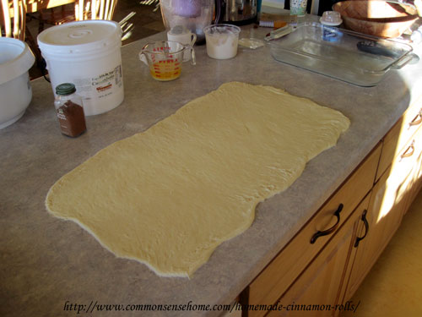
Spread butter to within 1/2 in. of edges. Combine sugar and cinnamon; sprinkle over dough. Roll up jelly-roll style, starting with a long side; inch seams to seal.
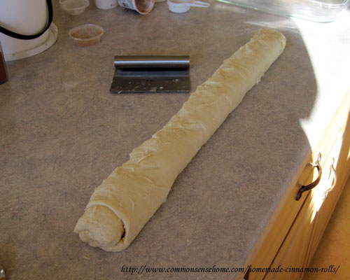
Cut into 16 slices. Place cut side down over caramel sauce (or in greased pan).
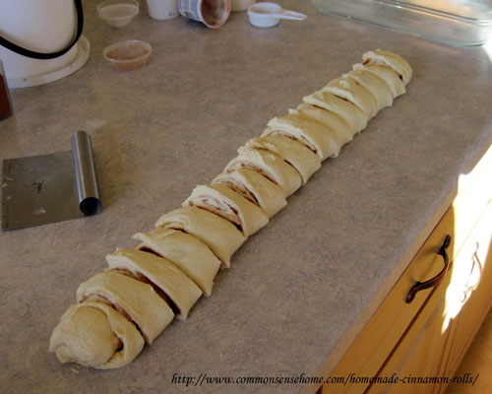Cover; let rise until doubled, about 30 minutes.
OR
If you want to prep these the night before to bake fresh in the morning, cover your pan with plastic wrap and place the rolls in the refrigerator overnight. In the morning, remove from the refrigerator and allow to come to room temperature and finish rising. Don’t put a glass pan straight from the refrigerator to the oven!
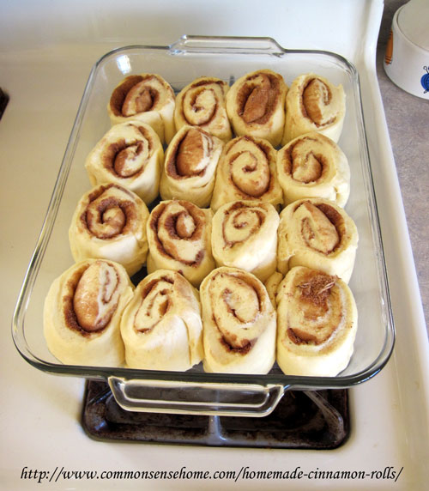
Raised and ready to bake.
Bake at 350° for 30-35 minutes or until golden brown. Glass pans will take longer to bake, metal pans will go a little faster.
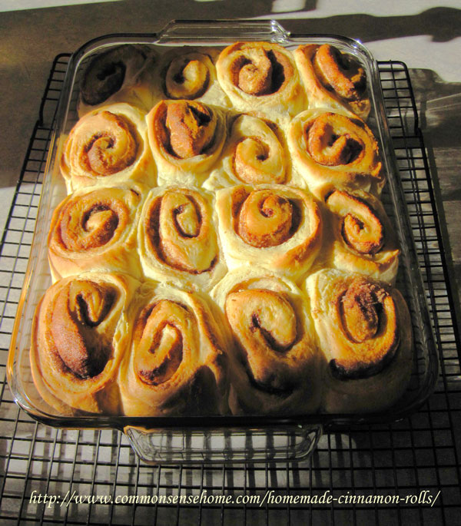
For caramel rolls, let stand 5 minutes; invert onto a serving platter. For iced rolls, allow to cool slightly in pan, then pour icing over rolls. The boys couldn’t wait, so my icing went on when the rolls were a little too hot.
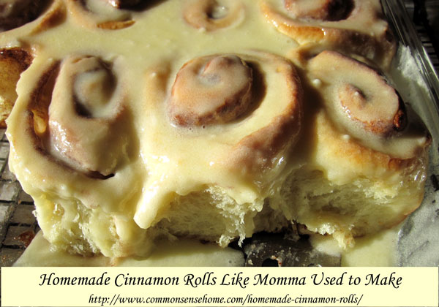
Yield: 16 rolls.

