Home Canning Guide:

Learn How to Can Your Own Food

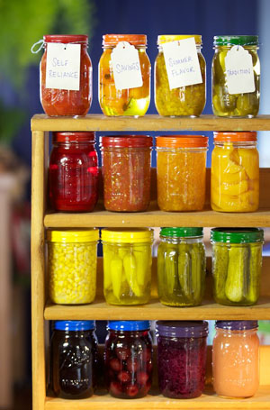

Why Do We Can?
We looked to our readers to find out why home canning is experiencing a modern revival. Their answer: Canning produces flavorful, high-quality food that saves money, builds self-reliance and creates lifelong memories. Check out some of their responses and get inspired to start stocking your pantry with home-canned food: Putting Food By The Old-Fashioned Way.

How Canning Works
The Science. The more you learn about food science, the more confident you’ll be in the kitchen. This is true for all kinds of cooking, but is especially helpful with food preservation. When you preserve food, you are either trying to freeze time or to encourage specific bacteria to proliferate and crowd out harmful bacteria. Canning is all about freezing time.
With the simplest method of canning — water bath canning — you fill jars with acidic food such as tomatoes, berries or cucumbers in vinegar, cover them with lids and boil them in an open pan of water until a seal forms under the lid. This action forces air out of the food and out of the jar and creates a vacuum in an acidic environment in which bacteria will not thrive.
Water bath canning can provide you with a number of delicious foods, including jams, jellies, whole tomatoes and pickles, and it’s a great place to start. A more advanced method is pressure canning. It requires a little more skill and some specialized equipment, but it will unlock a wide world of food and flavor options. If you want to put up the main ingredients for many meals, rather than just supporting players and condiments, you’ll need to get into pressure canning. To read about these methods in more detail, check out Learn to Can For Homegrown Flavor, Water Bath Canning and Pressure Canning: Explained, How to Can Using the Boiling Water Bath Method and How to Home Can: Raw-Packing vs. Hot-Packing.
The Equipment. You can get by without all of the fanciest canning-specific equipment, but you’ll need a few inexpensive basics, most of which are widely available used. A pot that holds enough water to cover whatever size jars you want to use with a little extra room for boiling water is key. Jar lifters are also extremely handy, and of course the jars are a necessity. If you’re serious about putting up a wide range of foods, you’ll also need a pressure canner. New ones can be pricey, but shop around for used options. Your local extension agency should be able to test old pressure canners to make sure they’re still functioning safely, and it’s a good idea to perform this test once each canning season.
The Ingredients. Use only the best, freshest and blemish-free produce, spices and herbs. Buy seasonally to find the best deals. Talk to farmers at farmers markets to see what they’ll have when, so that you can plan your canning time accordingly. Consider making bulk purchases with other canners in order to save even more money.
The Process. It’s Sunday morning and you’ve just collected your best specimens of perfectly ripe produce. Your clean jars, like ducks in a row, are lined up on the counter and your equipment is at the ready. The next few steps are easy. (1) Prep the ingredients. (2) Fill the jars. (3) Wipe the rims. (4) Screw on the lids and bands. (5) Boil. (6) Remove and cool until you hear the satisfying pop-pop-pops of the seals forming.
About Safety. There’s no reason to be afraid of canning, because ensuring safety is entirely possible. The basic rules of sanitized canning are simple and practical. That said, it’s important to follow those rules and to use pre-tested recipes. If you decide to experiment with canning recipes, you’ll need a pH meter, and you can learn more about that and all the other important canning concepts at the National Center for Home Food Preservation. See also: Are Old Canning Recipes Safe to Use?

Handy Canning Resources
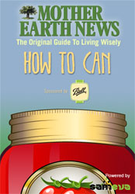
Have a smart phone or ipad? Download the free MOTHER EARTH NEWS How to Can App via Apple or Android. Our easy-to-use app takes the mystery out of both water bath and pressure canning with straightforward charts and instructions. The app will also get you set up with enough delicious, nutritious recipes to fill your pantry shelves with a rainbow of fruits and vegetables.
Consult the National Center for Home Food Preservation for more tested-and-approved canning recipes, plus official United States Department of Agriculture (USDA) safety and how-to information.
Your local cooperative extension agency may offer canning classes taught by certified food preservation instructors, and will certainly have other useful canning resources, to boot. Find the cooperative extension office nearest you by clicking on your state on this map.
If you think you might like canning with other folks, check PickYourOwn.org for a list of state-by-state community canning kitchens that make the work of canning easier and more fun by bringing motivated canners together.

Our Favorite Canning Books
Well-Preserved: Recipes and Techniques for Putting Up Small Batches of Seasonal Foods by Eugenia Bone is the book for gourmand canners who care more about stocking your pantry with variety than quantity and for urban canners who think it’s cool to have a larder in Soho.
Put ‘Em Up! A Comprehensive Home Preserving Guide for the Creative Cook by Sherri Brooks Vinton is an inspiring resource for new canners and for folks who like to have pretty pictures along with exceptionally interesting recipes.
The Big Book of Preserving the Harvest: 150 Recipes for Freezing, Canning, Drying, and Pickling Fruits and Vegetables by Carol W. Costenbader is for you if you’re looking for a comprehensive canning guide with straightforward, easy-to-understand instructions.
The Joy of Pickling: 250 Flavor-Packed Recipes for All Kinds of Produce from Garden or Market by Linda Ziedrich will delight anyone who loves exploring history and culinary traditions. Of course, pickle love is a must!

Canning Equipment
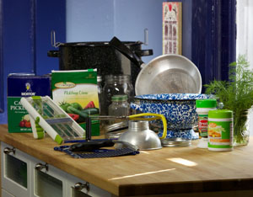
Order ingredients for jams, jellies, preserves and pickles;
plus canning jars, rings, lids and other equipment via
Ball, Fagor, Jarden, Kuhn Rikon, Lehman's and
Pressure Cooker Outlet.
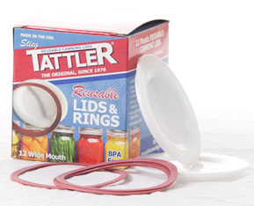
Try the nifty, reusable, BPA-free canning jar lids
from Tattler. (Then learn more about the dangers of BPA.)
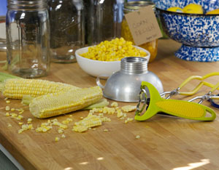
A delightful corn zipper by Kuhn Rikon
makes easy work of corn processing.
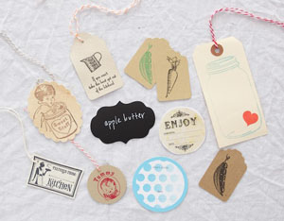
Decorate your jars with the creative labels, stamps and tags
handmade by the artisans on Etsy.com. We like the whimsical
and vintage decorations by Lazy Day Cottage, Let's Talk Chalk,
Papertivity, Pear Creek Cottage, River Dog Prints, Sincerely Sadie,
SugarSkull7 and Sweetpotatojack.
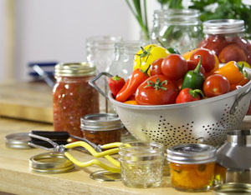

Water Bath Canning Recipes
- Apple Pie Filling
- Canned Tomatoes
- Canned Whole Tomatoes
- Corn Salsa
- Dilly Beans
- Ginger Peach Jam
- How to Can Peaches, the USDA Way
- How to Can Jam and Jelly, the USDA Way
- Pickled Beets
- Pickled Sweet Apple Cider Baby Beets
- Preserve Strawberries: Easy Recipes to Stretch Strawberry Season
- Raspberry Jam

Pressure Canning Recipes
- How to Can Beans, Snap and Italian Beans in Pieces, Baked Beans, and Beans With Tomato or Molasses Sauce
- How to Can Peas
- How to Can Potatoes, Sweet and White
- How to Can Asparagus: Spears and Pieces
- How to Can Beets: Whole, Cubed or Sliced
- How to Can Carrots: Sliced or Diced
- Canning Winter Squash and Pumpkins

Creative Canning-Inspired Goods
With the rise in popularity of home canning, you can now find a wide variety of canning-inspired household goods handmade by crafty artisans. We especially like these:
- Repurposed Mason Jar Chandeliers by LampGoods
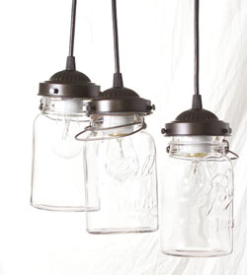
- Recipe Cards by Rethink Ink
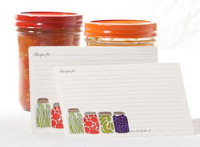
- Thank You Cards by DondaLee’s
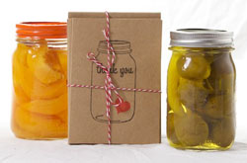
- Retrofit Soap and Lotion Jar Dispensers by Trash2Trish
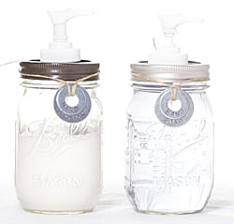
- Hand-printed Kitchen Towels by Oh, Little Rabbit
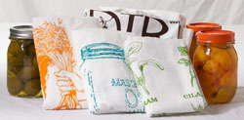
- Beautiful “Keep Canning” woodcut print by Old School Stationers
