Freezers
by Katherine Grossman
I keep two freezers.
One is mostly for meat and the other is for fruits, vegetables, bread and other assorted foods.
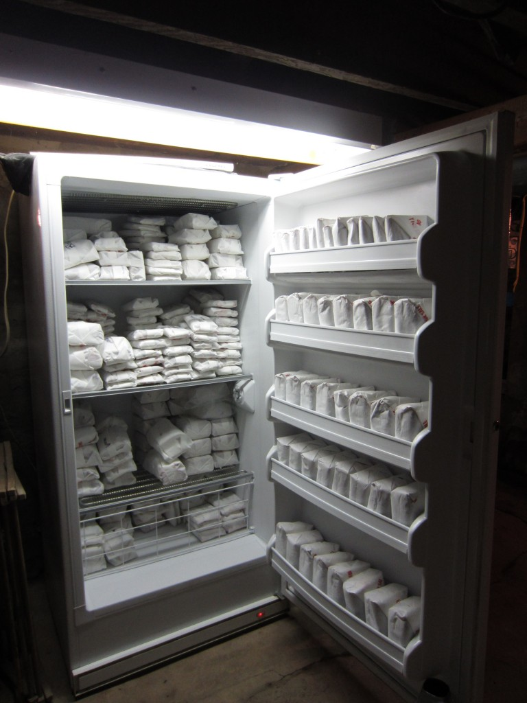
Upright Freezer With Meat
It may sound strange to you, but if I had to choose between owning a freezer or a refrigerator, I’d give up my refrigerator before I’d get rid of one of my freezers.
To my way of thinking a freezer is a much more practical electric appliance than a refrigerator. I can live very well with out a refrigerator, but not without a freezer.
Here’s why.
Most foods are best when consumed fresh.
In fact a pretty effective argument can be made for always eating as fresh as possible and to avoid overly processed foods with a long shelf life.
Many foods can be kept at room temperature for a few days to a week before any sign of spoilage begins.
Fresh eggs can sit out on a counter top and have a very long shelf life. Hard cheeses and breads do well as long as they are wrapped tight.
Potatoes, onions, squash, apples, oranges, celery, cabbage and many other common foods really never need refrigeration.
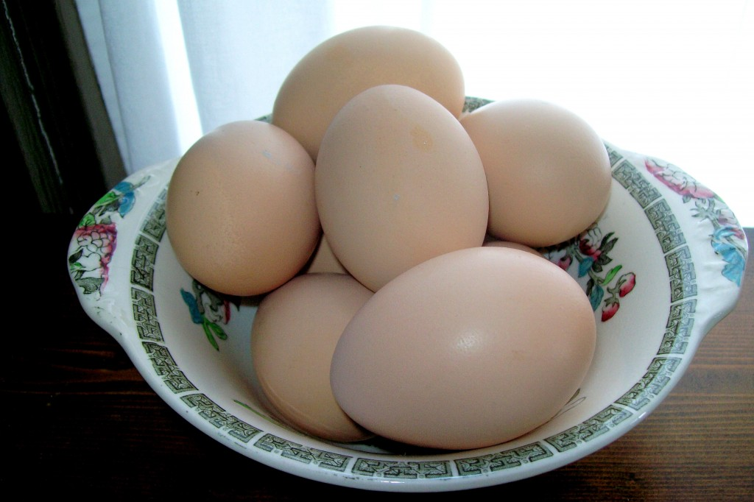
Spring Eggs
Dairy foods such as milk, yogurt, and soft cheese should be kept cool.Beer, fruit juice and soda pop are best served cold.
Happily those foods can easily be stored in a large cooler.
Meats and other foods from a freezer can be easily defrosted and consumed as needed.
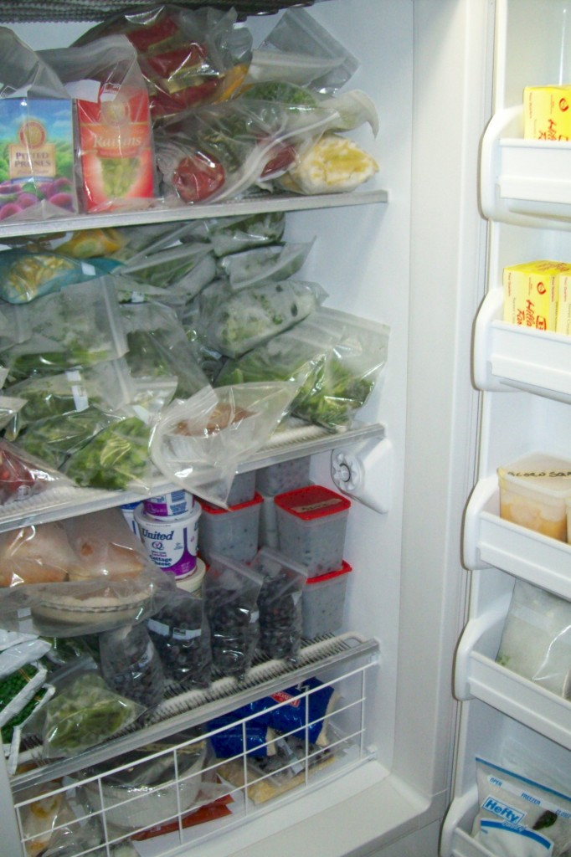
Upright Freezer In October
The way that the Old Order Amish here in my corner of Pennsylvania keep their dairy foods cold, is with ice. They use a cooler or an old refrigerator that doesn’t run.
The Amish who use a broken refrigerator will buy ice in town. The ice is put it into a large plastic dish pan or tub on the top shelf of the refrigerator and the food is placed on the lower shelves.
Depending upon the time of the year and how often the refrigerator door is opened, the ice is usually replaced every few days to once a week. During very hot weather the ice has to be replaced much more often.
Of course during the winter food can be kept in a cold pantry, in a cold attic, on a cold porch or in a cold box that is fitted to a window.
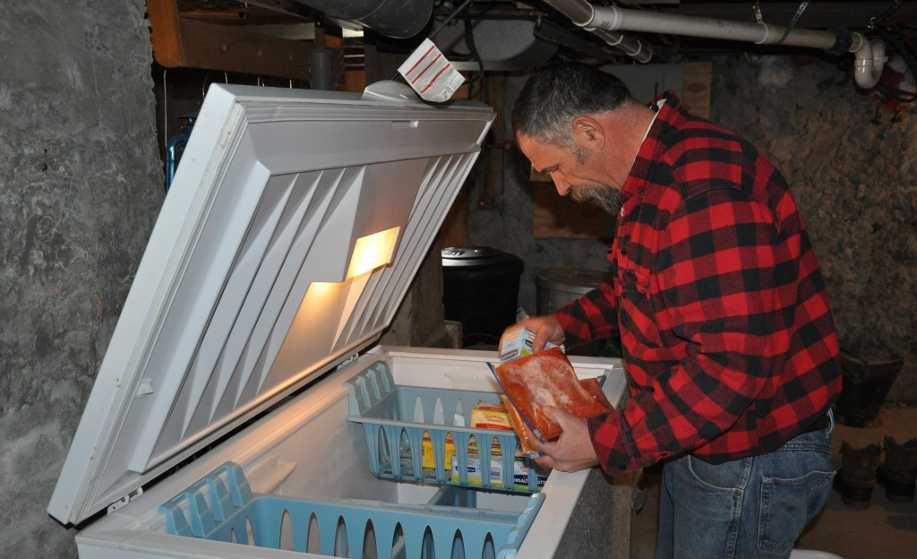
Removing Tomatoes & Butter From A Chest Freezer
When you have a freezer you can make the ice necessary to keep things cold. With ice you can keep your perishable food in a cooler or in an ice box.
I'm a food storage fanatic.
I always store at least one year's worth of food and supplies. Long-term food storage is best accomplished by stockpiling foods by at least two different methods. Canning and freezing are the two methods I most often employed.
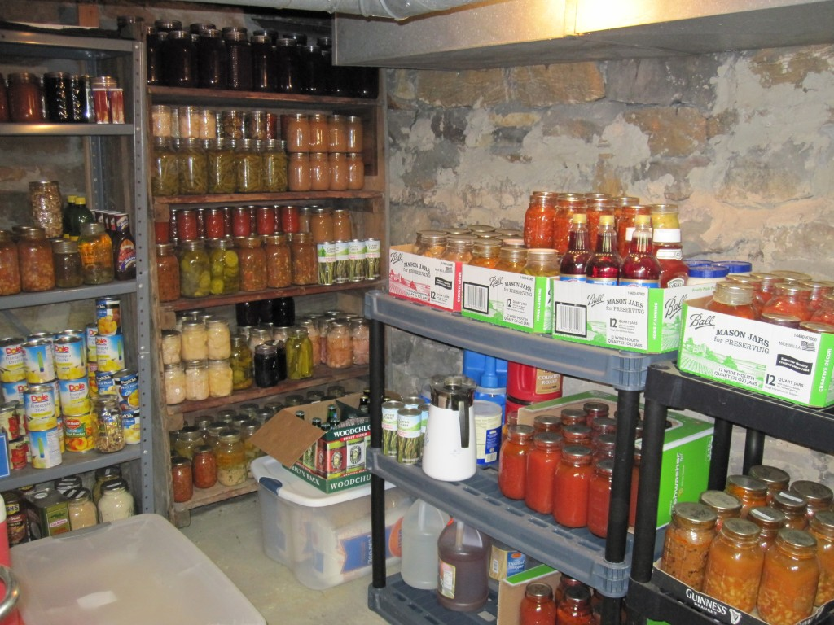
A Corner Of A Cool Cellar Pantry
A large freezer (or two in my case) allows for the long-term storage of food and preserves the taste and texture of many foods much better than canning. Some foods like broccoli, cabbage or egg-plant should only be frozen and never canned.
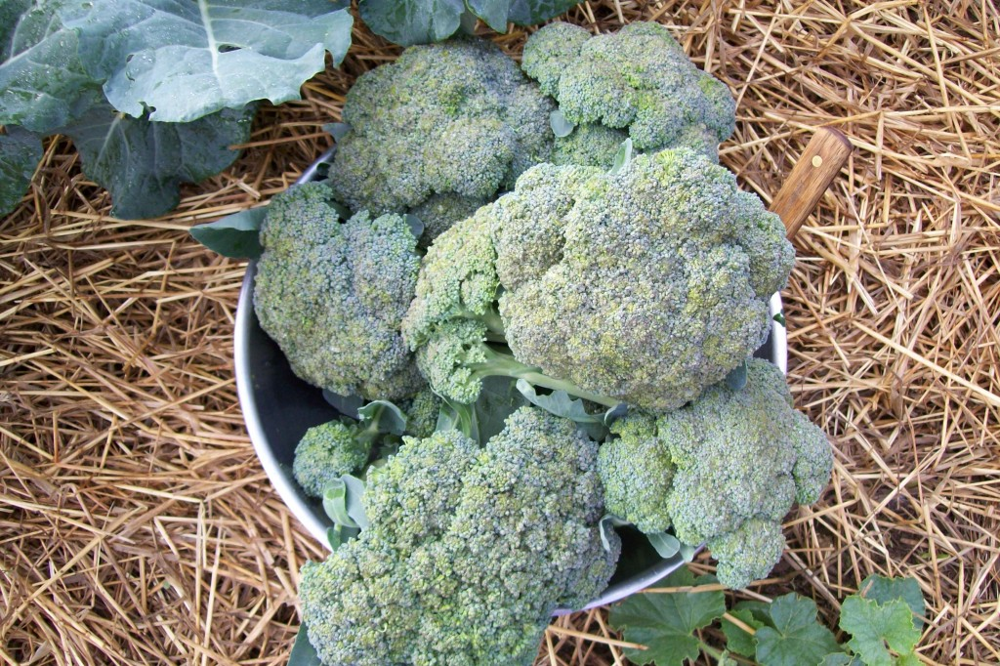
Fresh Cut Broccoli
A large freezer can be easily maintained during an electrical power outage with a generator and some common sense.
If for some reason a power outage should be weeks instead of days, most foods in my freezer can be canned in an orderly manner.
The foods that can only be frozen(like egg-plant or broccoli) will have to be eaten promptly or fed to pigs or chickens.
But that's not a real problem in the big scheme of things.
If I had to pick a freezer or a refrigerator – I’d pick the freezer every time.
If you ask me, a refrigerator is an expensive and overrated modern convenience that most people think of as a necessity. There are much cheaper ways to store milk, ketchup, onions, lunch meat and beer.
This the time of the year is when I begin to clean out and consolidate both my freezers.
Usually by the middle of March, one freezer is on its way to being empty and the other will be half way full.
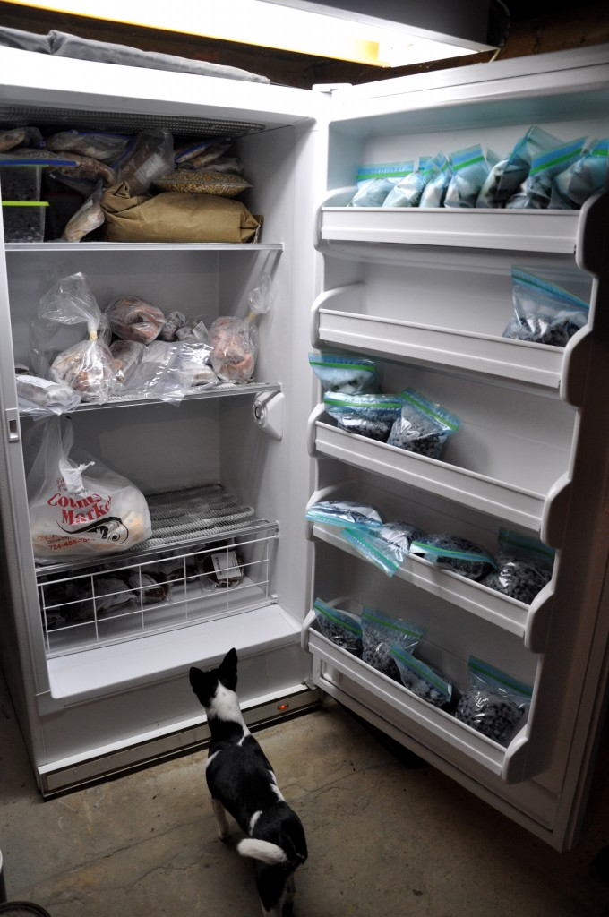
Helping Me Cleaning Out A Freezer
When I was cleaning out the meat freezer the other day I found two packages of old beef neck bones and one beef heart. I’ve lost my taste for beef heart and didn’t feel like cooking it for myself.
So I put the heart and the neck bones into a roasting pan, seasoned them with salt, pepper and garlic powder, and cooked them up for the dogs, cats, chickens and pigs.
It was a big mealtime hit with all the animals.
The pigs ate the beef heart and chewed all the meat off of the bones they were given.
When they were finished they threw the cleaned bones out into the aisle of the barn so the the dogs could have them.
And Lizzie has been burying bones in the yard for two whole days.
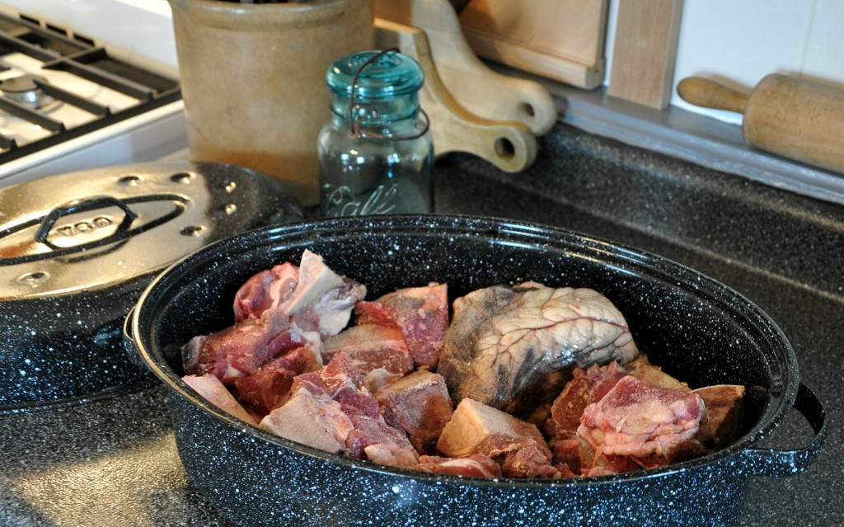
Beef Heart & Neck Bones In Roaster Pan

