Food Preservation Disasters
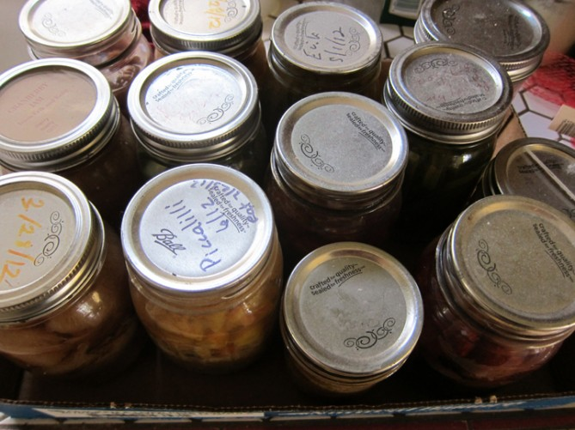
It’s ain’t 24/7 kittens and rainbows at the Root Simple compound. We do have our homesteading disasters. I was reminded of this after I emptied a box full of failed home preservation projects and contemplated a stinky trash can filled with a slurry of bad pickles and too-loose jams.
Of course you have to break a few eggs to make an omelet and, in the interest of learning from mistakes, I thought I’d review two lessons learned.
Not Using Tested Recipes
I vow to use tested recipes from trusted sources. Both for food safety reasons and culinary reasons, it’s a good idea to use trusted sources for home preservation projects. Some of the recipes I tried were from unfamiliar books and dubious websites. Some sources I’ve come to trust:
- The National Center for Home Food Preservation’s website.
- Kevin West’s book Saving the Season: A Cook’s Guide to Home Canning, Pickling, and Preserving.
Between those two sources I’ve got just about all the recipes I need.
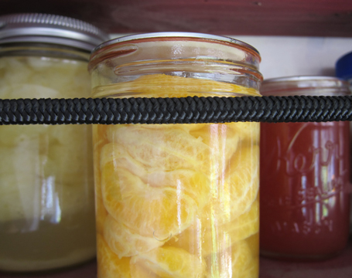
One Ring to rule them all
When you’re done processing jars and they’ve cooled down, remove the screw bands. Why?
- So you can clean underneath the band to prevent spoilage and bugs.
- The screw band can create a false seal.
- Leaving the screw bands on can cause corrosion.
That’s advice from our own blog and yet I failed, for some reason, to remove the bands on many of the jars I emptied. I found all three of the above problems as a result.

