Eating Acorns
by vickie
Let me preface this story to say that I am proud, very proud, to have Native American blood coursing through me. My great grandmother was full-blooded Osage. I grew up knowing this, but was never able to talk with my grandmother about her heritage. Why? Because grandma lived during a time when being American Indian was not so popular. She detested being called a “squaw”. When grandma and grandpa came to California from Missouri, they left most of their family ties, and stories, back at the old homestead. Too bad.
I have often thought that my interest in getting back to nature and living a simpler life may be, in part, because of my heritage. So, the other day when Ray and I were up on our future homestead working on the roof of the outhouse, I began to take note of all the acorns on the ground around us. Lots of acorns. In fact, one dropped right on my head!
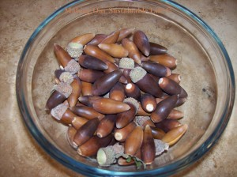
A bowl of some of the acorns I gathered. I think these are from a Black Oak, but I’m not sure.
But wait! Indians eat acorns! In fact, humans have survived on acorns for thousands of years – right? They are tree nuts, afterall, and nuts are nutritious! Perhaps while living up on the future homestead we could harvest the acorns, roast them and eat them as a nutritious snack. Right?
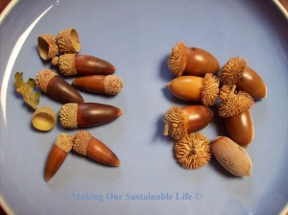
I think the acorns on the left are Black Oak and the ones on the Right are Canyon Live Oak, but I am not sure. I will have to do some more research to find out what kind of trees these came from.

I decided to gather some acorns to take back to our valley home and give it a try. I gathered acorns from two different trees. I really have no idea what kind of oak trees they are, but the one with the white trunk that keeps it’s leaves all year (Canyon Live Oak?) had fat acorns with velcro-like caps. The other tree (Black Oak?) had long, slender acorns with the more traditional looking cap.
I did a bit of research on the internet and found that the tannin in the acorn MUST be leached out before the nut can be consumed. Apparently, if one eats too much of the tannin, it can do a real number on your kidneys! Some acorns need more leaching than others because there is a different level of tannin in each species of oak. Centuries ago, the Maidu indians used to live in this area, and the preferred way for them to leach tannin out of acorns was to crack the acorn open to retrieve the meat, roughly crush the nut and then place the nuts in a fibrous basket in a flowing stream for several days. This was the most natural way to do it. Believe it or not, modern experimenters have found that you can do basically the same thing by placing roughly ground nut meats in a cloth bag into the water tank of your toilet. Not in the bowl, mind you! Every time the toilet is flushed, the rushing water simulates the flowing stream! Unfortunately, the tannin in the acorns are likely to stain the tank and the bowl, and since I hate to clean toilets, this was not an option for me.
So I tried the most sane method I found – successive boiling.
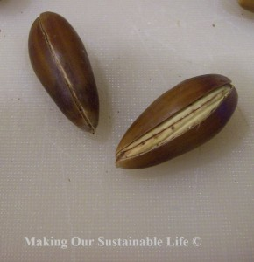
Getting the meat out of the acorn shell is not an easy task Ray’s vice and a sharp knife did the trick!
First, I had to get the meats out of the acorns – which is no easy feat! I wanted to try the long skinny acorns first. I tried pounding them and they just squished. Then I tried using a pair of pliers – no go. I figured that if I could somehow get through the shell in one spot, then I could chip off enough shell to get the nut meat out, but when I tried to cut the end off with a knife to make an access hole, I almost cut my finger off! Those things are slippery! Finally, I placed the acorn into my husband’s vice and with the acorn secured, cut a slit down the side with a very sharp knife. Voila! It took a while to do this. I have new respect for my ancestors! I didn’t bother with the smallest acorns – I have crafty plans for those!
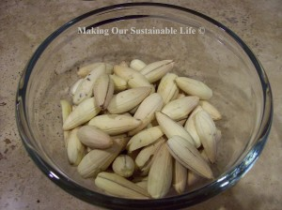
Acorn nut meats ready to be boiled to leach out the tannin.
Next, I got two pots of water boiling. ”Two?” you say. Yes, it takes several successive boilings to leach the tannin from the nut meats, and once you start the process the meats should never be put into cold water. This would close up the pores of the nut meats and prevent any further leaching. So, you boil the nut meats in one pot for about 15 minutes, then transfer them to the next pot, which is already boiling. While the nuts are boiling (and hopefully leaching) in the second pot, you have refreshed the water in the first pot and are heating it up to boiling. Continue in this fashion, tasting the nut meats after each change of boiling water, to see if they have leached enough.
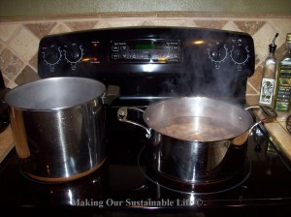
I used the two pot method to leach the tannin out of the acorn nut meats.
So, that’s what I did. I tried tasting a nut after the third pot of boiling water.
Holy. Mary. mother. of. Jesus. That was bad. Really bad. :(
I decided to try it again after the fifth boiling. Yuck. Ick. Pthooey. Then the sixth. Not good, but not horrible. The seventh was a bit better, but certainly not good yet. I decided to try one more pot of boiling water. Eight pots of boiling water for fifteen minutes each! These poor acorns had been through enough. Once the acorn nuts had cooled off, I tasted one. Meh. Not bad, but not really good either. Kinda bland. And mealy.

No, this is not a sampling of home made beer. This is the water I saved from each successive boiling, starting from the left (the lightest) all the way to the last (eighth) pot of boiling water – trying to leach the tannin out of the acorns
I saved the water from each pot because I wanted to see if the water would get lighter and lighter as the tannin leached out. No, the water actually got darker!
Now what to do with these bland, kind of mealy nuts? I decided to roast them with a little olive oil and sea salt. I roasted them for about 30 minutes at 350 degrees. The results – well, less than stellar, but palatable. I suppose if there came a time when food was scarce, I could always cook up a pot of acorns – eight times – and eat them. Besides, they are an excellent source of protein, and minerals! See this website for more information HERE
I decided to try the other acorns, the fatter ones, to see if they were any better. First, they were much easier to get the nut meats out! They actually cracked with a bit of muscle and my husband’s pliers. Well, that was refreshing. Then I started the same process that I had used with the other acorns, and tried them after the fourth boil (see, I learned not to try them too early). Whoa. I really have no words for how bad these were! Even after eight pots of boiling water, these acorns never leached enough tannin to be remotely palatable! No No No No No
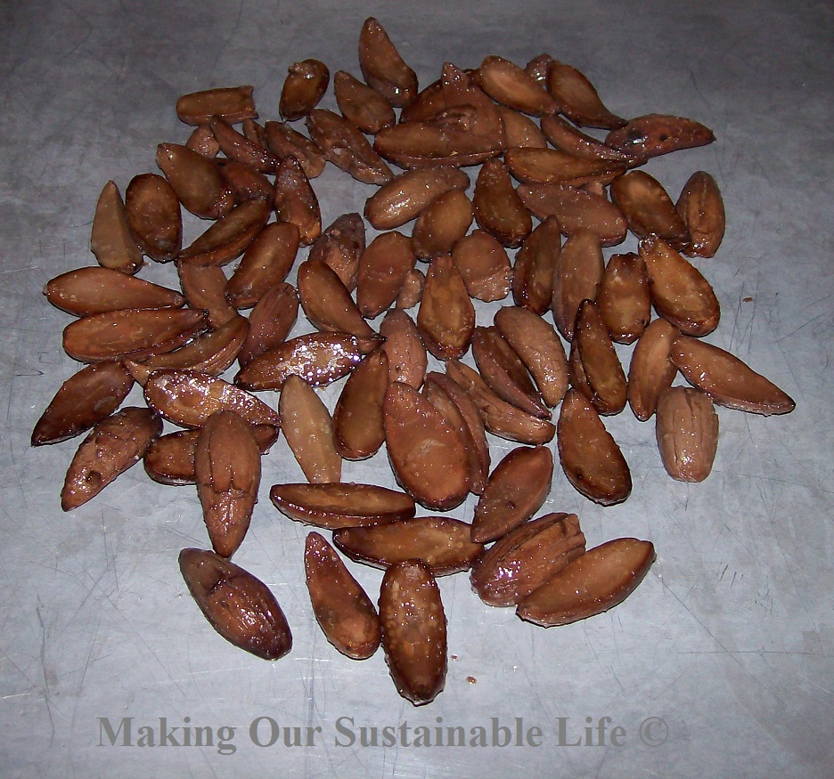
After boiling, I decided to roast them with a little olive oil and sea salt, just to see if I could jazz up the flavor a bit! Uh, no. Not really.
I think I will stick to using acorns for decorating and crafts!

