Dehydrating Strawberries!
by JKAdmin
We love the taste of Strawberries, but we can’t grow them all year and often the supermarket prices are cost prohibitive. So, when they do on sale we get as many as possible and store them away. Today we’re talking about dehydrating strawberries!
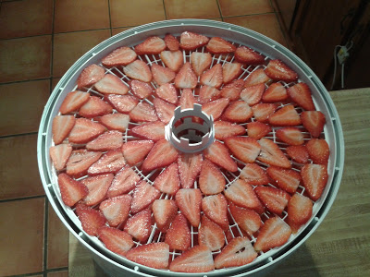
Here you can see our Nesco Food Dehydrator laden with sliced strawberries. We picked up 4 of the 16 oz (1 lb) clamshells at the supermarket. This resulted in a raw weight of 2.086 kg, and once we were done processing the berries a weight of 1.864kg. 1 cup of sliced strawberries weighs .0158kg
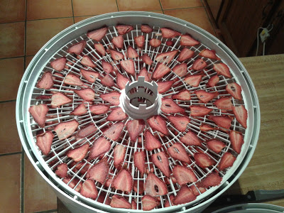
We ran the dehydrator at 115 degrees for ~18 hours. Here you can see the results!
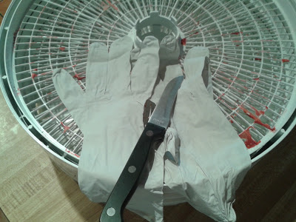
The trick to handling dehydrated foods is first ensure that you’re wearing nitrile or latex gloves. Despite how clean your hands may be, you have oils on them that can affect dehydrated foods. You’ll the knife there as well. I find it helps to pry up particularly stuck pieces from the dehydrator racks.

We put the resulting dehydrated strawberries into a quart wide-mouth ball jar. The dehydrated weight of the berries was 0.146kg. For short term storage they’re fine as is. for longer term storage you’ll want to add some oxygen absorbers to ensure they don’t go off.

