Datrex ration bars

lifeboat rations for use on land
by Pat Cascio
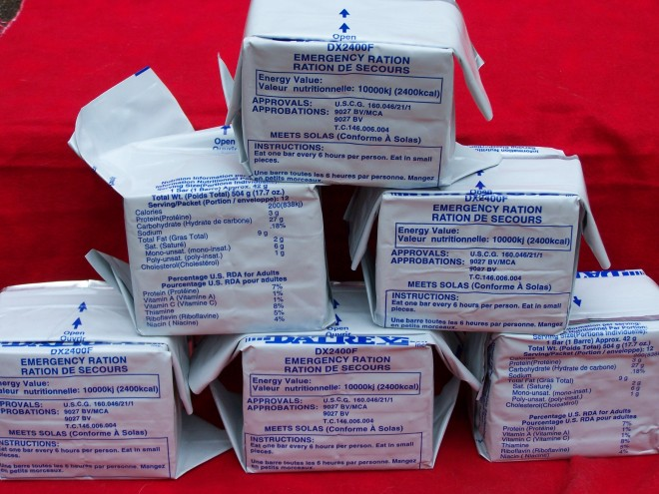
There are a lot of different opinions when it comes to “survival foods”. Many people believe that only freeze-dried or dehydrated foods are real survival goods. Others look at the military MREs (Meals, Ready to Eat) as the best survival foods. Still others think of a home supply of canned foods, that they canned themselves. Truth be told, any type of food can be considered a “survival food”, depending on what type of survival you’re talking about.
One often overlooked “survival” type food is from Datrex a company well-known in the marine industry for the numerous products they make for different types of survival purposes. One survival food I’m very familiar with is their Datrex White Ration bars. My wife and I keep a couple packages of these in each of our emergency boxes in our SUVs, as well as in our bug out bags.
For years, the Datrex White Ration bars were simply called “lifeboat rations” because many boaters keep these in their life rafts, along with Datrex Emergency Drinking Water, which comes in a white pliable container that’s easy to store and use. When it comes to a survival food, for on the go, when camping or hunting, or keeping in your vehicle, a lot of folks just don’t think about this handy-dandy survival food.
Let’s take a quick look at the Datrex White Ration bars. First of all they have a minimum 5-yr shelf life, but I believe they probably last much longer than that. However, the FDA requires some type of shelf life on foods, so 5 years is what they’re rated at.
These are high energy rations that are tabletized (more like a “bar” of candy) and ready to eat. They come sealed in white packaging that’s waterproof and keeps the bugs out. The rations are compact and not thirst provoking — the latter very important in a survival situation. Many survival foods, like freeze-dried, require that you add water to them before you can eat them, and they contain a lot of salt that promotes thirst.
Only natural ingredients are used (no preservatives or nuts), and the ingredients include wheat flour, vegetable shortening, granulated sugar, salt, water and coconut flavoring – that’s it! Te be quite honest, they taste extremely good. They also expand a bit in your stomach, giving you a full feeling — something that’s important in any survival situation.
A two-day supply of Datrex White Rations are vacuum sealed and weighs only 17.7 ounces. Each package contains 2,400 calories.
If you have school-aged children, it’s good to put a package of these rations in their backpacks. You never know when there might be an emergency, and your child can’t get home from school. This will afford them something to eat for two days. You might also include a couple packs of the Datrex emergency drinking water in their backpack as well.
I’ve mentioned in some of my articles that many times I’ve run across hunters who are lost out in the boonies and who have no food or water with them. I honestly don’t understand how anyone can go out in the wilderness with no food or water — it just doesn’t make any sense. I’ve also run across hunters who got their 4-wheel drive rigs stuck in the mud, and they had no food or water or cell phone reception. I’ve pulled more than one rig out of the mud because I carry a tow strap, and I’ve given more than a few hunters a bottle of water to drink, too. So, if you’re headed out hunting, you can toss a Datrex White Ration package in your truck or SUV, or in your backpack or fanny pack.
Now, would I want to live on Datrex White Ration bars for weeks on end? Absolutely not! Could I? Yeah, if I had to. While they are very tasty, and they can keep me alive, it’s not my first choice in a survival food. It would be like eating candy bars for weeks on end, without having anything else to eat — not a good situation. But if you’re lost while out hunting or hiking, or your child is stuck at school because they can’t get home due to flooding or a storm, the Datrex White Ration bars would taste good for several days. And they’re definitely better than going hungry.
The Datrex White Ration bars are fairly inexpensive. I’ve seen them for as little at $5.00 per package and as much as $9.00 per package. So shop around on the Internet for the best prices, just like you’d do for anything you’re looking to purchase. If you try some and you like them, it’s probably best to purchase a case — that’s 30-packages in a box. If you have a case, you can put a couple in each of your vehicles, as well as a couple packages in each of your kids’ backpacks that they carry to school, and keep some on-hand at home.
You really can’t find any excuse to not have some of this great-tasting survival food on-hand, in your vehicle or in your kids backpacks, and if you’re a hunter, shame on you if you don’t have some kind of food in your pack when out in the boonies.
- 
 