Cooking With

Food Storage
-----------------------------------------------------------------
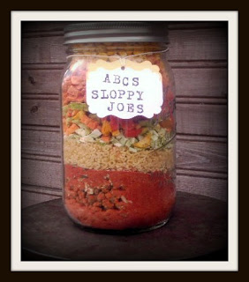

ABC's Sloppy Joe's Jar Meal
1 cup Thrive FD Hamburger
1/2 cup Thrive FD Tomatoes
1/2 Cup Thrive FD Bell peppers
1/2 cup Abc pasta
1/4 cup Thrive Celery
1/4 Cup Thrive Corn
1/4 cup Thrive Tomato power
4 Tablespoons Sloppy Joe Seasoning mix
Layer Ingredients in a one quart caning jar add oxygen absorber and label.

Sloppy Joe Seasoning mix

1 cup Dried Minced Onion
3 Tablespoons Green Pepper Flakes
4 teaspoons dried minced Garlic
2 teaspoon Dry Mustard
2 teaspoons Celery Seeds
2 teaspoons chill powder
mix well together and store in a air tight container.

To cook the Jar meal
Bring 4 cups of water to a boil turn off heat let sit for 10 to 15 mins to rehydrate turn heat back on and let Simmer for 20 to 25 mins.

Savory Onion Roll Jar Mix

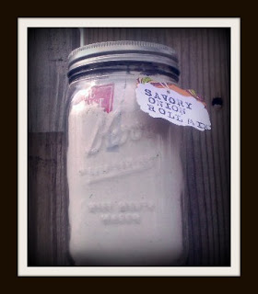

1/4 Cup dehydrated onions flakes
3 1/3 cup bread flour
2 Tablespoons granulated sugar
1 Tablespoon powdered milk
1 1/2 teaspoon salt
1/2 teaspoon dyed parsley
1 envelope yeast

place the onion flakes in a small Zip lock baggie and set aside.
Combine ingredients except for the yeast, in a one quart jar. add the baggie of onions and the yeast to the top of the mix and close the jar. vacuum seal and store the mix in a cool, dry place.

To Make
follow your bread machines instructions... add the Jar Mix, yeast and onions to 1 and 1/8 Cups of Water (105 to 110 degrees F) along with 1 tablespoon of vegetable oil... I put my machine on the dough cycle and when it is done I cut and shape them into rolls I get about 12 rolls out of this jar mix.
I let the rolls rise again and then brush the tops with butter and bake at 350 for about 20 t0 25 mins. Until golden brown...
If you do not have a bread machine use traditional instructions.

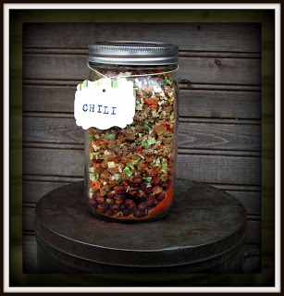

Chili Jar Meal

1 cup Thrive Instant Red Beans
1/2 cup Thrive Tomato Powder
1 cup Thrive Freezed Dried Cooked Ground Beef
1/2 cup Thrive Mixed Bell Peppers
1/2 cup Thrive Diced Freezed Dried Tomato Dices
1/4 cup Thrive Freezed Dried Thrive Chopped Onions
1/4 cup Thrive Freezed Dried Celerly
1 Tablespoon Beef Bulloin
1 Tablespoon Chili Seasoing Mix

In a one Quart Mason Jar add
1 cup red beans and the 1/2 cup tomato powder
shake the tomato powder down into the red beans.

In a med sized bowl add...
all other ingredients mix well...Add to quart jar put in your oxygen absorber and lable and date.

To Make
Put 8 cups of water in a pot and bring to a boil add the Chili Jar meal and simmer for 25-30

Chili Seasoning Mix

1/4 cup all-purpose flour
4 teaspoons chili powder
1 tablespoon crushed red pepper
1 tablespoon dried minced onion
1 tablespoon dried, minced garlic
2 teaspoons white sugar
2 teaspoons ground cumin
2 teaspoons dried parsley
2 teaspoons salt
1 teaspoon dried basil
1/4 teaspoon ground black pepper

Mix well together and store in a air tight container

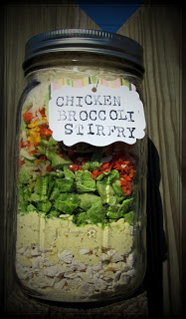

Chicken Broccoli Stir-Fry Jar Meal

1 cup of Thrive FD Chicken
1/3 cup Chicken stir-fry sauce mix
1 cup Thrive FD Dried Broccoli
1/4 cup Dehydrated Thrive Carrots
2 tablespoon Thrive Chopped Onions
1/2 Cup Thrive FD Green Peppers
1 Cup Thrive Instant Rice

Layer ingredients in a one quart jar in the order listed...Add oxygen absorber or vacuum seal the jar.

To Make
Add 4 cups of water to a skillet and bring to a boil. Add Jar meal and mix well turn off the heat and let rest for 10 minutes. After your rest period simmer for 20 to 25 minutes covered.

I like to add more sauce so I then take 1/3 cup of the chicken stir-fry sauce mix and add that to 1 1/4 cup water and mix and simmer until it thickens...stir into the jar meal when it is finished cooking.

Chicken Stir-Fry Seasoning Mix

1/4 cup chicken bouillon
3 Tablespoons corn starch
2 Tablespoons Sugar
2 Tablespoons dried minced Onion
2 teaspoons dried Parsley
1/2 teaspoon Ground Ginger
1/4 teaspoon Crushed Dried Red Pepper flakes

To make the Sauce
1/3 cup stir-fry seasoning mix
1 1/4 cup water

In a sauce pan add water and sauce mix stir over low heat until sauce thickens.

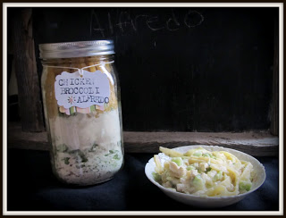

Chicken Broccoli Alfredo

1 cup of freeze dried Chicken
1 cup of freeze dried Broccoli
1/3 cup Basic Sauce Mix
1/4 cup Parmesan dry cheese
1/4 Ramano dry cheese
3 Tablespoons Dry Sour Cream Powder
1/4 teaspoon Pepper
1 1/2 cups Broken up Fettuccine Noodles

In a one Quart Jar layer Chicken,Broccoli add basic sauce mix and shake it down do the same with the cheeses,sour cream powder and pepper. Shake it down into the jar so there are room for the noodles. Add Noodles. With a paper towel or a dry dish towel wipe off the rim of the jar and add a oxygen absorber. place lid on jar and store in a cool dry place.

To Make your jar meal...In a skillet add four cups of hot water add your jar meal and stir together well let set for 10 minutes. Bring it to a boil then reduce heat to low cover and let simmer for 20 to 25 minutes until noodles are tender.

Alfredo Sauce Mix

1/3 cup Basic Sauce Mix (recipe for that is below)
1/4 cup Parmesan dry Cheese
1/4 cup Ramano dry Cheese
3 Tablespoons Dry Sour Cream Powder
1/4 teaspoon Pepper

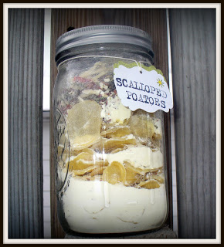

Scalloped Potatoes Jar Meal

3 cups dehydrated Potatoes
1/4 Cup of dehydrated bell peppers
6 Tbsp Basic Sauce Mix
1/3 cup Nonfat Dry Milk
3 Tablespoons Dry butter powder
2 Tablespoons Dehydrated Onions

Place these ingredients into a one quart jar, add Oxygen absorber
Place lid on jar and store in a cool dry place until ready to use.

To Make
Remove Oxygen absorber and Pour the Scalloped potatoes Jar meal into a medium size ungreased casserole add 2 3/4 cups of boiling water, Mix well Bake at 400 degrees F for 30 to 35 minutes
or until tender.

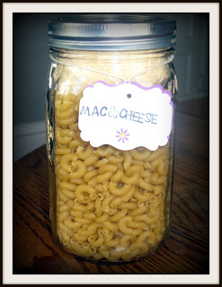

Mac & Cheese Jar Meal
1/3 cup Basic Sauce Mix
1/2 Cup Thrive Cheese Blend Powder
2 Tablespoons Thrive Dehydrated Butter Powder
1/8 teaspoon Pepper
2 1/4 cup of elbow macaroni Or small pasta shells
1 1/4 Cup of Water

In a 1 quart mason jar add 2 1/4 cups pasta, set aside.

In a mixing bowl mix together well the basic sauce mix,cheese blend powder,dehydrated butter and the pepper. Place mixture in a baggie and add to the top of the 1 quart mason jar add your oxygen absorber and vacuum seal the jar and label.

To make the meal cook remove the baggie and oxygen absorber, toss the oxygen absorber in the trash.
Boil the pasta until tender and drain. In a small sauce pan add 1 1/4 cups water and bring to a boil add the sauce mix and whisk over med heat until thickened pour over pasta.

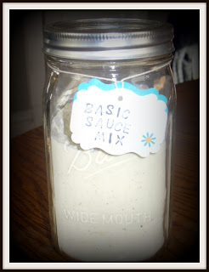

Basic Sauce Mix

2 Cups Powder Non-Fat Dry Milk
3/4 cups Corn Starch
1/4 Cup Chicken Bullion Powder
2 Tablespoons Dry Onion Flakes
2 teaspoons Italian Seasoning

Mix well together in a medium sized bowl.
Store in a mason jar and label.

Minestrone Jar Meal



In A Quart Jar Layer

1 Cup Orzo (or tiny pasta)
1/3 Cup Instant FD Red or Black Beans
1/3 Cup FD Green Beans
2/3 Cup FD Ground Beef
¼ Cup FD Spinach
1/8 Cup Thrive Mixed Red/Green Peppers
2 Tsp Italian Seasoning
1 Tsp Garlic powder
¼ Cup FD Celery
1/8 Cup FD Sweet Onion
¼ Cup FD Sweet Corn

Directions For Making
Bring to simmer in a 2+ quart pot :
4 Cups of chicken (or vegetable) broth
A splash of Olive Oil.
One (160z) Can diced tomatoes

Optional Ingredients
Add 8 Leaves Fresh cut Basil

Add all ingredients from Jar. Stir Often. As soup thickens, stir in additional chicken (or vegetable) broth until desired thickness. Cover between stirrings. Once orzo or pasta is tender, soup is ready to serve.

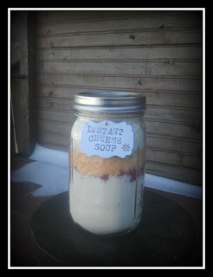

Instant Cheese Soup

2 Cups Instant Coffee Creamer
1/2 Cup Ham TVP
1/2 Cup Thrive Cheese Blend
1 Tablespoon Dried Parsley Flakes
1 Tablespoon Chicken Bullion Granules
1 Tablespoon Thrive Dehydrated Onions
1/2 teaspoon Pepper
2 Cups (approximately) Of Instant Potato Flakes

Layer ingredients in the order given in a one quart glass jar. Use a spoon to pack each layer in place before adding the next ingredient. Pack instant potato flakes tightly, right to the top of the jar.

To Make: Empty Cheese Soup mix into a soup tureen or serving bowl. Stir in 5 cups of boiling water. Allow to stand for five minutes and stir well.

Add 1 cup of re-hydrated broccoli or Cauliflower if you would like.

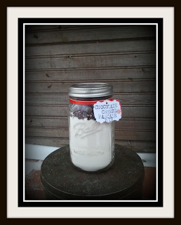

Chocolate Cherry Pancakes Mix in a Jar recipe

2 cups all-purpose flour
1/3 cup granulated sugar
4 1/2 teaspoons baking powder
1/2 teaspoon baking soda
1/2 teaspoon salt
1 cup dried cherries
2/3 cup semisweet chocolate chips
Stir flour, sugar, baking powder, baking soda and salt together in mixing bowl. Transfer flour mixture to 1-quart wide-mouth jar. Add cherries, then chocolate. Seal Jar. Decorate jar and attach gift tag with the following instructions:

Makes 20 to 24 pancakes.
2 eggs, beaten
1/4 cup (1/2 stick) butter, melted
Contents of Chocolate Cherry Pancakes Mix jar
1 1/2 to 2 cups milk
Combine eggs and melted butter in large bowl. Add contents of jar. Stir until well blended. Add 1 1/2 cups milk. Stir until dry ingredients are moistened. Add additional milk if thinner pancakes are desired.
Heat griddle or large nonstick skillet until a drop of water dropped on surface sizzles.pour batter onto hot griddle 1/4 cup at a time. Cook pancakes until golden on both sides.

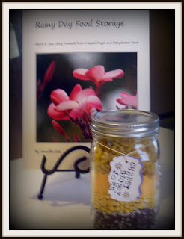

Cheesy Sloppy Joe Hot Dish

1 1/2 Cups Sloppy Joe TVP
2 Tablespoons Chopped Dehydrated Onions
1/2 Cup Freeze Dried Corn
1/2 Cup Thrive Cheese Blend
1/2 to 1 Cup Elbow Macaroni Noodles
4 Cups Water
Layer all ingredients in a wide mouth quart sized Jar.
To Store : Add oxygen absorber
Cooking Instructions: Put 4 cups of water in a pot or skillet and bring to a boil add contents of the jar meal stir well cover and simmer for about 20 to 25 Minutes until noodles are tender.

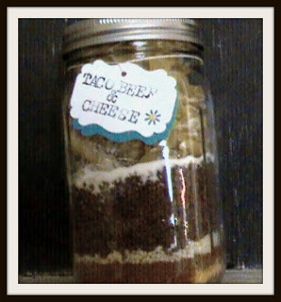

Taco Beef & Cheese
In a one quart wide mouth Jar layer,
½ Cup Powder Cheese Blend
4 Tablespoon Taco Seasoning
¼ Cup Dehydrated Onions
2 Tablespoon Powder Milk
Fill the rest of the Jar with Egg Noodles.
Layer all ingredients in a wide mouth quart sized Jar.

To store: Add oxygen absorber and or vacuum seal.

Cooking Instructions: Brown 1 pound of Ground Beef and
drain off fat...add 3 cups of water to the meat and bring
to a boil. Now add the Jar mix of the Beef Taco & Cheese.
and simmer for 20 Minutes until the noodles are cooked.

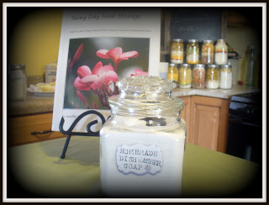

Homemade Dishwasher Soap

1 cup 20 Mule Team Borax
1 cup Arm & Hammer Super Washing Soda
1/2 cup Kosher Salt
1/2 cup Citric Acid or 4 envelopes of Lemon or Lemon Lime kool-Aid.

Mix all ingredients well and store in a large labeled container.

To Use: Add one Tablespoon to your dishwasher per load.

Make Your Own Homemade Laundry Soap

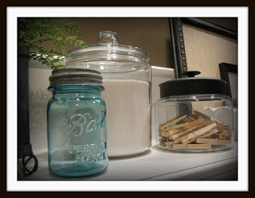

2 cups of Zote Soap Or
Fels-Naptha soap or Ivory Soap (finely Graded)
1 cups Arm & Hammer Super Washing Soda
1 cup 20 Mule Team Borax
1/4 cup Oxy-Clean
Finely Grated the bar of soap
add 2 cups of the grated soap to the washing soda,borax and the oxy-clean. add to a food processor or blender and blend in to a fine powder.
Store in a container
To use add 1 to 2 teaspoons of washing powder to your load of wash.

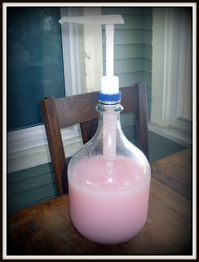

Make Your Own Homemade Fabric Softener

6 cups of HOT water
1 1/2 cup White Vinegar
2 cups Hair Conditioner

Any scent of your choice such as Suave Lavender, Ocean Breeze Etc.
Mix Conditioner & HOT water well, until conditioner is dissolved completely. Add the vinegar and mix well.
Store in a large container.
To use:
Pour into a Downy ball up to the medium fill line or pour into the fabric softer dispenser in your washing machine.

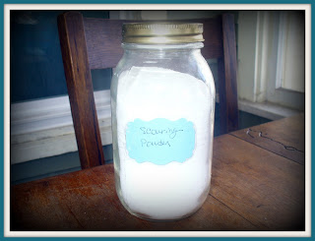

Make Your Own Home Made Scouring powder

2 cups Baking Soda
1 Cup of Borax
1 Cup Kosher Salt

To Make
Mix all Ingredients well and store in a air tight container...Poke holes in the lid to make a shaker.

Cheese ReconstitutioN Recipe
Todd C. Leonard, CEC | Serves: 8 | Prep Time: 4 min
Ingredients
2 cups THRIVE Shredded Colby Cheese (FD)
½ cup cold water
Directions
1. Place the THRIVE cheese in a glass bowl.
2. With a spoon, lightly stir cheese while drizzling cold water over the cheese. Stir continuously until all the water is incorporated into the cheese.
3. Water should just barely start to collect on the bottom of the glass bowl. This is a sign that the cheese has absorbed enough water.
4. Place cheese in a zip lock bag and store in refrigerator overnight or for several hours before use.
Note: Cheese will last up to 8 days in refrigerator. Continue to reconstitute cheese, as you need it, following these simple steps. Adjust quantity for individual needs.
Serving Ideas
Enjoy THRIVE Cheese in your nachos, quesadillas, lasagna, pastas, salads, sandwiches, and many more wonderful cheesy and delicious recipes!

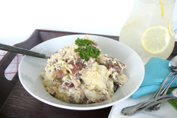

Summer Potato Salad
Ingredients
11⁄2 cups THRIVE Potato Dices (FD)
1⁄2 cup THRIVE Diced Ham (FD)
1⁄2 cup THRIVE Celery (FD)
1⁄2 cup THRIVE Chopped Onions (FD)
1⁄2 cup mayonnaise
11⁄2 teaspoons Dijon mustard
THRIVE Iodized Salt and pepper to taste
green onions, chopped, optional
Directions:
1. In a medium-sized bowl add potato dices, ham, celery, and onion and cover with water. Let sit for 5-10 minutes or until ingredients are rehydrated and soft. Drain.
2. In a large mixing bowl add all ingredients with mayonnaise and Dijon mustard. Stir until combined. Season generously with salt and pepper to taste. Garnish with chopped green onions, if desired.
3. Chill for at least 1 hour before serving.

Blueberry Peach Cobbler
Ingredients
1⁄2 cup butter, softened
3⁄4 cup THRIVE White Sugar, divided
zest of 1 lemon
2 THRIVE Whole Eggs, rehydrated
(2 tablespoons powder + 1⁄4 cup water)
1⁄2 teaspoon vanilla extract
1 cup THRIVE White Flour
1 teaspoon THRIVE Baking Powder
1⁄2 teaspoon THRIVE Iodized Salt
1 cup THRIVE Peach Slices (FD)
1 cup THRIVE Blueberries (FD)
1 cup THRIVE Peach Drink, prepared
1⁄2 teaspoon cinnamon
Directions:
1. In a medium-sized bowl, cover peach slices and blueberries with peach drink or warm water. Let sit 5-10 minutes until softened and rehydrated.
2. Preheat oven to 350˚F.
3. In a medium-sized mixing bowl, mix together butter and ½ cup sugar. Add lemon zest, eggs, and vanilla extract.
4. In another bowl, sift together the flour, baking powder, and salt; add to the butter mixture, stirring to incorporate. Spread half of the batter on the bottom of a greased 8 x 8 x 2 inch baking dish.
5. Top the batter in the pan with the rehydrated peaches and blueberries, along with 1⁄2 of the hydrating liquid (about). Carefully spread the remaining batter over the top of the peaches. Sprinkle cinnamon and remaining sugar over the top.
6. Bake for 38-45 minutes, or until golden brown.
Serve hot with ice cream.
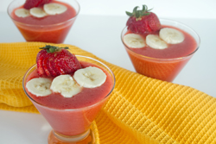
Strawberry Banana Freeze
Ingredients
1⁄2 cup THRIVE Orange Drink, rehydrated (1 tablespoon powder + 1⁄2 cup water)
11⁄2 cups cold water
1⁄2 cup THRIVE Pineapple Chunks (FD)
1 cup THRIVE Strawberries (FD)
1 cup THRIVE Banana Slices (FD)
1 cup ice cubes
Directions:
1. Combine the orange drink, water, pineapple, strawberries,
bananas, and ice in a blender and process until smooth.
Refrigerate until cold.
Rich and Creamy Broccoli & Cauliflower Bake
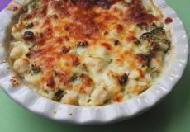

by Natalie Riley on Oct 20 2009

This cheesy dish is chock-full of vegetable goodness
Prep Time
30 minutes
Yield 6 servings
Ingredients
- 1 T butter
- 1 T thrive white flour or whole wheat flour
- 1 c thrive powdered milk, prepared
- 1 c mozzarella cheese, divided
- 3 T grated Parmesan cheese
- 1⁄2 t nutmeg
- 1⁄2 t thrive iodized salt
- 1 1⁄2 c thrive freeze dried broccoli
- 1 1⁄2 c thrive freeze dried cauliflower
- 2 T heavy cream

Instructions
In a medium size bowl, cover broccoli and cauliflower with warm water. Let sit 5-10 minutes until softened and re hydrated. Drain. Repeat same process for THRIVE freeze dried cheese if necessary.
Preheat oven to 350 degrees F.
Meanwhile, melt butter in a medium saucepan. Whisk in flour and cook for one minute. Next, whisk in prepared milk, stirring quickly to avoid lumps. Continue stirring over heat while sauce thickens for about 2-3 minutes.
Add cream, nutmeg, salt, and 2/3 cup of mozzarella cheese. Stir to combine and remove from heat.
Add well-drained broccoli and cauliflower. Gently stir together, adding salt and pepper to taste.
Place mixture in a greased baking dish or a small pie plate. Top with remaining mozzarella and the Parmesan cheese. Bake for about 20 minutes or until hot, bubbly, and golden brown.
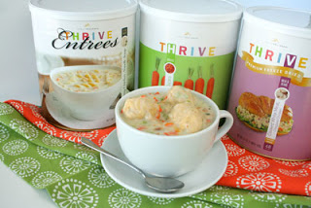
Creamy Chicken Noodle Soup with Dumplings

2 | tablespoons butter | 1 Bring 6 cups water to a boil. Add butter, carrots, celery, and chicken in addition to 2 cups soup mix. Stir until combined and simmer for 5-10 minutes.  For Dumplings:  1 In a large bowl combine flour, baking powder, cornmeal, sugar, and salt. Add the prepared milk and mix just until combined; mixture should be thick. Drop 12 tablespoons of dumpling mixture into simmering soup. Cover and simmer for another 12 minutes.
1/2 | cup THRIVE Carrot Dices
1/2 | cup THRIVE Celery (FD)
2 | cups THRIVE Creamy Chicken Noodle Soup Mix
1 | cup THRIVE Chopped Chicken (FD)
1 | cup THRIVE White Flour
1/2 | cup THRIVE Whole Wheat Flour
2 | teaspoons THRIVE Baking Powder
1/2 | cup THRIVE Cornmeal
1 | tablespoon THRIVE White Sugar
1 | teaspoon THRIVE Iodized Salt
3/4 | cup THRIVE Instant Milk, rehydrated (4 1/2 tablespoons powder + 3/4 cup water)

