Coffee in a Post Collapse Economy
Coffee is not really necessary for human survival, but some of us feel like it is. Unfortunately coffee is only grown in tropical regions that are above 3000 feet elevation, so unless you live in one of these regions you will not be growing your own coffee. So storing coffee, or coming up with a substitute, is the only option. The question is how do you store coffee, how long can you store it, and how do you process it? 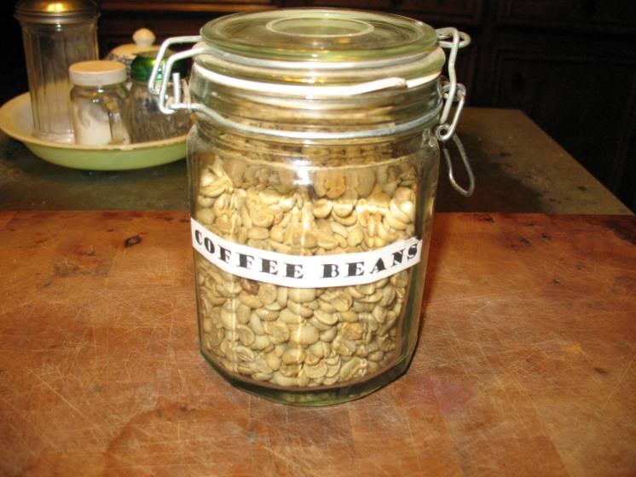
First of all, coffee does not store well. Moisture and oxygen are the main enemies of coffee. Once coffee has been roasted it begins to deteriorate immediately. I am no coffee expert, but I am told that roasting releases the oils in coffee and the beans begin to turn rancid when they are exposed to oxygen. If the coffee is ground, this process happens even faster. Now the question is, what is bad coffee? I and the coffee connoisseurs have a little difference of opinion on this. The gourmet will tell you that you might as well drink mud as to drink coffee made from pre-ground beans. Well, I don’t pay $4.00 a cup for my coffee, and I have even been known to drink left-over coffee that was made the night before. So if you are a coffee connoisseur my opinion is probably not worth much to you, but I have drunk many a cup of coffee made from ground coffee that came from a can opened three or four months earlier. It maybe wasn’t the best quality cup of coffee, but I lived to tell about it.
I will say that if you are going to store coffee long-term, the order of preference is:
best – whole green coffee beans
next best – vacuum packed roasted whole coffee beans
worst – vacuum sealed roasted ground coffee
You can buy green coffee beans over the inter-net for around $7.00 US per pound. If you buy green beans you will need to repack them into smaller storage bags, add oxygen absorbers and seal the bags in a food grade plastic bucket. Coffee stored this way will keep, I am told, for two to five years. I have not stored any coffee for this long, but it sounds reasonable to me.
If you are storing whole roasted or ground coffee, leave it in the vacuum sealed bags, and let your taste buds be your guide. What one person thinks is awful coffee, another person may find perfectly good.
If you are storing green coffee beans you will have to roast and grind the beans before you make a cup of coffee. There is no mystery attached to roasting coffee beans. Just put the beans in an iron skillet over medium heat and keep stirring them until they change color.
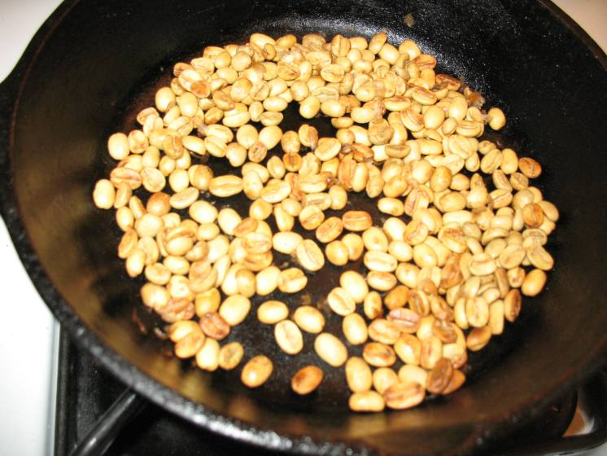
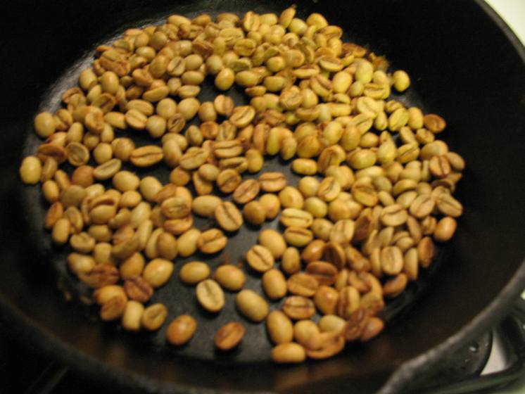
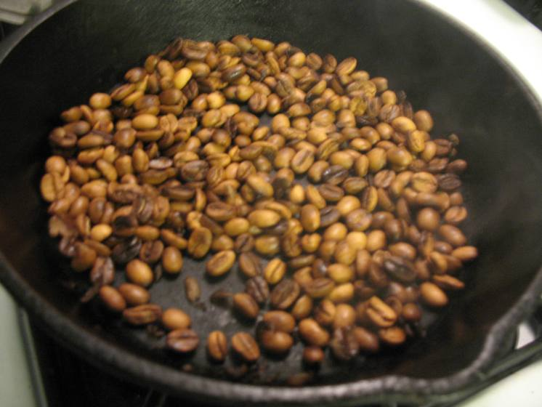
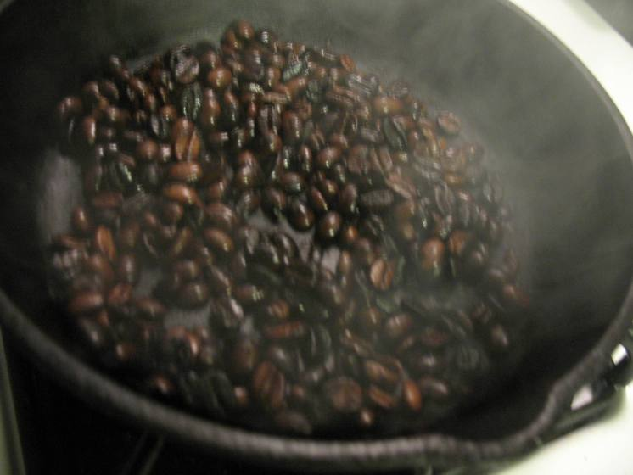They will go from yellow-green, to tan, to brown, and eventually to black. Just roast them until they are brown or black depending on whether you like light roast or dark roast coffee. Don’t be worried if they smoke a little. When they are the color that you like, let them cool and then blow off the chaff. You are now ready to grind the beans. 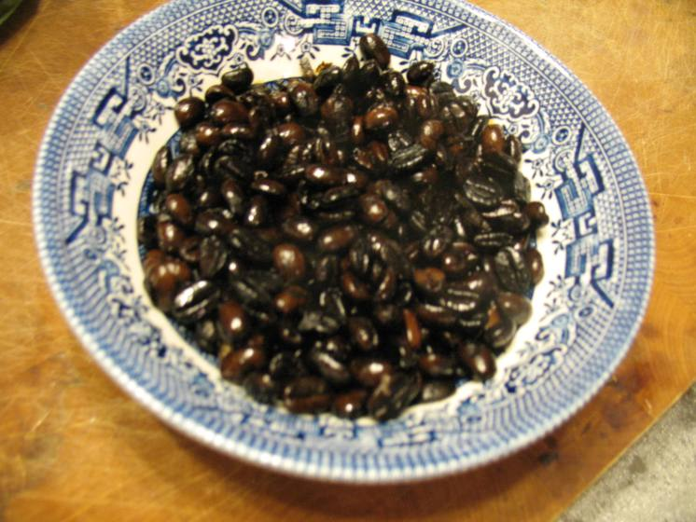
You can grind coffee beans in your grain mill but this is kind of a hassle unless you are grinding a lot. I have a small grinder that is perfect for making a cup or two of coffee at a time so this is what I usually use. If you are using pre-roasted beans you will, of course, need to grind them also. 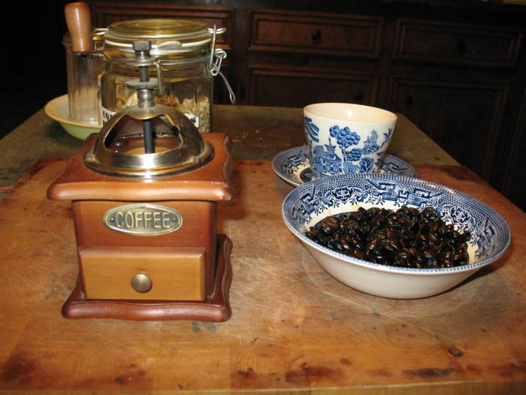
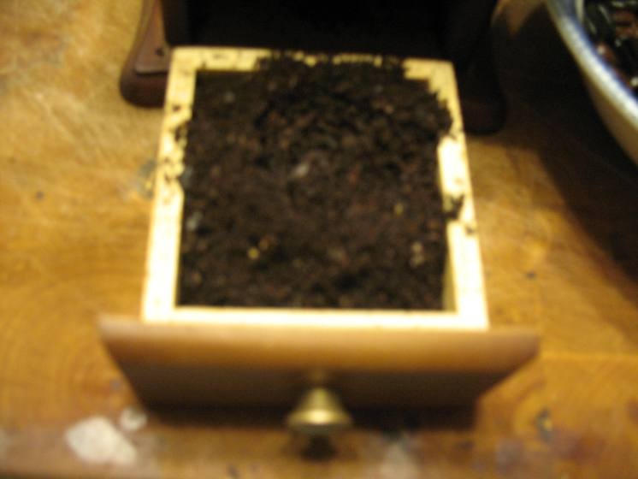
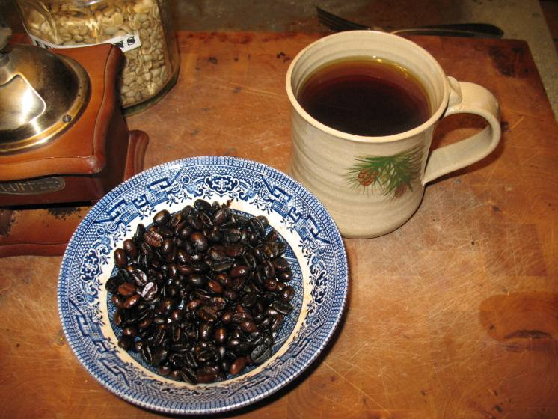I was on a campout one time and a friend of mine named Doyle said that he would make us a pot of coffee. He pulled out a bag of green coffee beans and put some beans in a skillet to roast. Immediately he started digging through his pack, pulling out socks, and sniffing them. The rest of us wondered what the heck he was doing. When he found a sock that passed his smell test, he poured the coffee beans out of the skillet and into the sock. He then placed the sock of coffee beans on a stump and started smacking it will the hammer end of his hatchet. When the beans were sufficiently crushed he dumped them into a coffee pot and proceeded to make a very good batch of coffee. Every campout after that we always called on Doyle to make us a nice, fresh pot of “toe-jam coffee.”

