10 Can Rotation for $0
by: Bev Sandlin
Bob brought home canned pop for Thanksgiving in those cardboard 12 packs. Well, after everyone left I got to thinking that if pop cans can rotate in those, why can’t veggie and soup cans do the same thing?
Well, yeah, with one you can fit in five cans, but you need access from the back. So then I got to thinking, what about two stacked?
Lots of duct tape, repeated cutting, and some experimenting later and I now have a 10 can rotation system for $0 spent - if you don’t count the pop, these are just leftover cardboard.
Approximate Dimensions: 16″ L 11″ H 5″ wide
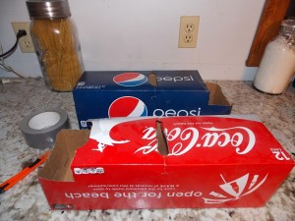
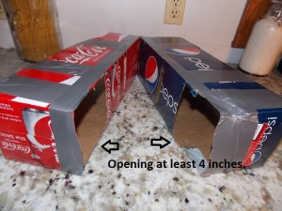
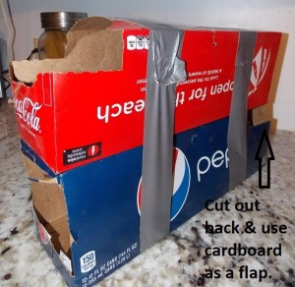
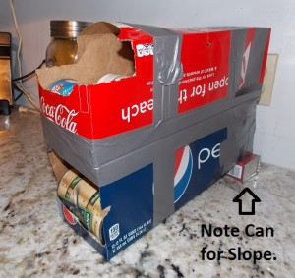
Not pretty! But I figure next time I get to Wally World I will buy some 99 cent spray paint, give them a few coats and they will be acceptable. If you know anyone who drinks pop or beer, these should be pretty easy to come by. I know I’m going to start asking around as the size works well with my plastic shelving units and the price is right!
* These could easily be sized to fit different can sizes just by cutting and taping to the size you desire. Also to fit your cupboards just by shortening them, if you have the height.
* I’m thinking that next time I do this I will use Modpodge (white glue) to glue the boxes together and perhaps glue two pieces of cardboard on the outsides to stiffen them. Then if I wanted, I could have a nice paint job or decoupage some brown paper bags or wrapping paper onto them for added durability and attractiveness.

