Bug Out Meals Ready To Eat
By Creek
I recently received a package in the mail that I thought was worthy of sharing. I’ve got to give credit to Dutch from Texas for this awesome DIY Bug Out Meal idea! When I opened the box I found a couple homemade vacuum sealed food kits. UPS delivers here right before lunch so it was hard for me not to cut them open and gorge myself right then and there. The enclosed letter explained a really cool concept: DIY At Home Bug Out Meals Ready To Eat Kits.
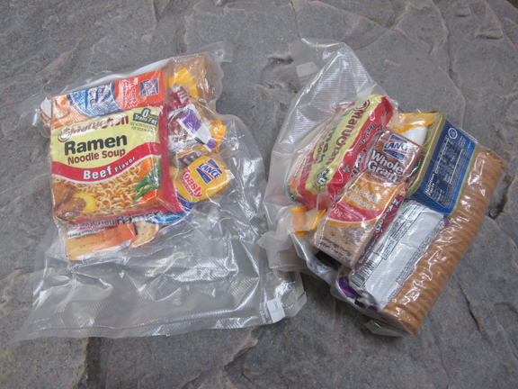

My Opinion About Bug Out Meals
As many of you know, I am a huge fan of simple, “Open & Eat” Bug Out Meals. I like the idea of being able to eat on-the-go versus spending too much time having to prepare meals. Bugging Out is all about getting from Point A to Point B. In fact, I currently only pack high calorie energy bars in my BOB but this recent package is making me reconsider. Regardless, Bug Out Meals should meet the following criteria:
- Long shelf life: ideally at least a year – minimum 6 months
- Open & Eat: Nothing that takes too much time, energy or resources to prepare
- Calorie Rich: Be sure to choose foods that are high in calories – our body converts calories to energy
- As small as possible in both weight and size (remember, they have to go in your Bug Out Bag)

DIY At Home MREs
As Dutch mentions in his letter, traditional MREs can be very expensive and are jam packed with sodium and preservatives. In addition, one single meal is rather bulky. His solution is to gather meal items and snacks from a local grocery store and vacuum seal them into Full Day Bug Out Meal Kits.
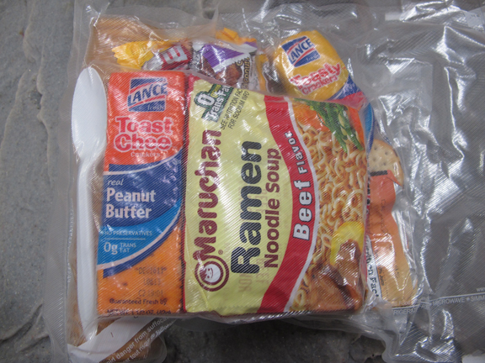
Below is what Dutch puts in his meal kits. This is taken directly from his letter:
- BREAKFAST: Qty 2 Kellogs Fiber plus breakfast bars. I also use Instant Oatmeal or Oatmeal Squares. Nescafe Tasters Choice Coffee, or if not a coffee drinker, throw in a tea bag.
- LUNCH: Crackers and SPAM or Kipper-Snacks or a can of Sardines. All of which can be eaten cold and on the march. Rspeberry Lemonade drink mix, just add to a bottle or canteen of water.
- SNACK: On grueling hikes, you have to keep your blood-sugar levels up, so these have 2 packages of peanut butter crackers and several packs of Peanut M&Ms to be eaten between meals.
- DINNER: I try to have a least one hot meal a day. I advocate Ramen Noodles. I also pack beef jerkey to break up and add to the soup.
*NOTE: The meals he sent me were almost 1 year old and they showed no sign of mold or spoilage. Good sign!
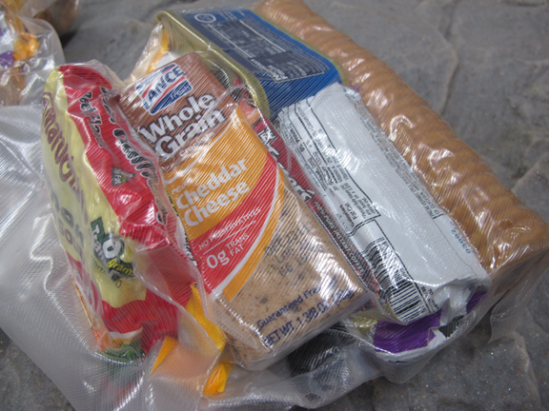
With traditional MREs and camp meals, the selection is fairly limited. And Dutch is right, they are packed full of salt and preservatives. Furthermore, if you’ve ever eaten MREs for very long they’ll back you up worse than traffic during mass exodus.
I’ll admit that these are pretty lavish Bug Out Meals but I really like this concept. It allows you a ton of creative freedom when prepping your Bug Out (or BUG IN) emergency meals. You aren’t limited to ‘stock’ entrees and each meal can be tailored to fit specific dietary needs. Gluten Free? No problem – pack non gluten items. Peanut allergy? No problem – your meal kits get plain M&Ms. You get the point. Vacuum sealing the meals not only helps to preserve them longer but also waterproofs them. The added bonus is that they are also organized and very compact – 2 Bug Out Packing essential qualities.
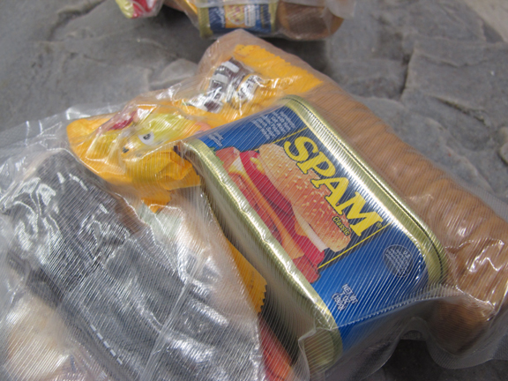

The Expiration Date Marks a Camping Trip
Write the expiration date on the outside of the package with a Sharpie Marker (you choose the time frame but I’d be just fine with 1 year). Don’t throw away the meals when they expire. That expiration date marks a much needed camping trip and your meals are now already packed!

