Beef Jerky

It’s pretty rare that I call things ‘freakin’ amazing’.
I’m telling you, this homemade beef jerky is freakin’ amazing, and that’s coming from somebody who doesn’t typically swoon over jerky at all. So, yeah.
One of the biggest hurdles with purchasing beef jerky is the insane amount of GMO’s also known as genetically modified organisms. Turn over any package of beef jerky and you’ve got high fructose corn syrup (GMO), beet sugar (GMO), and lots of soy sauce (GMO), not to mention a bunch of nitrites & nitrates thrown in the mix. Even if the beef jerky comes from a health food store, it still most likely will have soy sauce in it, which we like to avoid as much as possible ’round here. You can click here to read why we avoid soy unless in properly prepared fermented forms like natto or miso. People often think Asian cultures eat soy like crazy, when in fact, they only eat it properly fermented soy in small amounts.
As much as I believe in following the 80/20 rule, I also strive to make healthy food as much as possible, without stressing out too much. Since we recently purchased some grass-fed beef in bulk, naturally I thought making some delicious, nutrient-dense beef jerky was in order! Right-o! Let’s get on to the recipe!
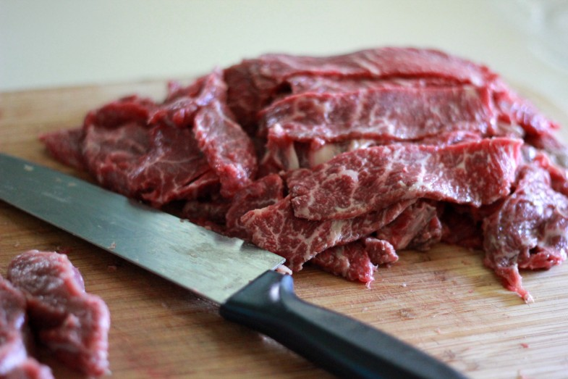
Here’s a tip from yours truly…Slice your meat while it’s slightly frozen. That way you can make thin slices (about a 1/4 inch thick) without cutting off your finger, or worse, swearing.
Most beef jerky recipes will tell you to slice WITH the grain, meaning they recommend you slice parallel with the existing muscle fibers in the meat. The purpose is to help the meat stay together. I’m going to recommend opposite. When making beef jerky, I like to slice the meat AGAINST the grain, meaning, perpendicular to the natural lines of the meat. This makes the meat more tender and it doesn’t really fall apart much at all, especially if you are sure to slice your meat when it is slightly frozen. And if some of it DOES fall apart, well, then my dear, you’ve just created the very best part of beef jerky. Jerky nibblets.
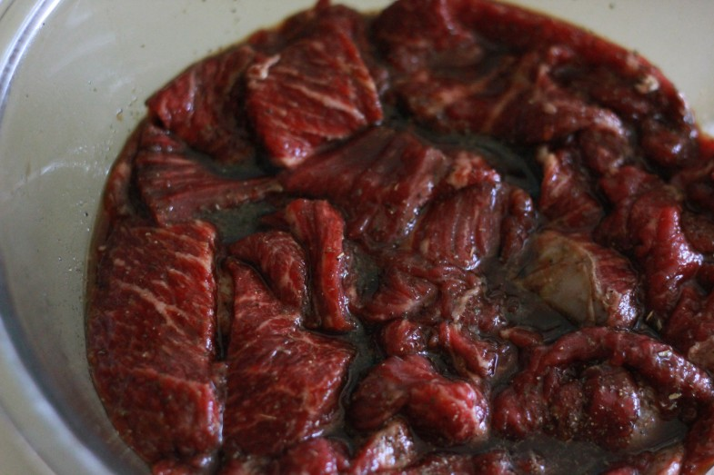
Now it’s time to marinate your meat. Oh em gee. This marinade is ah-mah-zing! For about 2-3 lbs. of meat, you’ll need a marinade of:
- 1/4 c. coconut aminos (Which is basically a soy sauce substitute that tastes just like soy sauce.) -click here to buy.
- 1/4 c. coconut sugar – click here to buy
- 2 TBS. liquid smoke (This is a natural brand that uses natural cedar and by a natural process obtains natural liquid smoke. Did I mention it’s natural?) – click here to buy
- 1 tsp. apple cider vinegar
- 2 tsp. sea salt
- 1 tsp. pepper
- Add any spices you like (onion, garlic, etc.), though I didn’t add anything and it still turned out awesome.
Place that meat & marinade in a bowl, cover with some plastic wrap, and let sit in your fridge for 24 hours.
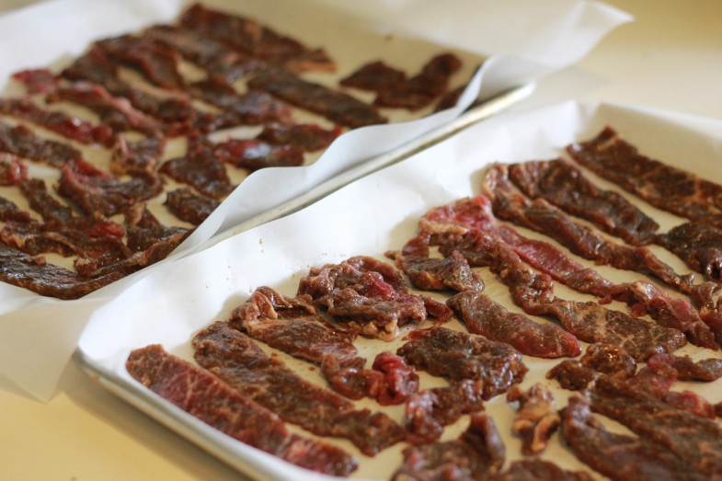
After 24 hours, lay your meat out on parchment paper-lined baking trays and bake in an oven on the lowest setting (mine gets to 170 degrees) with the oven convection fan on if you have one, for about 4-5 hours.
You can also place in a dehydrator, if you have one, for about 4-6 hours. P.S I’m saving up my monies for this dehydrator.
You’ll know when your meat is done when, well, when it looks like beef jerky and tastes like it too.
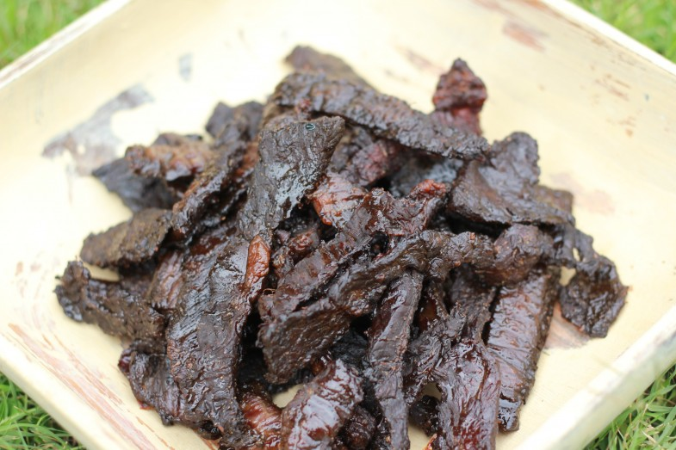
It looks a little burnt, but oh, it is SO NOT burnt! It’s tender and chewy and delicious. Just how jerky should be.

