Applebox Oven - Bake in a Box!
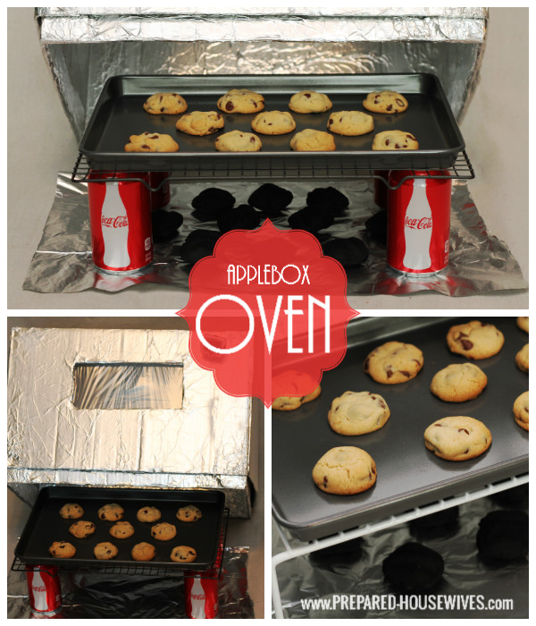
I’m starting to understand why people sometimes get the impression that preppers are crazy. Who else does a photoshoot with an aluminum covered box at 3 am? I know, I really need to get a life!
At the Emergency Fair, multiple people told me they had made an AppleBox Oven when they were in Girl Scouts! The only thing I remember from my Girl Scout days was trying to see how many cookies I could sell my mom. The top earner would get a prize and I was so excited when I finally got it one year… a $5 compass (LAME), I haven’t sold a cookie since!
Anyways, if you didn’t have an awesome Girl Scout leader, have no fear. You can make one of these with a box and a few supplies you can find in your neighbor’s trash. Also, don’t feel like you have to do it at 3am, but I think it works better if you do ;)

MAKE AN APPLEBOX OVEN
This is another alternative cooking method and a great way to bake in an emergency! It only uses about 1/2 the charcoal that a Dutch Oven uses and gives the same results as baking in a regular oven! You can bake your kid’s birthday cake, whip-up your famous muffins, or even cook up to 3 loaves of bread in it at the same time! Go ahead and make one, or if you don’t have time, grab the supplies to have on hand for if the power goes out (or if your oven breaks)!

SUPPLIES:
- APPLEBOX – Need top and bottom (20″x 13″ x 12 1/2″)
- HEAVY DUTY FOIL – 1 Wide Roll
  - I just walked into HEB and asked for one!
- HIGH HEAT FOIL TAPE
- SPRAY ADHESIVE – I used the Loctite High Performance
- OVEN BAG - 1 oven bag cut into a 10×5″ piece
- BOX CUTTER
- CANDY THERMOMETER – Needs to read up to 400

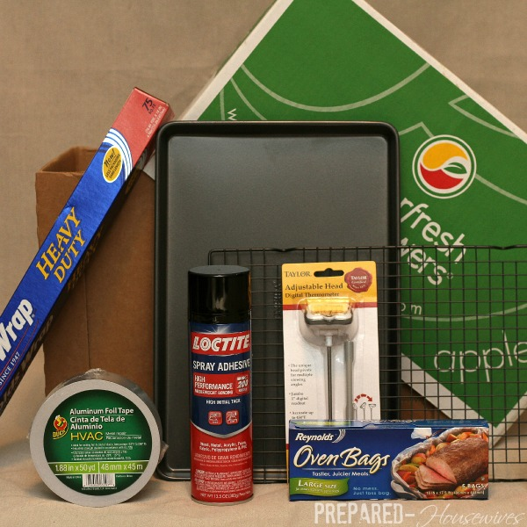

1- Cut out a window!
Cut out a window about 9″x4″ that is centered, and 2 1/2″ from the top.
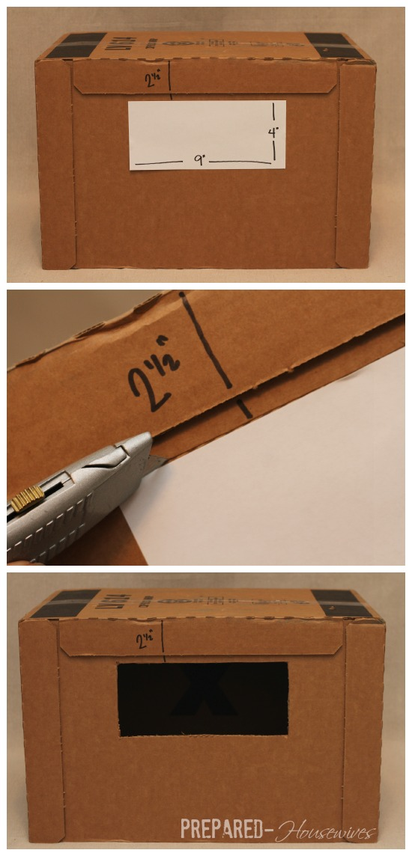

2- Cut out the 2nd Window
Place boxes inside of each other, trace the window on the 2nd box, then cut it out!
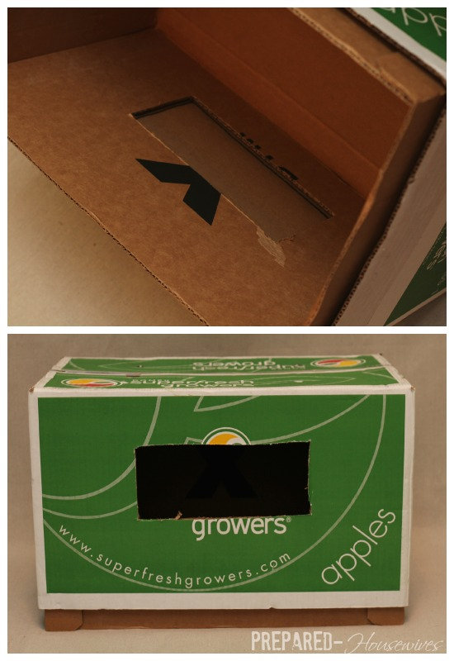

3- Fill in Holes & Gaps
With the extra cardboard you just cut for the windows, use it to fill in all the gaps and holes on the box.
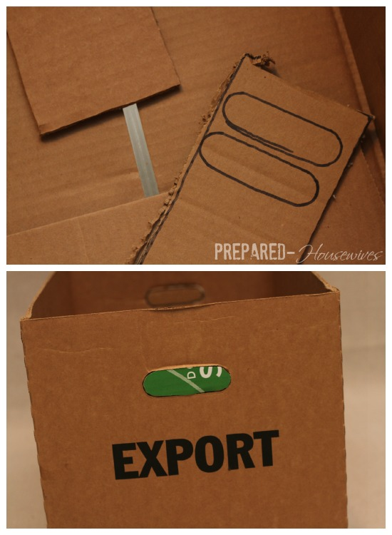

4 – Tape up Corner/Edges/Holes
Using the High Heat Foil Tape, put it on all the seams, corners, sides, holes, window openings, and anything else that will make it extra durable!
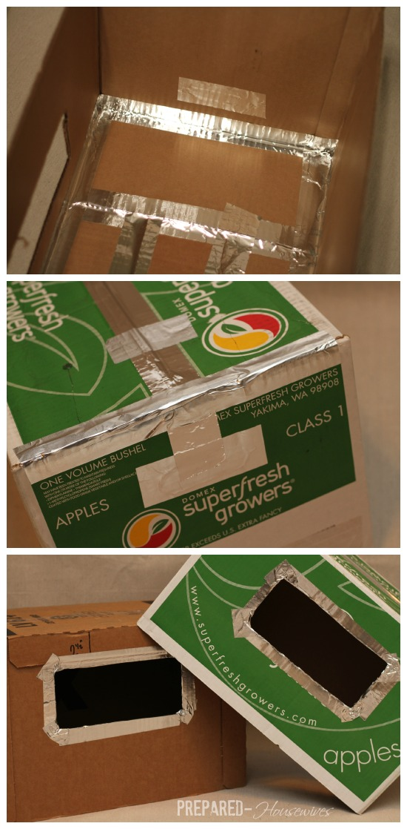

5- Cover EVERYTHING with Foil!
Now it’s time to make your box look like a spaceship!
- Roughly estimate the size of foil you need and tear off a piece.
- Go ahead and mold it gently so it won’t tear when you put it in.
- Spray Adhesive spray on the DULL SIDE (shiny side will show).
- Press the foil on the box and smooth until it is as secure as possible
- REPEAT: Tear Piece, Spray Dull Side, Smooth on Box, do this until the ENTIRE box is covered!
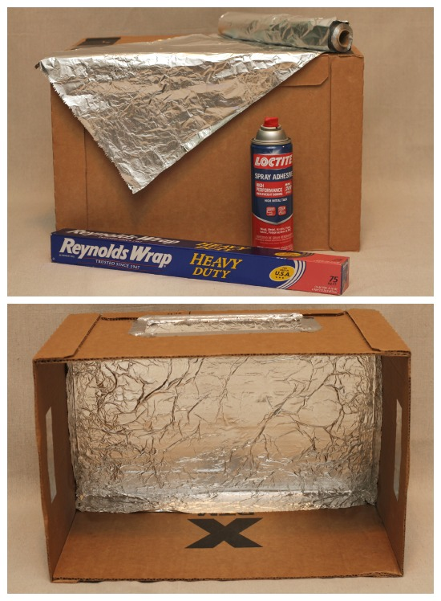

6- Make the Window
Cut the center of the foil, then cut diagonally to meet the center line, repeat this with each corner. Spray the foil inside of the window and fold tabs inside the box, smooth it, and tape if needed.
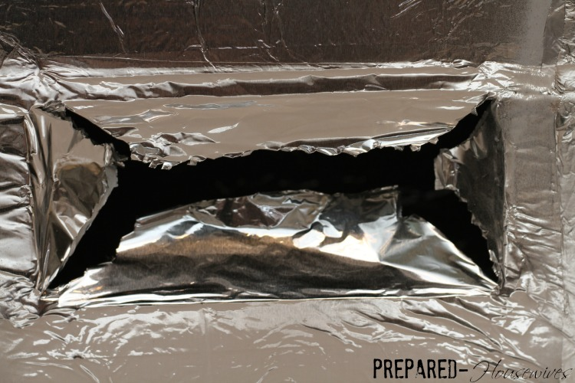

BOTTOM BOX ONLY:
- Using the oven roasting bag, cut a double layer rectangle.
  - 10″x5″ (1 ” larger than window).
- Secure oven bag in place on the OUTSIDE of only the BOTTOM box!
  - Use the Foil tape and Stretch it Tightly!
  - I accidentally did the inside, but not a big deal.

7 – Put Boxes Together
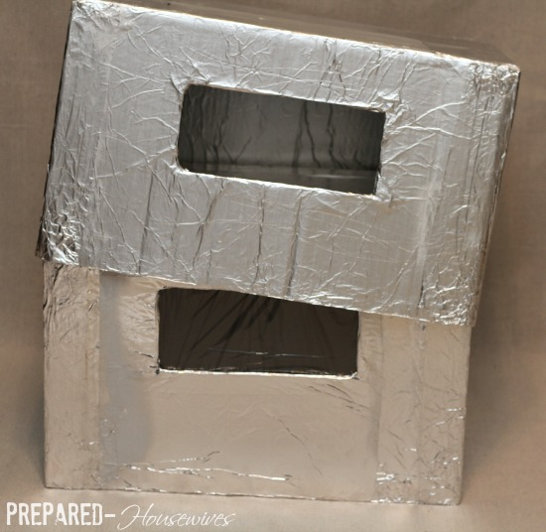

8 – Stick Candy Thermometer Through Box
Put a candy thermometer through both boxes in the upper right hand corner.
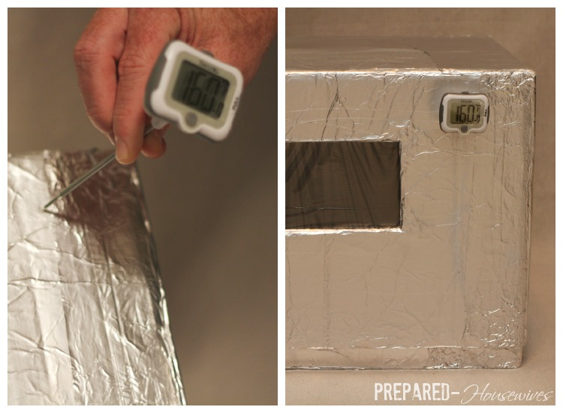

COOKING WITH THE APPLEBOX OVEN

SUPPLIES:
- CHARCOALS - About 17 coals for 1 Hour @ 350 (Kingsford Brand is Best :)
  - One Year = 22 (16 lb bags)
  - Don’t Forget to Store Newspapers & MatchesPOTS & PANS – Make sure they FIT Inside the oven.
  - CHIMNEY CHARCOAL STARTER
- LONG-HANDLED TONGS
- MATCHES & NEWSPAPER – To help light the charcoal.
- FOIL OR PAN – To place the charcoals on.
- BLANKET – If it’s cold, place one on top to help keep the heat in.
- RACK – Make with:
  - 4 empty cans filled 1/2 way with rocks
  - Cookie Cooling Rack

1- PREPARE AREA:
- Place piece of foil, shiny side up, on level ground, and on nothing flammable!
- Place cans filled with rocks so that the corners of the rack will rest on them.Make sure the AppleBox oven fits easily over the cans and rack without knocking them over.
  - Don’t use full cans, I just didn’t feel like drinking 4 Cokes!
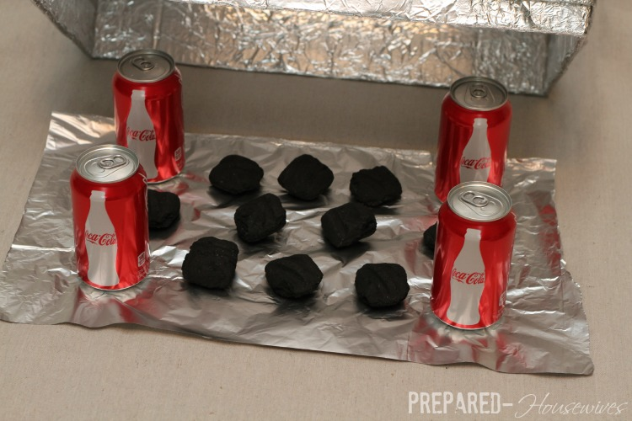

2- PREPARE CHARCOAL
You can control the temperature of the oven by the number of coals you use in it.
- Each coal is about 35 F (350 = 10 coals)
- In very cold weather a couple additional charcoals may be needed.

USING THE CHARCOAL CHIMNEY STARTER*:
- Put desired number of coals into the charcoal chimney.
- Place chimney on a piece of foil on the ground.
- Place a wadded up piece of newspaper in the base of chimney and light.
- Allow to stand 5-10 minutes .
- Wait until all the coals have white spots at least the size of a dime.
- Using tongs, place the hot briquettes on the foil.
- Spread them out evenly between the cans and across the middle.
*A charcoal chimney starter allows you to ignite charcoal without needing starter fluid, using only newspaper! Charcoal rests on a shelf with holes and there is space below for the wadded up newspaper. Place some heavy-duty foil on the ground, then light some newspaper beneath the chimney. You’ll have charcoals ready for cooking in only a few minutes.
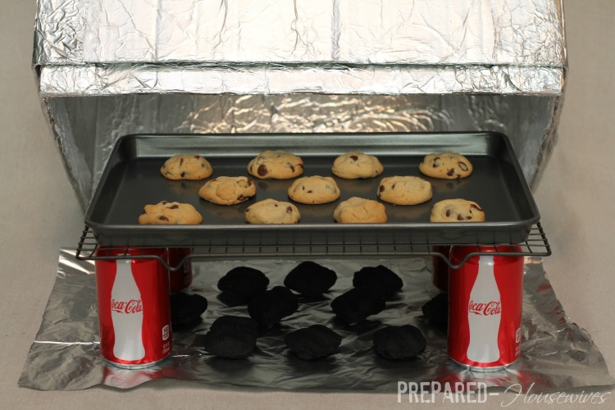

3- COOK!

PRE-HEAT OVEN
- Place the Applebox over the coals and the rack.
- Rest one corner of the box on a 1″ rock or something that will leave a little space (this allows enough air in the box for the charcoal to stay lit).
- Let stand for 5 min.

COOK
- Carefully lift Applebox above rack and place on the ground (this will help to hold trapped heat in the box).
- Quickly place the tray of food to bake on the rack and replace box over coals, resting one corner on the rock for air.
- Charcoal will burn for 35-40 minutes.

ADDING ADDITIONAL HEAT
- When longer cooking times are required, additional hot charcoals can be added by slighty lifting the box and slipping them in with long tongs.
- When adding more coals, only add 1/2 the original number.
- SAFELY dispose of charcoal! No burning up church trash cans ;) At least I know what to do if that happens!
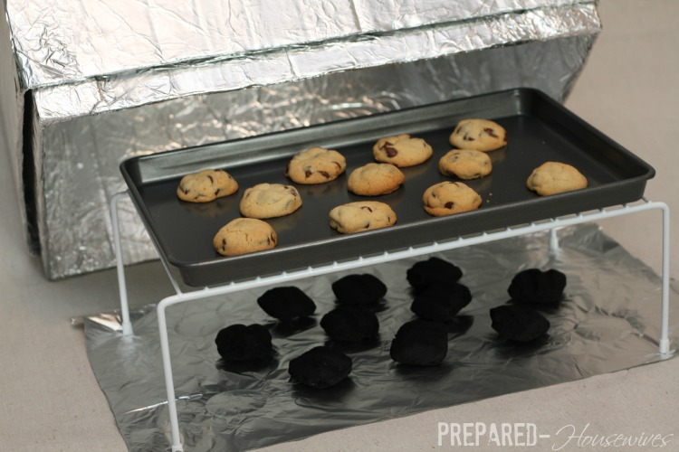

EXTRA NOTES:
- I found the rack above at Wal-mart that fit perfectly. Yes, it will melt the plastic off, but now I don’t have to worry about drinking 4 Cokes before making dinner!
- Use light-colored pans so that baked foods do not get too dark on the bottom.
- When setting up the oven, face the window toward the sun. This allows you to check the foods visually if it’s done.
- When baking in freezing temperature, place a doubled piece of wool blanket or other material that is insulated on top of the box to retain the inside heat.

