All-Purpose Quick Mix
This is my everyday go to mix for biscuits, shortcake, coffee cake, scones and even a delicious self crusting quiche. You can use this mix in any recipe calling for biscuit mix.
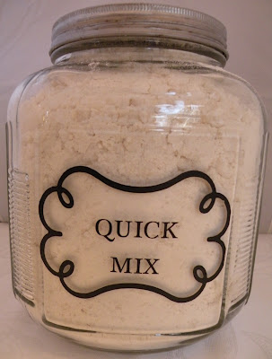
All-Purpose Quick Mix
5 lb. bag flour (20 Cups)
4 C. nonfat dry milk powder or buttermilk powder
3/4 C. baking powder
2 Tbsp. salt
1 Tbsp. cream of tartar
5 C. vegetable shortening
In a large bowl, sift together the dry ingredients. With Pastry blender (or your hands) cut in shortening until mixture resembles cornmeal in texture. Store in airtight container.
~Use 1/2 whole wheat flour, if desired.
~Cut recipe in 1/2 for smaller households.
Biscuits
3 C. All-purpose quick mix
3/4 C. milk or water
Stir together until blended. Drop dough by spoonfuls onto baking sheet. Bake in 450 degree oven for 10-12 minutes or until golden brown.
~Add 1/3 C. shredded cheese and chopped herbs to dough for a cheesy herb biscuit
Shortcakes
Follow above biscuit recipe adding 2 Tbsp. sugar to dough. Sprinkle tops of dough with sugar.
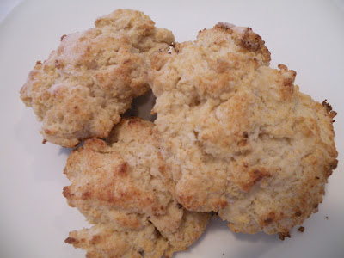
Biscuits and Shortcakes
Coffee Cake
3 C. All-purpose quick mix
1/3 C. sugar
1 egg
1 C. milk or water
1 tsp. vanilla extract
Filling:
1/2 C. flour
1/2 C. packed brown sugar
1 tsp. cinnamon
1/4 C. butter or margarine
Preheat oven to 350 degree. Spray an 8" pan with cooking spray. Combine quick mix and sugar in medium bowl. Mix egg, milk and vanilla. Add to dry ingredients and stir to combine. Prepare filling by mixing flour, brown sugar and cinnamon. Cut in butter till mixture is crumbly.
Spread half of the cake batter in bottom of pan. Sprinkle filling over batter. Top with remaining batter. Bake 40-50 minutes until toothpick comes out clean.
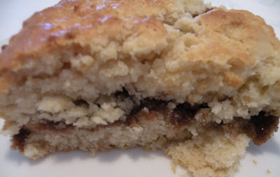
Coffee Cake
Self-Crusting Quiche
~I love this for a lazy weekend breakfast or a busy weeknight!
3 eggs
1/3 C. all-purpose quick mix
1 1/2 C. milk
1 tsp. minced dried onion (or 1/2 tsp. onion salt)
salt and pepper to taste
1/2-1 tsp. herbs of your choice (parsley, thyme, oregano)
1 C. shredded cheese of choice ( I love swiss or cheddar)
1 C. finely chopped meat, crumbled bacon, sausage or cooked veggies (little bits of leftovers make a great filling!)
Preheat oven to 325 degrees. Coat a 9" pie plate with cooking spray. Layer meat and cheese in bottom of pan.
Combine rest of ingredients in blender and mix about 1 minute. Pour over cheese and meat. Bake 30-40 minutes until toothpick comes out clean. Serve warm or cold.
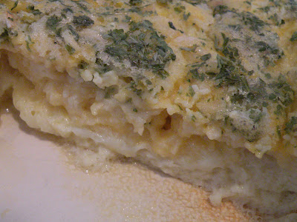
Self-Crusting Quiche

Griddle Scones
~These tender scones are a favorite in our house. Top with lemon curd, fresh whipped cream or your favorite preserve
~These are great for camping
3 1/2 Cups All-purpose quick mix
2 eggs (room temp).
2 Tbsp. honey
1/2 C. milk, cream or whipping cream
Place all-purpose quick mix in a bowl. Mix eggs, honey and milk in separate bowl. Stir into mix with a fork just until blended (do not overmix!). Turn dough onto floured surface. Using 1/3 of the dough at a time, pat or press mixture into a circle about 1/2" thick. Cut each circle into 4 or 6 wedges.
Preheat a pan on med.-low heat. Gently place the wedges on griddle. Cook until bottoms are lightly browned and the scones rise slightly (be careful not to burn). Turn and brown other side. Serve warm
For an extra special treat serve with Devonshire Cream:
Combine 1/2 C. chilled whipping cream and 2 Tbsp. brown sugar in mixer and beat until stiff peaks form. Fold in 1/2 C. sour cream.
You can also add 1 C. diced fresh fruit (peaches, strawberries, raspberries).
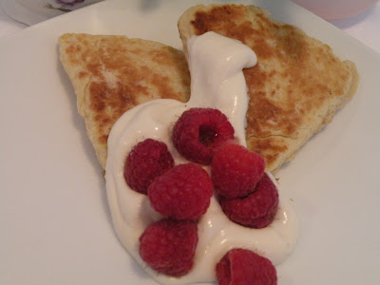
Griddle Scones w/Devonshire Cream and Raspberries
Gingerbread Mix
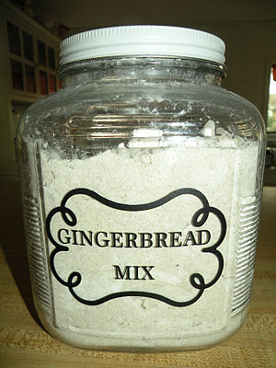
Gingerbread Mix
8 C. flour
2 C. sugar
1/4 C. baking powder
1 Tbsp. salt
1 tsp. baking soda
1 tsp. cloves
1 Tbsp. ginger
1 Tbsp. cinnamon
2 C. shortening (I use all natural palm oil)
In a large bowl mix together dry ingredients (I like a whisk for this job). Using a pastry blender, cut in the shortening until mixture resembles cornmeal. Store in an airtight container.
~This mix makes a great gift packaged in a cellophane bag.
~To use this for gingerbread house: use the Easy Ginger Cookie recipe below adding 1 C. flour (you will have to use a mixer or your hands to get it mixed). Roll 1/8"-1/4" thick and cut as desired. Bake about 7 minutes, until edges are browned. Cool on wire racks overnight. This makes a very durable gingerbread house!
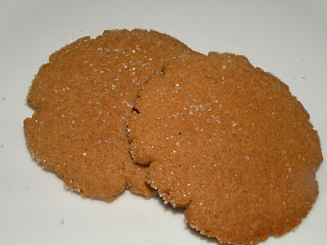
Easy Ginger Cookies
Easy Ginger Cookies
3 C. gingerbread mix
1/3 C. molasses
1 egg
Preheat oven to 350 degrees. Combine all ingredients in a bowl, dough will be fairly stiff! Roll dough into 1 inch balls, roll in sugar (or cinnamon/sugar mixture) and place on cookie sheets. Flatten cookies with the bottom of a glass. Bake for 12-15 minutes, until edges are browned.
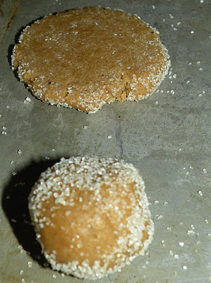
~I like to pre-portion this mix in ziploc bags, that way I can have cookies ready for the oven in a matter of minutes--perfect for last minute company, to tuck in a gift bag or just to enjoy with your afternoon tea.
~To make rolled gingerbread cookies: add 1/4 C. flour to the Easy Gingerbread Cookie recipe. Roll out on lightly floured surface and cut with desired cutters. Bake 10-12 minutes until edges are browned.
Maple Brown Sugar Oatmeal Mix
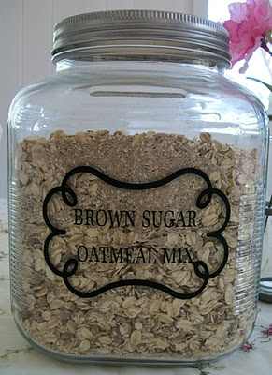
Here is another mix recipe for your collection:
Maple Brown Sugar Oatmeal Mix
1 C. quick oats (grind in blender or food processor till finely ground)
1 C. quick oats (leave whole)
3/4-1C. brown sugar
1 Tbsp. maple flavoring
2 tsp. salt
1 tsp. cinnamon
1/2 tsp. nutmeg
Combine brown sugar, maple flavoring, salt, cinnamon and nutmeg in a medium bowl. Stir to thoroughly combine the sugar and extract (a mixer is really helpful for this). Add in oats and ground oats. Stir to combine. Store in airtight container.
To Serve:
Place 2/3 C. oatmeal mix in a bowl and add hot water to desired consistency.
For Apple-cinnamon oatmeal-substitute vanilla extract for the maple and add 1/2 C. dried apple pieces.
*Just like the packets you buy in the store, only you can control the ingredients.
*Package in individual baggies for quick, single serving sizes.
*Add more oats and ground oats to make a less sweet mix.
*Double, triple or quadruple the recipe and store in a large jar, scoop out how much you need.
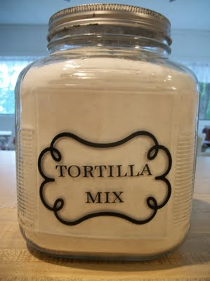

Our family loves Mexican food: tacos, burritos, enchiladas, quesadillas--pretty much anything you wrap in a tortilla. The cost of store bought tortillas seems to keep going up--$1.67 for 10 tortillas?!
Homemade tortillas are not only very easy and inexpensive to make (about $.25 for 10) they taste so much better than the store bought ones.
Tortilla Mix
16 C. flour (use unbleached or add up to 1/2 whole wheat)
2 Tbsp. baking powder
2 Tbsp. salt (you can use a little less, but some salt really does make a difference in the flavor)
1/2 C-1C. shortening (I like about 3/4 C. of palm shortening (no trans fat!))
Combine dry ingredients in a bowl and stir with whisk to fully mix. Cut in shortening with pastry blender or hands. Store mix in airtight container.
To Make:
Place 2 C. tortilla mix in a bowl, making a well in the center. Add 1/2-3/4 C. warm water, a little at a time, mixing until you have a soft dough.
Knead dough for a short time till it becomes elastic.
Cover with plastic and let it rest 10-15 minutes.
Form small balls, pull the dough around the bottom of the ball to make top smooth. Set aside, covered with plastic wrap.
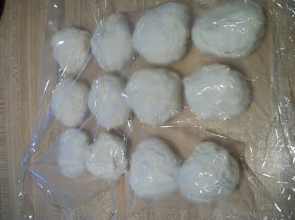
Dip dough balls in flour and roll out thinly.
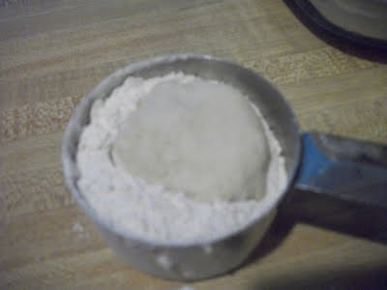

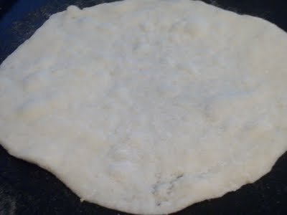

Cook on preheated dry griddle until top begins to bubble, Flip and cook for about 15 seconds more.
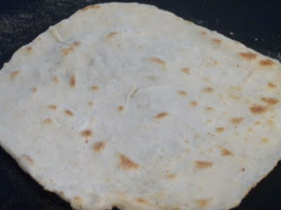
To keep warm: stack between towels.
Wrap in plastic wrap and store in refrigerator.

Five Minute Bread--(A Refrigerator Mix)
This mix is for your refrigerator and allows you to have have hot homemade bread for dinner whenever you want!
To make the dough you will need:
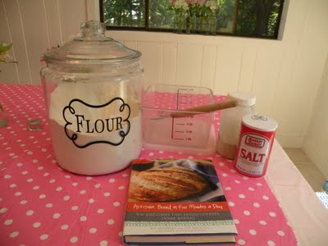
-four qt. container for mixing
-flour (unbleached or all purpose)
-salt
-yeast
-warm water
Step1: Measure 6 1/2 cups of flour into your container using the scoop and sweep method.
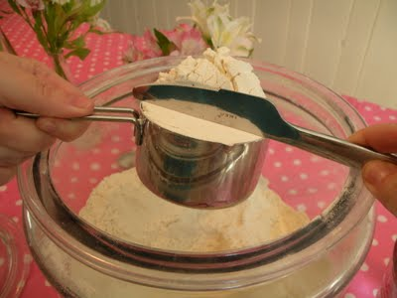
Step 2: Add 1 1/2 Tbsp. yeast to flour (or approx. 2 pkgs.)
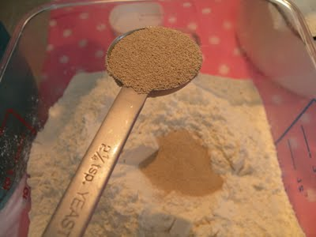
Step 3: Add 1 1/2 Tbsp. salt to yeast and salt
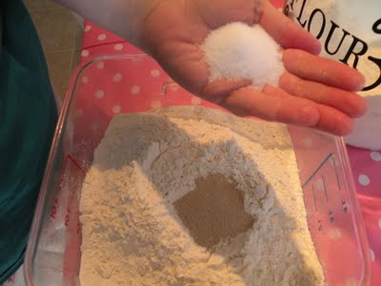
Step 4: Whisk dry ingredients together. I use a danish dough whisk to mix my ingredients together and then mix the dough. It does a great job of mixing up the dough and is easier to clean than a regular spoon. You can use whatever you have on hand.
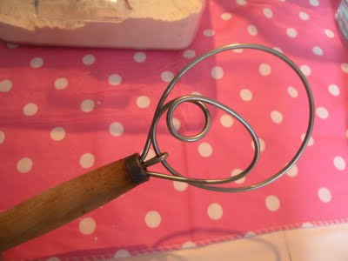
Danish Dough Whisk
Step 5: Add 3 C. warm water and mix till flour is all moist. You do not have to knead!
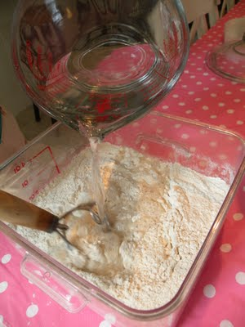
The dough should be moist with no dry flour in the bottom of the bowl. It may even seem sticky, but it's okay!
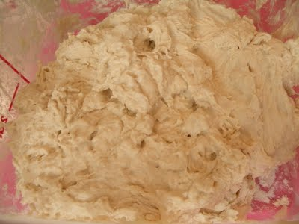
Step 6: Lay the top on the container but DON'T seal. Set in a warm place to rise.
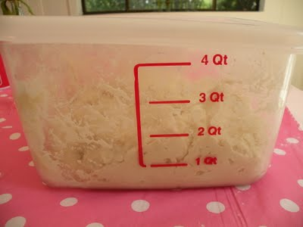
Dough before rising
Let rise until doubled in size (about 1 1/2-2 hours). Pop the top on and put in the refrigerator.
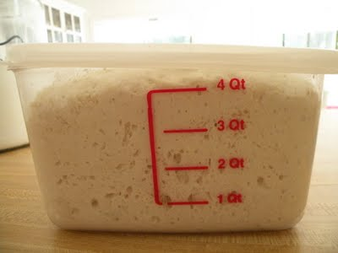
Dough after rising

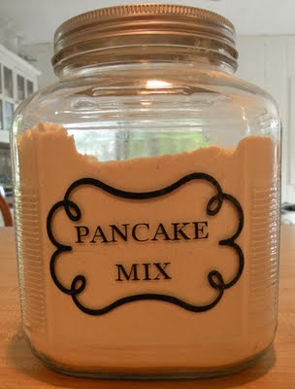
Perfect Pancake Mix
6 C. Unbleached flour
2 C. Whole wheat pastry flour
2 C. Nonfat dry milk powder (or buttermilk powder)
1/2 C. sugar
3 Tbsp. baking powder
1 1/2 Tbsp. baking soda
2 tsp. salt
In a large bowl, whisk all ingredients together. Store in large airtight container.
-You can use all unbleached flour or combination of flours to get to 8 C. (I found it is best not to go over about 1/2 whole wheat flour with this recipe).
Pancakes:
2 C. perfect pancake mix
1 1/2 C. water (or to desired consistency)
1 egg
2 Tbsp. oil
In a medium bowl, combine egg, oil and water. Whisk in pancake mix. Let stand 2 minutes. Add additional water, if desired. Cook on preheated griddle or pan.
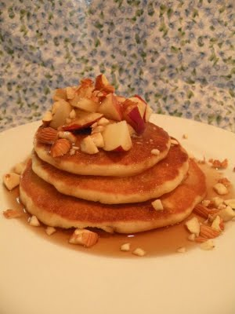
Easy Waffles
2 1/2 C. Perfect Pancake Mix
2 C. water
3 eggs, separated
1/4 C. veg. oil
Combine pancake mix, water, egg yolks and oil in large bowl. In a separate bowl, beat egg whites until stiff. Gently fold egg whites into batter. Bake in preheated waffle iron.
Puff Oven Pancake
4 Tbsp. butter or margarine
4 eggs
1 C. milk
1 C. Perfect Pancake Mix
Preheat oven to 450 degrees. Place 2 Tbsp. butter in each of 2-9" pie plates. Place pie plates in oven to melt butter. In a blender, combine eggs, pancake mix and milk. Pour batter into prepared pie plates.
Bake for 18 minutes until puffy and browned. DO NOT open the oven while pancakes are cooking.
Remove from oven and top with fruit or powdered sugar.
~These are an easy brunch dish for a crowd.
Topping Ideas:
~Fried apples and pecans
~Fresh peaches, blueberries or strawberries with a sprinkle of powdered sugar
~Sprinkle with powdered sugar and lemon zest and then sprinkle the juice of a lemon over it (my fav!)
~Bananas, coconut, pineapple and drizzled with chocolate sauce.
~Any fresh fruit and fresh whipped cream
Perfect Batter
1 C. Perfect Pancake Mix
1 C. milk
2 eggs
Combine eggs and milk in shallow bowl, Add pancake mix and stir till combined.
Use this batter to make Monte Cristo Sandwiches, onion rings, or even fried fish.
~For Monte Cristo Sandwiches, make sandwiches using your favorite bread, meat and cheese combo (ham and cheddar, turkey and swiss, roast beef and provolone) and topping (mayo, mustard). Dip sandwiches and cook on preheated griddle till browned on both sides and cheese starts to melt. Monte Cristos are traditionally topped with a light sprinkle of powdered sugar and a dollop of jelly.

Taco Seasoning Mix
No more expensive packages of taco seasoning with artificial ingredients or fillers!
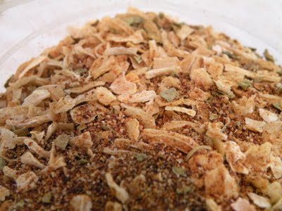
Taco Seasoning
Taco Seasoning
1 C. minced dried onions
1/2 C. chili powder
1/4 C. garlic powder
1/4 C. cumin
2 Tbsp. oregano
2 Tbsp. salt
2-3 Tbsp. red pepper flakes (optional, add if you like spicy!)
Mix together all ingredients in a bowl. Store in airtight container.
Use 2-3 Tbsp. of mix to 1 pound of meat. My family likes more seasoning on their meat--just use what tastes good to you. You can add a little water if your meat is really lean to help it coat all the meat evenly.

This recipe is great because you can control how spicy (add red pepper flakes) or smokey (add more or less cumin) you like it, plus, you can leave the salt out all together if you need a lower sodium version (this version already has less sodium than most store brands out there).

Corn Bread Mix

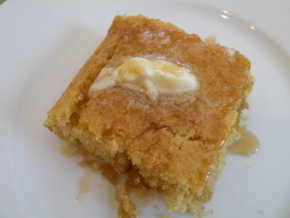
Cornbread w/butter and honey
Corn Bread Mix
4 C. unbleached flour
4 C. yellow cornmeal
2 C. nonfat dry milk (or buttermilk powder or milk powder substitute)
1 C. sugar
1/2 C. baking powder
1 Tbsp. baking soda
2 tsp. salt
Combine all ingredients in a bowl and stir with wire whisk. Store in airtight container.
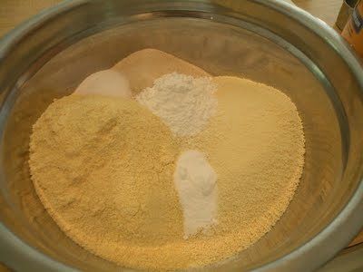
Ingredients layered in bowl
When I am making my mixes, I usually put the flour on the bottom and then add the other ingredients in piles on top, it makes it easier to see what I have already put in the bowl.
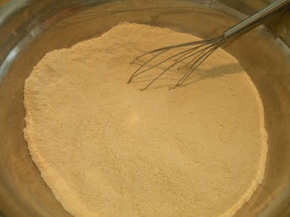
Mixed ingredients
To make:
1 egg, beaten
1/2 C. water
2 Tbsp. oil
1 1/4 C. cornbread mix
Preheat oven to 425 degrees. Mix egg, water and oil. Add cornbread mix and stir to combine. Place batter in greased 8" x 8" pan and bake for 12-15 minutes, until golden brown.
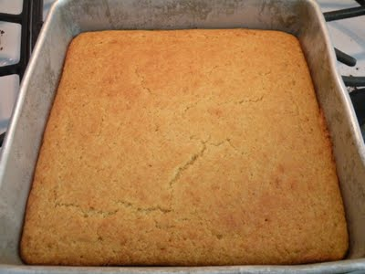
baked cornbread
* Use this batter to make homemade corndogs. Add a pinch of dry mustard and 1/4 C. (approx.) more cornbread mix to make a stiff batter. Place hotdogs on skewers, dip in cornbread mix to completely coat and deep fry in 2-3 inches of hot oil until golden brown. Drain on paper towels.

Having everyday and convenience food mixes on hand are a great way to save time (no running to the store for something to serve last minute guests) and money (brownies for $.50 instead of $1.50 or more) in the kitchen. Not to mention, making your own mixes allows you to control the quality and the ingredients making them adaptable to special diets or allergies. So where do you start if you want to stock your pantry with quick and easy mixes?
First, look around your pantry and think about what convenience foods you would like to make mixes to replace. Do you love having brownies on hand for an after-school snack? Would having pancake mix on hand make Saturday morning breakfast more relaxing? Are you looking for a use for all those bread crusts the kids never seem to want to eat--turn them into bread crumbs or stuffing mix!
Next, decide how you want to package your mixes. I use large glass jars that I keep on open bookcases in my kitchen. This works great for me because I have a long wall that not much else fits on it. Using quart and gallon size ziplock bags is great because you can stack them up, write the directions right on the package and they are pre-portioned. You can also put the bagged mixes in a plastic bin in your cupboard to keep them all together.
Now the fun part, making all the mixes! Grab your apron and maybe even a couple of friends and have some fun!
Buy your frequently used ingredients in bulk (flour, sugar, baking powder, etc.....) If you have limited storage space, gather a couple of friends for a mix day and split the ingredients. I can easily go through 25 lbs of flour on my mix days!
Using a large, shallow bowl will make mixing your ingredients much easier. It allows you to see if your ingredients are thoroughly mixed! (I used a dishpan from the dollar store for years to make my mixes in before I finally bought a GIANT stainless steel bowl). Make sure your bowl is big enough to hold all of your ingredients and give you enough room to stir (flour showers are just not pretty!).
A whisk makes quick work of dry ingredients. I keep a couple of different size whisks on hand for mixing my dry stuff together.
When cutting in shortening, especially into a large batch, I have found the best tool is--my hands. I can feel the shortening mixing in and can scoop easily to the bottom of the bowl to make sure everything is fully incorporated.
Making your own mixes allows you to control the ingredients. You can use all organic ingredients and still save over what an organic mix would cost you. Make gluten free mixes using an all purpose gluten free flour for a celiac friend (be sure all the other ingredients are gluten free also). Use a non-dairy dry milk powder for kids with dairy allergies. Leave the salt out for those with sodium or blood pressure concerns. It really opens up a lot of choices when you can control the ingredients. Sometime it takes a little experimenting, but it is worth it!
Mixes are great for sharing with other families. A can of peaches (store bought or home canned) and a bag of cobbler mix with a carton of whipping cream is a yummy gift for a new mom or as a housewarming gift. Moms of toddlers love cookie mixes that require just the addition of and egg and milk as an easy rainy day activity!
Mixes are great for camping! We fill a box with pre-measured mixes and only have to bring along a few extras (eggs, milk, water) in the cooler and we know we will be eating well. Some of our favorite camping mixes are: pancake mix (buttermilk or cinnamon oat pancakes), skillet scone mix, corn bread mix, quick cobbler mix (to use with fresh fruit from a local farmers market or picked straight from the tree), and tortilla mix, Our friends always tease us that we eat better when we are camping than they do at home.
Over the next few weeks, I will be sharing many of my favorite mix recipes and how I use them, so here is one to get you started:
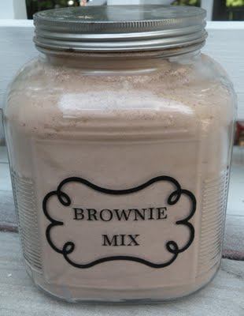
Brownie Mix
8 Cups of sugar
6 Cups of unbleached flour
2 Cups of cocoa powder
1 1/2 Tbsp. baking powder
1 Tbsp. salt
Mix together and store in airtight container.
To Make:
2 1/4 C. brownie mix
2 eggs, beaten
1/3 C. canola oil (or melted butter or margarine)
2 tsp. vanilla extract
1/2 C. chopped nuts or chocolate chips (optional)
Preheat oven to 350 degrees. Grease an 8 inch square pan. Combine ingredients and mix until smooth. Bake for 30-35 minutes until center is set. Cool, cut, serve.
*try adding mint chips for choco-mint brownies.
*top warm brownies with mini-marshmallows, choco chips and some chopped graham cracker pieces for s'more topped brownies
Texas Sheet Cake
4 C. brownie mix
1/2 C. oil
1 C. water
1/2 C. sour cream
2 eggs, slightly beaten
1 tsp. vanilla extract
1 tsp. baking soda
Preheat oven to 375 degrees. Grease a 10" x 15" jelly roll or sheet cake pan. Put brownie mix in bowl. In small saucepan bring oil, water, and sour cream to a boil. Add to the brownie mix. Stir in eggs, sour cream and baking soda. Pour into pan. Bake for 20-25 minutes until toothpick inserted in center comes out clean. Prepare frosting and frost while cake is still hot.
Sheet Cake Frosting
1/2 C. evaporated milk
1/2 C. butter or margarine
1/4 C. cocoa powder
3 C. powdered sugar
2 tsp. vanilla extract

