72 Hour Food Kit
By Misty
As many of you know, I am a member of the Church of Jesus Christ of Latter Day Saints.
I was recently asked to help many of the families in our congregation put together 72 hours worth of food that could be placed in a complete 72 hour pack / survival kit. I thought I’d post a bit about what I came up with here as it would be helpful to anyone trying to put together 72 hr food kits for a large group.

What you’ll find in this post:
- I’ll start by telling you what my goals were with these kits and why I created them the way I did.
- Then I’ll give you the details: I will tell you what you will be eating for each meal each day, where I bought everything and what it all cost. (Yes, you have my permission to scroll down right to this section if you’d like to right now)
- Last, I’ll give you links where you can download menu labels for each day, handouts, and signup forms that you can use when planning your kits with your group!

1. A BIG Undertaking: My Goals
This was quite a project as I really wanted to meet a few basic needs:

1. I wanted to keep the cost as low as possible.
The cost of food adds up quickly and having to buy 3 days worth all at once in addition to your regular spending can seem daunting, especially for large families, which there are many of in our congregation. I did not want the cost to deter people from taking this important step.
I set a goal to keep the cost for each meal at $2 or less per person. I ended up beating this goal!

2. I wanted to keep the calories as high as possible while not sacrificing nutrition.
In most disaster situations, you actually would not need your kit. For example, in a house fire, you’d likely be able to go to a friend or family member’s home. You wouldn’t grab your 72 hour kit and go camp out at the park! Or in an earthquake, you’d likely still stay at (or near) your home once it was over and have access to all the food in your home, not just your kit (well, at least anything that isn’t destroyed).
So, in reality, the only time you’d actually use your kit is if you had to quickly evacuate and the evacuation radius was wide enough that you couldn’t quickly get to a family / friend’s home. This means, you’d likely be expending a lot of energy and would need calories. I looked at many other 72 hour food kit lists online and most offered only 600-1000 calories / day. Hunger makes both my kids and I (any maybe you, I’m guessing?) terribly grumpy! In my opinion, a large scale disaster is not the time to cut your calorie consumption by half or more.
I set a goal to get calorie consumption at 1500 calories / day or more while including at least some nutrient dense foods. I also ended up beating this goal!

3. I wanted all the items to be “non-cook” type items
I wanted this for a few reasons.
First, many items that need to be cooked (canned soups, stews, chilis etc) are heavy and would add significant weight to your packs. In addition, “just add water and cook” type meals require extra water….and water is HEAVY! Ideally, since you may have to carry them, your packs should be as light as possible.
Second, if you truly are evacuating on foot, simple will be best. I know that even in my nice home, when I have a bad day, I prefer making a simple meal to a complicated one. It will be much easier to pull out a granola bar, open it and give it to my child than to pull out the stove, the fuel, light it, then the can opener, open the can, wait for it to cook, then dig through my pack to find bowls / cups / spoons etc.
Third, many families do not already have a small portable stove, light weight mess kit etc. This would be an added expense to them and may again deter them from getting their kits altogether.
I completely met this goal! None of the food requires cooking!

4. I wanted foods that tasted good!
Again, multiple reasons for this.
First, and most obviously, you are more likely to eat food that tastes good. This is especially true of children. As adults, if we know we need to eat, we are likely to eat most anything even if it doesn’t taste great. But children are different. They may not understand how serious the situation is and will react just like they would at the regular dinner table. They will whine and complain if they don’t like something and end up not eating much. That may not regularly be a huge issue, when tomorrow morning they will wake up and have pancakes, but in a true survival situation, they need to eat all they can.
Second, you are more likely to rotate food you like! When we rotate the food in our 72 hour kits, we have a PARTY! It is fun! We get out all that yummy food (stuff we don’t usually eat otherwise) and have FUN. Then, we re-stock it with more yummy food. But if the food in our kits is gross, we won’t likely rotate it. Then, it might not be use-able when we need it.
This was tricky b/c everyone has different tastes. Also, not everything that tastes good & is high in calories is extremely nutritious! Some things in my kit are things that I might not want my kids eating every day (sugary, salty, processed etc), but that they really enjoy. Other things are relatively nutrient dense. I figured this would work for most families without serious allergies in a survival situation.

2. The Results & Details:

1503 Calories per Day and $1.32 per Meal!
I created a 1503 calorie / day non-cook food kit for $11.86! That is just $1.32 / meal! Seriously! I was so proud of myself I had to call my Mom to brag. It took about 6 hours to figure it all out, but I really think it is a great kit!
In addition, if you can afford a few more dollars, you can get that kit up to over 2100 calories per day for $16.29. That is still under $2 / meal at $1.81!

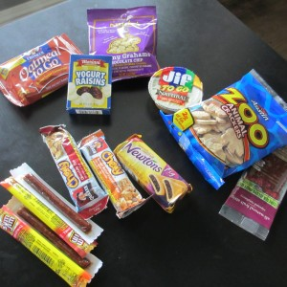

The Three Day Menu:

Day #1
- Breakfast: Oatmeal to Go Bar, Annie’s Bunnies, Yogurt Raisins
- Lunch: Peanut Butter and Animal Crackers, Fruit Leather
- Dinner: 4 Slim Jims, 2 Chewy Granola Bars, Fig Newtons

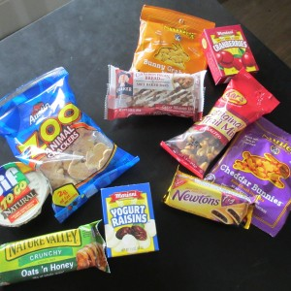

Day #2
- Breakfast: Soft Baked Breakfast Bar, Annie’s Bunnies, Craisins
- Lunch: Trail Mix, Annie’s Bunnies, Fig Newtons
- Dinner: Peanut Butter and Animal Crackers, Crunchy granola bar, Yogurt Raisins

Day #3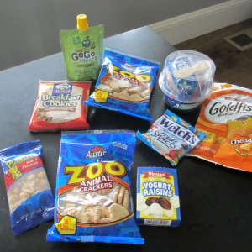
- Breakfast: Breakfast Cookie, Animal Crackers , Applesauce
- Lunch: Tuna & Crackers, Goldfish, Fruit Snacks
- Dinner: Bag of peanuts, Animal Crackers, Yogurt Raisins

Add-Ons:
If you are like me and want a few more calories / snacks, you can add the following. You may only want to add some to your adult kits and keep the kids kits smaller, or you may add the candy to the kids, but not the adults etc etc:
- Additional bag of nuts per day: Adds 170 calories per day, $0.96 additional cost per kit
- 6 pieces chewy candy per day: Adds 130 calories per day, $0.37 additional cost per kit
- 1 pantry can Peach Drink for three people: Adds 306 calories per day, and LOTS of vitamins. Enough for 1 cup peach drink at each meal per person. $2.66 additional cost per kit
- 1 pouch Peach Drink per two people: Adds 275 calories per day, and LOTS of vitamins. Enough for 1 cup peach drink 2-3 times per day per person. $3.10 additional cost per kit
So, for my family of six, I would purchase the basic $11.86 kit for everyone, add the nuts and candy for everyone and 2 pantry cans peach drink. My total cost would be $97.74 or $16.29 per kit ($1.81 per meal). Total calories per day per person would be 2106 per day!
*Note: If you can take advantage of the sales at Costco through Sept 1st, 2013, you can save an additional $0.22 / per kit.

Where to Buy / Prices:

Amazon (using Amazon Prime for free shipping):

Note: Prices on Amazon change frequently
- Quaker Breakfast Cookie 36 Pkg: $14.77
- Quaker Oatmeal to Go 36 pkg: $16.72
- Animal Crackers 36 Pkg: $14.95
- Kar’s Trail Mix 72 Pkg: $32.42
- Fig Newtons 48 pkg: $27.96
- Slim Jims 100 Pkg: $24.36
- Nature Valley Crunchy Granola Bars 48 pkg: $21.89
- Planter’s Peanuts 48 Pkg: $14.99

Local Walmart (or online with free shipping if spending $55+):
- Yogurt Raisins 6 Pkg: $2.98
- Craisins 6 Pkg: $2.98
- Quaker Soft Baked Breakfast Bars 6 Pkg: $2.18
- Jif Peanut Butter To Go 8 pkg: $2.47
- StarKist Tuna Lunch to Go: $1.41 each

THRIVE Life:
- Peach Drink Pantry Can: $7.99
- Peach Drink Pouch: $6.19
The Peach is my favorite, but you can also get Apple, Melon, Orange, Fruit Punch and Mango! You can learn more about what makes these drink mixes so great here: Product Highlight: Drink Mixes.

Costco:
- Annie’s Bunnies 36 Pkg: $8.65 (Currently on sale through Sept 1st, 2013; regular price $11.65)
- GoGo Squeeze Applesauce 20 pkg:$6.99 (Currently on sale through Sept 1st, 2013; regular price: $8.99)
- Fruit Leather 48 Pkg: $10.59
- Goldfish Crackers 24 Pkg: $7.99
- Welch’s Fruit Snacks 80 Pkg: $7.99 (Currently on sale through Sept 1st, 2013; regular price $10.99)
- Chewy Granola Bars 60 Pkg: $8.99 (Quaker brand currently on sale for this price (regularly $10.99); but Costco brand regularly $8.79 for 60)
- Hi-Chew Candies 104 Pkg: $6.39

A Few Important Notes:
- Obviously, the prices in your area may vary a bit, or you may end up reading this post months after I post it. But, unless there has been some sort of HUGE inflation since I posted this, I believe you can easily get this 72 hr food kit for under $2 / meal.
- Part of the reason I was able to get these prices was b/c we were buying in bulk. I went to Costco and shopped online in bulk. So, if you are to do this, it will be best to get a large group of people together! You could get your church group together or a few families in your neighborhood. You can even all rotate at the same time each year and buy your re-supplies together too!
- Also, because things are packaged in different sizes, you will NEVER be able to buy just exactly what you need for “x” number of kits. You will always have a little extra of something. You can roll that extra cost into the cost of the kits or whoever is in charge can front the extra cost and keep the extra food. (That is what I will be doing)

3. Downloads:
I have three FREE downloads for you:

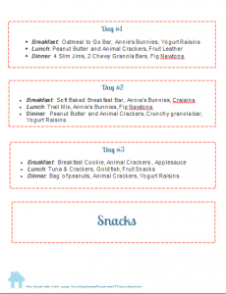

1. Printable Daily Menu Labels
Print, Cut, and put on each day’s bag so you know what to eat when!
- Download in pdf format here (you will be able to print only, not edit)
- Download in Microsoft Word format here (you will be able to make changes as needed and then print)

2. Informational Handout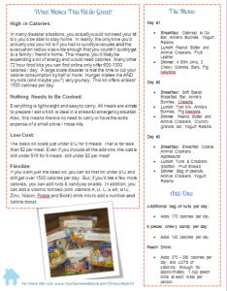
Give this handout to anyone you’d like to invite to join your group. It should help them understand what it is you are trying to do and why you are building the kits this way!
- Download in pdf format here (you will be able to print only, not edit)
- Download in Microsoft Word format here (you will be able to make changes as needed and then print)

3. Signup Form: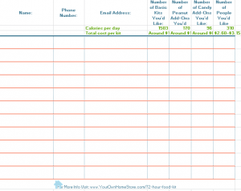
Pass this form around a group meeting so people can sign up for what they want in each kit!
- Download in pdf format here (you will be able to print only, not edit)
- Download in Microsoft Excel format here (you will be able to make changes as needed and then print)

