10 Foods With a Long Shelf Life
When prepping for a survival situation, food is a crucial priority. Although the human body can go a relatively long time without food (3+ weeks), you still need to stock up as much as possible. But don’t just stock up on any foods. Stock up on ones that won’t spoil. After all, you never know how long a survival situation is going to last. With that said, let’s take a look at 10 foods with a long shelf life (I’d recommend writing these down so you don’t forget them).
In no particular order, here are 10 foods with a long shelf life that you should invest in:
Dried Beans
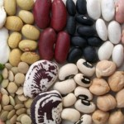Beans are an excellent source of protein, which is one reason why they’re perfect for disaster prepping. They’re also cheap and easy to make. Not many people realize that you can actually ground beans into flour to make cookies, biscuits, or bread. Because of their versatility, cost efficiency, and quality source of protein, it’s one of the foods with a long shelf life that I highly recommend.
Dried Rice
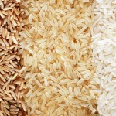Believe it or not, dried rice is capable of lasting for 30 years or more. However, to make it last this long, it will require proper packaging. Like dried beans, rice is cheap and relatively simple to cook. Buy it in bulk and store it away in case of an emergency. On Amazon, you can find 50-pound bags of dried rice for about $50. Dried rice is one of those foods with a long shelf life that can also provide you with energy.

Dried Lentils
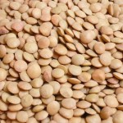From what I’ve read about, dried lentils have lifespans that are practically indefinite. You can make them last longer by keeping them whole (not cracked). Not only are they a quality source of fiber, but they also cook pretty quickly as well. Lentils can be as cheap as $15 for a 20-pound bag, which is affordable for most people I think. Definitely add this to your list of foods you’ll need.
Raisins
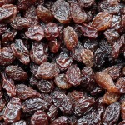This dried fruit not only tastes delicious, but can also be stockpiled away for a rainy day. Raisins are packed with energy, and they don’t require refrigeration. Sun Maid raisins are a good option, but if those are too expensive, you can always buy the generic brands (they’ll benefit you just the same). Believe it or not, raisins are an excellent source of energy, and they taste great too.
Popcorn
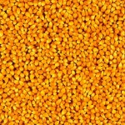This is one of my favorite foods with a long shelf life. According to Eat By Date, unopened popcorn has an indefinite lifespan. Additionally, popcorn that’s been popped can last for 2-3 weeks, which is respectable. I’d recommend stocking up on as much popcorn as possible. Don’t go for the tastiest option since those will probably be the most expensive. Remember, this is about survival, not luxury.

Dried Peas
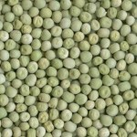This is one of those foods that people often overlook. However, dried peas are another example of foods with a long shelf life. They can last for 4-5 years, which is quite a long time. There are ways to extend the lifespan of dried peas to 25+ years, but this requires specialized packaging that goes beyond the scope of this article. On average, expect to pay about $1 per pound of dried peas.
Beef Jerky
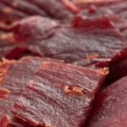Beef jerky is one of those foods that can last a long time without going bad. According to Eat By Date, it can last for 1-2 years if left unopened. Keep in mind that nearly all dried meats have relatively long lifespans. Here’s a Wikipedia page showing a list of all the different types of dried meat that exist in the world. Do your research and buy what you can afford!
Dried Pasta
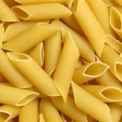When most people think of foods with a long shelf life, this is one of the first things that come to mind. On average, dried pasta can last for 1-2 years. Once it’s cooked, though, it can only last for 7 days (roughly). Pasta is filled with carbohydrates, so it can be a great way to get more energy. If you don’t like your pasta plain, you can always buy tomato sauce, which has a shelf life of 12-18 months according to StillTasty.com.

Oats
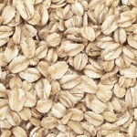There’s not much to say about oats. They’re nutritious, cheap, and versatile. Needless to say, they’re highly recommended for any prepper. A 50-pound bag of oats will cost you, on average, $50. That’s about on par with many of the foods on this list. Oats as a whole are considered relatively healthy. They contain a ton of fiber (which helps digestion), and they’ve even been shown to lower LDL cholesterol (the “bad” kind).
Powdered Milk
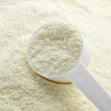Powdered milk has an indefinite lifespan. However, experts recommend repacking it for an even longer storage time. If your powdered milk develops an odor, of if it’s developed a yellowish tint, then it’s no longer safe for consumption and should be thrown out. On Amazon, I found 340 grams of powdered goat milk for about $8. This is an attractive deal in my opinion.
There you have it- 10 foods with a long shelf life. By no means is this an exhaustive list. I simply wanted to show you some common and cheap foods that you can begin stocking up on as early as today. You can get a discount on some of the above food items if you buy them in bulk (like dried rice or dried beans for example). Now that I’ve showed you what these foods are, let’s move on to non-perishable condiments.

12 Condiments/Spices With a Long Shelf Life
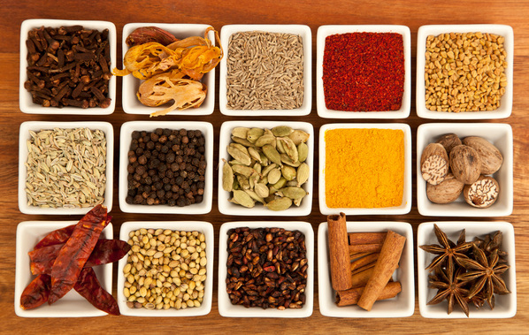
Here are 12 condiments/spices that can last indefinitely:
- Tea
- Honey
- Sugar
- Salt
- Dried Coffee
- Maple Syrup
- Vanilla Extract
- Cacao
- Vinegar
- Soy Sauce
- Coconut Oil
- Baking Soda
Most of these are cheap, and can be purchased at any grocery store. For example, an eight-ounce container of baking soda costs about $4.50, while a 30-ounce container of dried coffee costs about $8.50. That’s pretty cheap! This will allow you to prep for a rainy day without breaking the bank.

3 Types of Foods to Buy
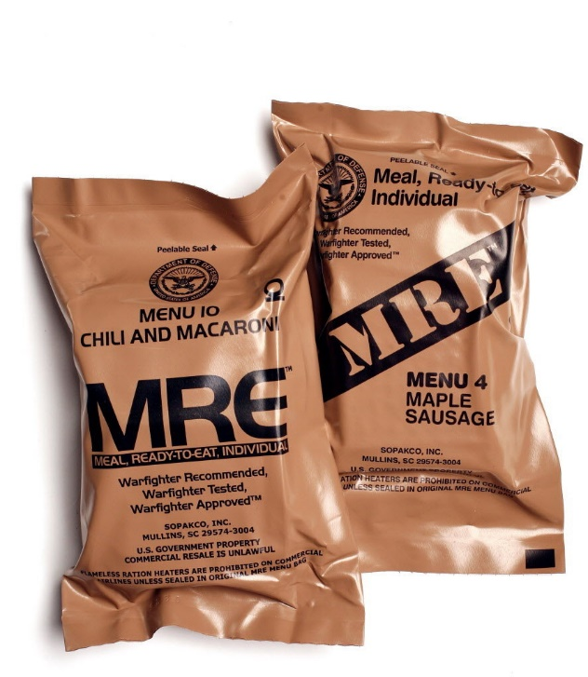Now that we’ve talked about specific foods with a long shelf life, I want to take a step back and look at broad categories. Specifically, I want to show you three types of foods that, for the most part, all last a long time. They include:
- Canned Foods: All canned foods have lifespans that hover around 1-3 years. They all come with expiration dates. If you try to eat canned foods after the date printed, the food inside may become “mushy” (although it might still be edible). Before the printed date, the only way canned food will go bad is if you puncture the can, or if you expose it to extreme heat or cold. In these cases, something called “Botulism” can happen.
- MREs: Also known as “Meals Ready-to-Eat”, MREs are the standard of food in the military, but can also be purchased by consumers as well. MREs contain a variety of non-perishable foods, from crackers, meats, and vegetables (among other things). MREs contain dozens of foods with a long shelf life, making it a recommended option for any prepper.
- Dehydrated Foods: As its name implies, a dehydrated food is one in which all of the water/moisture has been removed. Once this happens, the food is capable of going much longer without spoiling. It’s one of the oldest food preservation techniques known to man. You can either buy dehydrated foods straight from the store, or if you can make them at home using specialized equipment.
This isn’t a specific list of foods with a long shelf life- it’s more of a broad category that will give you a general idea of what you’ll need. For a specific list, refer to the food items mentioned earlier in this article. Before ending this article, I want to provide you with a few tips for buying the right types of non-perishable foods.
Check Prices

How to Buy Non-Perishable Foods
When comparing all the foods with a long shelf life that exist, it can definitely make your head spin. Below I’ll show you a few tips that you can follow to make sure that you’re buying the right stuff (without getting ripped off). I’ll show you how to:
- Decode Food Dates
- Differentiate Between Dehydrated and Freeze-Dried Foods
- Understand the Role of Salt in Foods That Are Shelf-Stable
Let’s talk about each one of these individually.
Understanding Food Dates
In the U.S., there isn’t a system of food dating that is universally accepted. However, there are a few core “principles” that you’ll want to understand. First, realize that there are three main food dates you’ll encounter:
- “Sell By”: This is the date that the store uses to show how long the product will display for sale. This means that you can’t buy the product after the “sell by” date.
- “Best By”: This is the date recommended for optimal quality and/or flavor. It doesn’t relate to safety.
- “Use By”: This is the date that’s been determined by the manufacturer, and tells you when the product will be at peak quality.
With exception to the “use by” food date, product dates don’t pertain to home storage after purchase. What I mean is that the “best by” and “sell by” date will tell you about how long the product will remain fresh- not about whether it will become dangerous. Even if the date expires on a specific food item, it’s still possible for it to remain safe (assuming that you’ve handled it properly and taken the proper measures of storing it). Eggs, milk, and meats aren’t examples of foods with a long shelf life. If you notice these foods developing an odor, they are most likely bad- even if you haven’t reach the food date on the package.
Dehydrated vs. Freeze-Dried Foods
When shopping for foods with a long shelf life, you need to understand the difference between freeze-dried and dehydrated products. Why is knowing the difference important? Well, each type of food has a different lifespan, and they’re priced differently as well. Let’s take a look at the primary differences between the two:
- Dehydrated Foods: These types of foods have had their water completely removed via heat. These process is exceptionally useful for storing vegetables, legumes, grains, and fruit. While they are an example of foods with a long shelf life, keep in mind that dehydrated foods tend to lose their texture and/or flavor once brought back to their original state.
- Freeze-Dried Foods: These foods are “flash frozen” in a process where the water is removed by something called “Sublimation”. Basically, the ice is transformed from a solid to a gas. What’s the benefit to this method? Well, it allows foods to have longer shelf lives than dehydrated foods. Also, they tend to retain their flavor well once rehydrated.
If you’re going to take prepping seriously, then you need to understand the difference between these two types of preservation methods.
Role of Salt in Food Preservation
Salt has been used in food preservation for thousands of years. That’s because it helps inhibit the growth of pathogenic microorganisms. Salt draws water out of bacterial cells via a process known as “Osmosis”. Once too much water is removed from the food, the bacteria inside are no longer able to reproduce as efficiently. For meats to become foods with a long shelf life, you need salt. A concentration of just 20% salt is typically good enough to kill most bacteria.
https://youtu.be/6g4tSSjpo6M

