10 Food Hacks For Kitchen Mastery
There's two things everyone does: they cook and they eat. Sometimes those things can be a burden, so why not make both easier? Here are 10 genius food hacks for kitchen mastery. Never let cooking and eating ever make a fool of you again.
- Want to make a perfect, edible chocolate cup to put your desserts in? Use a balloon!
http://www.youtube.com/watch?feature=player_embedded&v=k71g_GojFQ0
2. Want your bananas to last as long as possible? Separate each banana individually then put plastic wrap on the tops!
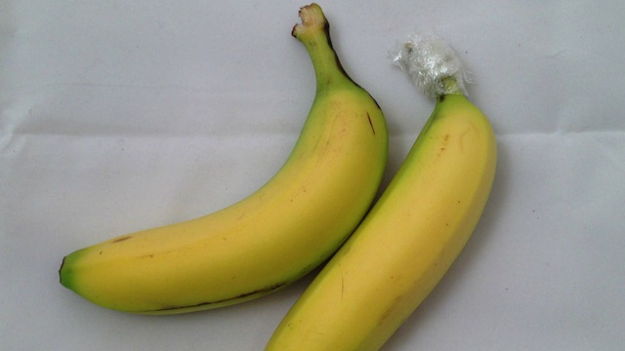
3. For perfect hard-boiled eggs, bake them, not boil! Set an oven to 325F and bake up to 4 dozen eggs at once for 30 minutes. Plunge into ice water after!
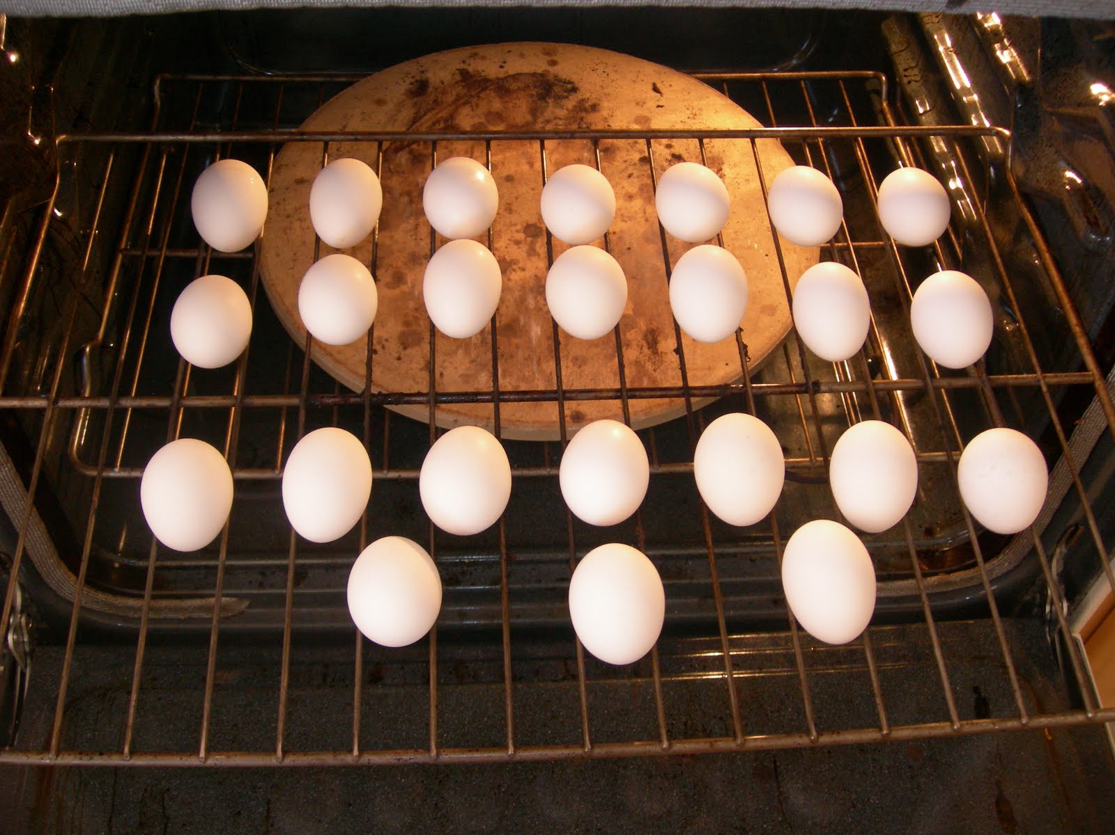
4. Hate when your burgers turn into golf balls and don't cook evenly? Solution is simple! Put a small indent in the middle using your thumb.
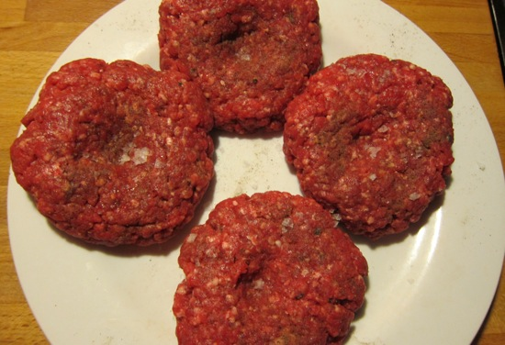
5. We don't all have pizza stones, so he's a $5 hack to give you the best homemade pizza!
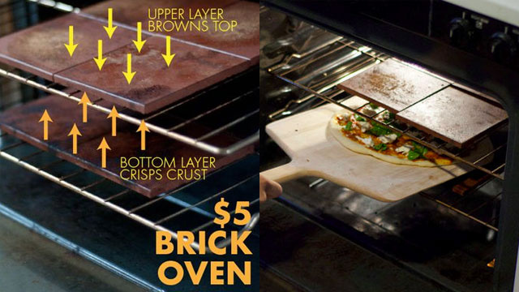
6. Homemade taco shells are easier than you think. Preheat oven to 375F and warm the tortillas until they're pliable. Cover the tortillas in cooking spray then drape over the oven racks.
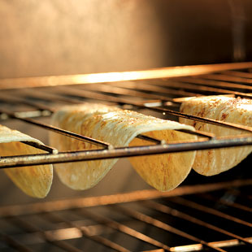

7. Skip using ice cubes with water in your coffee! It just dilutes your drink. Instead, put some crushed Oreos in an ice cube tray and cover with milk.
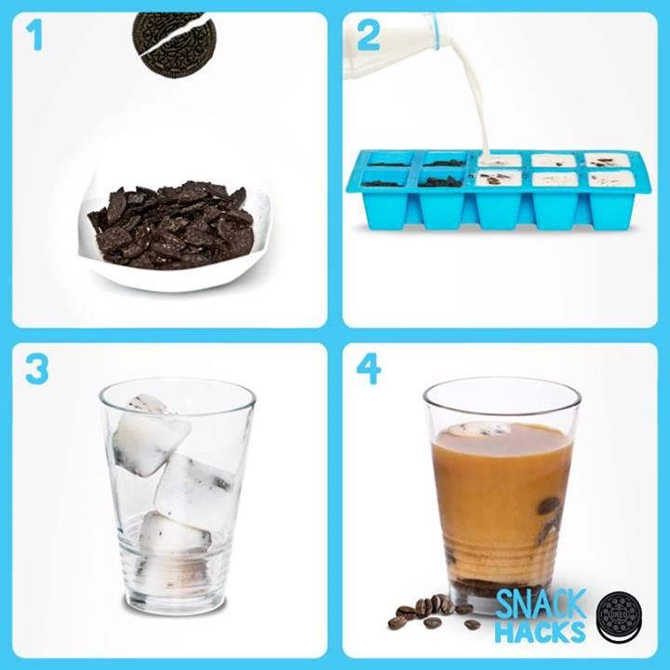
8. Can't ever remember what teas require what temperature and time? Never fear!
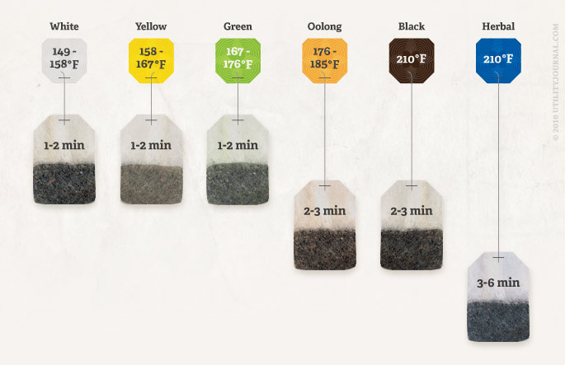

9. Don't you hate when burgers or BLTs come with a criss-cross bacon pattern? Make a mini bacon weave instead. It covers sandwiches perfectly!
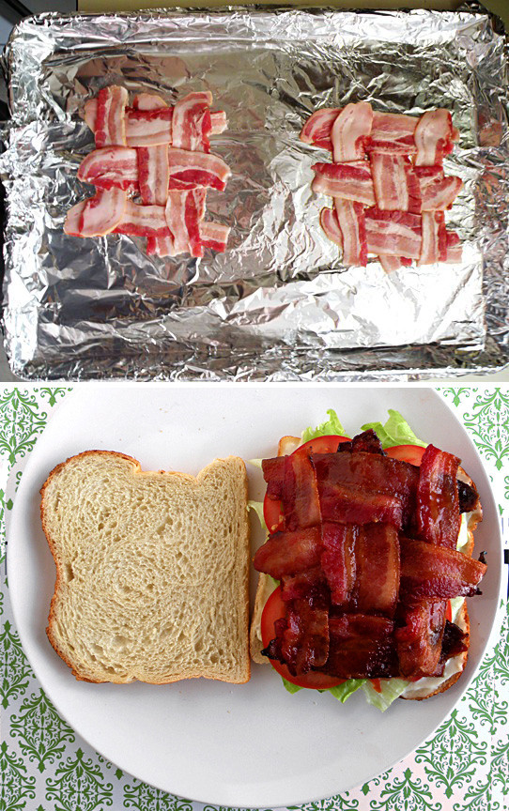
10. Want to know how fresh your eggs are? Use this test to figure it out!
