A Guide to Using Essential Oils for Your Body
- April 2, 2014
- Mom with a Prep
After reading so much in the Essential Oil movement, and scoffing at it for so long (though I am a HUGE fan of Tea Tree Oil), I’m beginning to start the research on REAL uses of EO’s instead of just all of the promised uses.
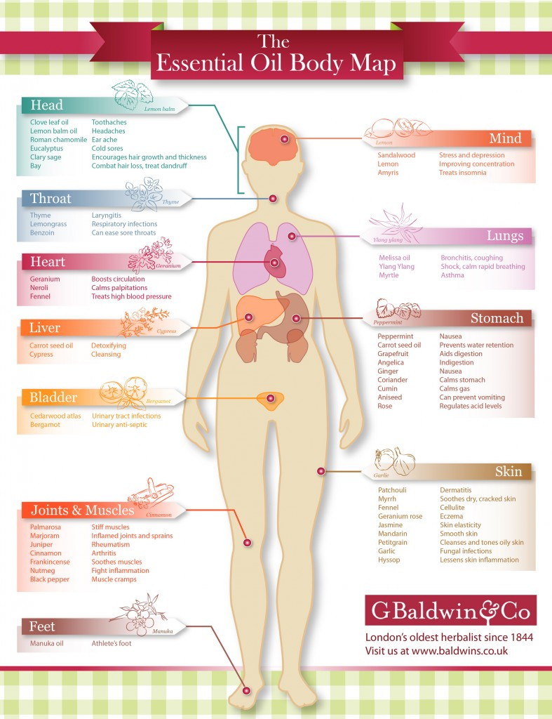
Courtesy of: G Baldwin & Co
This chart by the Baldwin Company is a great visual aid on what EO’s can help what vital bodily organs, and is something I’ll keep handy when I need to find out what works where! Hope it helps you, too!
If you need another Essential Oil Resource, check out the new Preparedness Planner Essential Oil Edition that Jennifer from AreWeCrazyorWhat.net has created to go along with her Preparedness Planner. It is included FREE, this month, with the purchase of the Preparedness Planner. Starting next month, it will be a separate purchase for $4.99.
This is a great handy reference on what EO’s are, how to use them, and a great way to keep track of your supply.
This work is copyright @2014 by Mom with a Prep {blog} and may not be copied in part or in whole without the express consent from Mom with a Prep. This post may contain affiliate links. Shopping through these links helps support the efforts of Mom with a Prep.com and our family. We appreciate you so much!

